

Untitled Mapping Project

Peter Warrington’s NEA project

World map emoji icon sourced from the Twemoji project - Copyright 2020 Twitter, Inc and other contributors - licensed under the CC-BY 4.0 license.

**Table of Contents**

Untitled Mapping Project 1

Analysis 5

The problem 5

Problem research 5

Objectives 7

Prototype 8

Modelling 8

High level project structure 9

Documented design 10

Main data containers 11

Map objects 12

Database layout 13

Path finding pseudocode 13

HCI 17

Technical solution 22

Shared (used by both server and client) 22

src/shared/sharedStructures.js 22

Web client 39

src/web/index/index.js 39

Server 71

src/index.js 71

src/convertFromOSM.js 73

src/logging.js 81

src/dbFromQuery.js 82

src/findRoute.js 87

src/pointSearch.js 91

src/getDBfromFile.js 93

src/getTestDB.js 94

Abandoned – Tile mapping 96

src/MapAreaToImage.js [excerpt] 96

src/shared/sharedStructures.js [excerpt] 98

Testing 99

Testing video 99

Objective 1 (“Web client is able to send requests and receive appropriate data back to/from backend”) 102

Server successfully starts up 102

Web application successfully loads 103

Corresponding JSON data is returned for requests to GET /api/GetDBfromQuery 104

Objective 2 (“The backend is able to read from OpenStreetMap data and return this to clients via this API”) 107

convertFromOSM.js on OSM data for Cambridgeshire 107

Objective 3 (“The web client is then able to display and represent data returned from the server on a map that can be panned and zoomed”) 109

Pan without zoom to map extreme 109

Zoom out to show whole of map 111

Zoom in from initial position 111

Zoom in, pan, zoom out 114

Zoom out, pan, zoom in 116

Objective 4 (“A search function is available on this web client to be able to find locations using the API”) 119

API request to /api//PointSearch, searching for “museum” 119

API request to /api/PointSearch for a specific point ID 120

Searching for “museum” via web app 121

Search for specific point via web app 123

Objective 5 (“A function will be available to find an efficient route from one location on the map to another using path theory. This will take into account distance and this route must be traversable in the real world.”) 125

API request to /api/FindRoute searching between “Cambridge station” and “Cambridge north” 125

Search for route between “Cambridge station” and “Cambridge north” via web app 126

Objective 6 (“Function serviced by database on the backend to allow a user to sign-in/register and save places/routes”) 127

Objective 7a (“Testers reports that they are able to easily find their home using the search function”) 127

Objective 7b (“Testers reports that they are able to easily generate a route”) 127

Objectives 7c and 7d (“Testers report that they are able to easily register and log in, save their location and route to their account”) 128

Evaluation 128

Evaluating against set objectives 128

Possible improvements to project 131

Apendix 132

Analysis 132

Graph theory research from start of project: 132

Planned database/object structure 132

Version of analysis documentation during early stages of project 134

Early project purpose documentation 135

Project development screenshots over time 137

02/07/2021 137

18/11/2022 138

17/02/2022 138

20/02/2022 139

21/02/2022 140

23/02/2022 140

24/02/2022 141

26/02/2022 142

27/02/2022 142

Early testing 143

27/12/2021 143

Code 143

Final project - index.html 143

Final project - Index.css 146

Git commit log 155

# Analysis

## The problem

For my NEA, I have decided to create a self-hosted mapping solution, accessible from web clients via an API. This is as opposed to commonly used proprietary cloud services that are hosted by third parties, such as Google Maps, which cannot be hosted on-site, and which do not allow organisations and individuals the high level of control a self-hosted system provides.

This may be useful for individuals that have access to such services blocked or censored due to Government influence, where a decentralised self-hosted service allows people to avoid this. For example, mapping services offered in China face strict legislation that mandate these to meet Government conditions, for example to reflect their government’s own disputed position on territorial boundaries.[1]

It may also be useful for organisations that want to manage and share their own confidential map data securely with authorised parties.

This service should be fully accessible from a variety of platforms, including desktops, smartphones and tablets in order to provide a mapping service for users when they need them, much like Google Maps. It was for this reason that I decided to create a web application for this service that communicates with the server in order to meet these requirements.

## Problem research

In order to begin to understand how a solution to this problem could be approached, I broke down the problem into several questions.

1. What map data can be used in order to build a reliable, real-world map hosting system?

The most well-known Internet mapping service is of course Google Maps, at least in western countries such as the United States.[2] The map data underlying the service however available publicly, unless using Google’s API under strict conditions banning external re-use.[3] Data from this service therefore could not be utilised in this project.

I therefore decided to use OpenStreetMap data as this is publicly available under an open source licence[4], as well as being comprehensive and reliable[5], available in machine readable XML format.[6]

I considered using Ordnance Survey data for this purpose, which is publicly available under the open-source Open Government License and meets those conditions met above, being very reliable given it is the UK’s national mapping agency.[7] I however decided to use OpenStreetMap data as this is globally comprehensive, meaning adding OSM support would allow the importation of existing worldwide map data, not just for the UK.

1. How can map data be plotted on a map?

OSM provides data for streets, bodies of water, and land use, alongside nearly a hundred other map features.[8] As part of my research, I analysed the OSM XML file format and proposed an algorithm to be able to convert this into a custom database format included in my appendix (“OSM Conversion Algorithm”).

OSM data which I used in my project is defined in terms of points specifying latitude and longitude, which must be displayed on a map using a projection in order to map the globe onto a rectangular plane like ours. The Mercator projection is one of the simplest of these, being regarded as much of a standard, with calculations to map latitude and longitude onto x and y coordinates being straight-forward.[9]

From a more implementation focused perspective, there are then two main ways for map data to then be displayed on a client. The simplest of these is to return raw map data to the client that is then processed and drawn onto the display accordingly. This can be resource intensive however, especially when drawing lots of map elements to screen, something that can lead to lag. Alternatively, a process of tile-mapping can be used, where a server returns pre-generated images of the map to the client, something that can lead to faster load times. This approach is used by Google maps.[10] As part of my project, I decided it was more feasible to get an implementation which doesn’t use map tiling working first as it made map manipulation and map display implementation easier during the development process, leaving open the option of implementing tiles later.

1. How can map data be queried?

OSM provides comprehensive metadata for map elements[11], which can easily be queried and searched by implementing a database.

1. How can routes be plotted using map data?

Plotting routes requires the use of a path-finding algorithm. The main algorithm that I researched was Dijkstra’s, as this enables path finding between connecting nodes from a start node to an end node reliably and reasonably efficiently. I considered the use of the A* path search algorithm, which is generally more efficient than Dijkstra’s, but this requires the use of a heuristic function which I was unsure how to define. I therefore considered it more feasible to implement a Dijkstra’s path finding algorithm within my project time frame and researched into this towards the start of the project as included in my appendix under “Graph theory research from start of project”.

## Objectives

During the analysis stage of my project, I outlined the following objectives that I wanted to achieve:

1. Web client is able to send requests and receive appropriate data back to/from backend
2. The backend is able to read from OpenStreetMap (OSM xml) data and return this to clients via this API
3. The web client is then able to display and represent data returned from the server on a map that can be panned and zoomed
4. A search function is available on this web client to be able to find locations using the API
5. A function will be available to find a efficient route from one location on the map to another using path theory. This will take into account distance and this route must be traversable in the real world.
   1. a. **Extension:** Take into account traffic, whether that be based on a custom specified metric or the location of traffic lights along a route
6. Function serviced by database on the backend to allow a user to sign-in/register and save places/routes
7. Testers reports that they are able to easily:

a. Find their home using the search function

* + Generate a route
  + Register and log-in
  + Save this location and route to their account

1. Data structures and important algorithms are well-documented using comments
2. API is well documented
3. Effective use of object-oriented programming to be able to create effective data structures shared across the project, including the appropriate use of inheritance.
4. Normalised database structure to store the data mentioned above.

**Extension:**

1. Cache the most frequently accessed places directly on the database
2. Function to be able to plot new data on map that is then made available
3. Ability to add notes to the map
4. Ability to add other annotations to the map

## Prototype

During my analysis stage, I designed a basic prototype of a web application that can display points and paths locally on a translatable map. The data structures and methods that I created here went on to serve the basis of much of my finished implementation, establishing classes for the displayed canvas, map points and paths. This did not yet make use of a server, but demonstrated that much of the project was achievable, and served as a firm foundation from which I further developed the project.

A screenshot of it is included below, while the JavaScript code for this prototype is included in the appendix (Prototype - src/web/index/index.js).

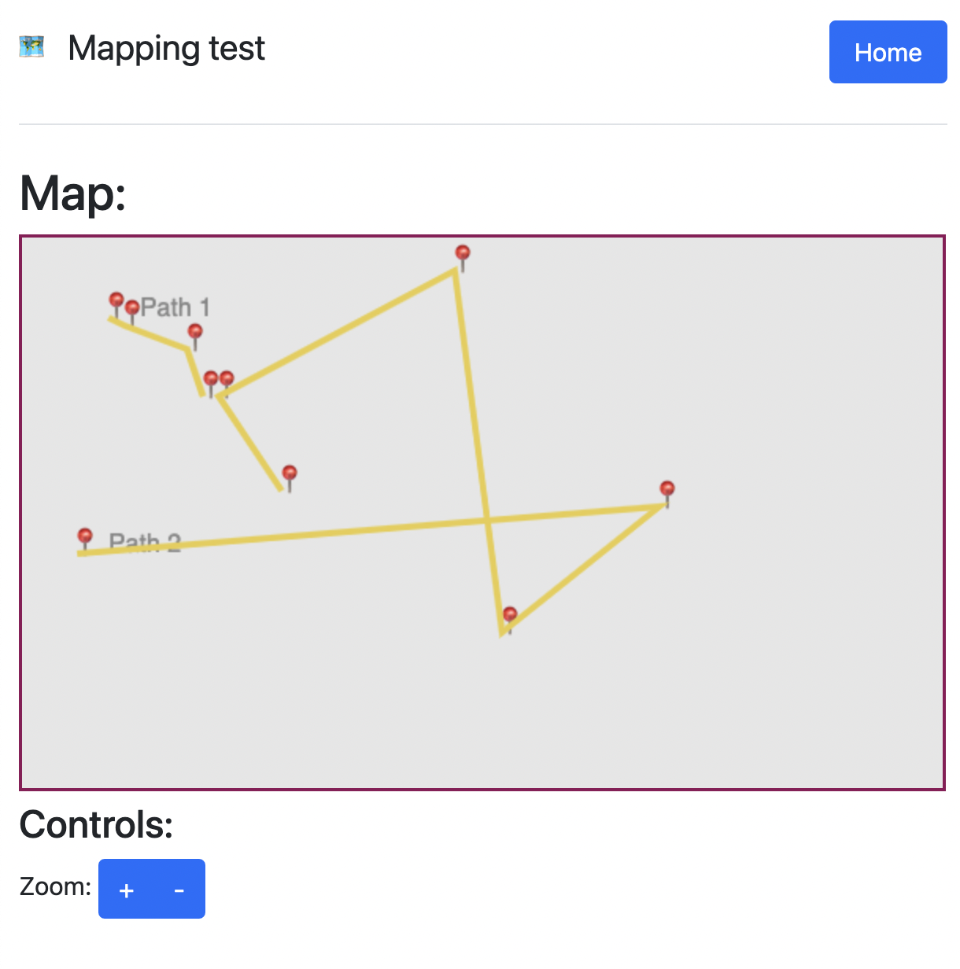

## Modelling

During the analysis stage of my project having completed the prototype, I decided to draw up a project structure model, included below, describing the planned components of the project and how I expected them to interact.

### High level project structure

This document outlines an initial plan for the main components of my NEA, and how these will interact.

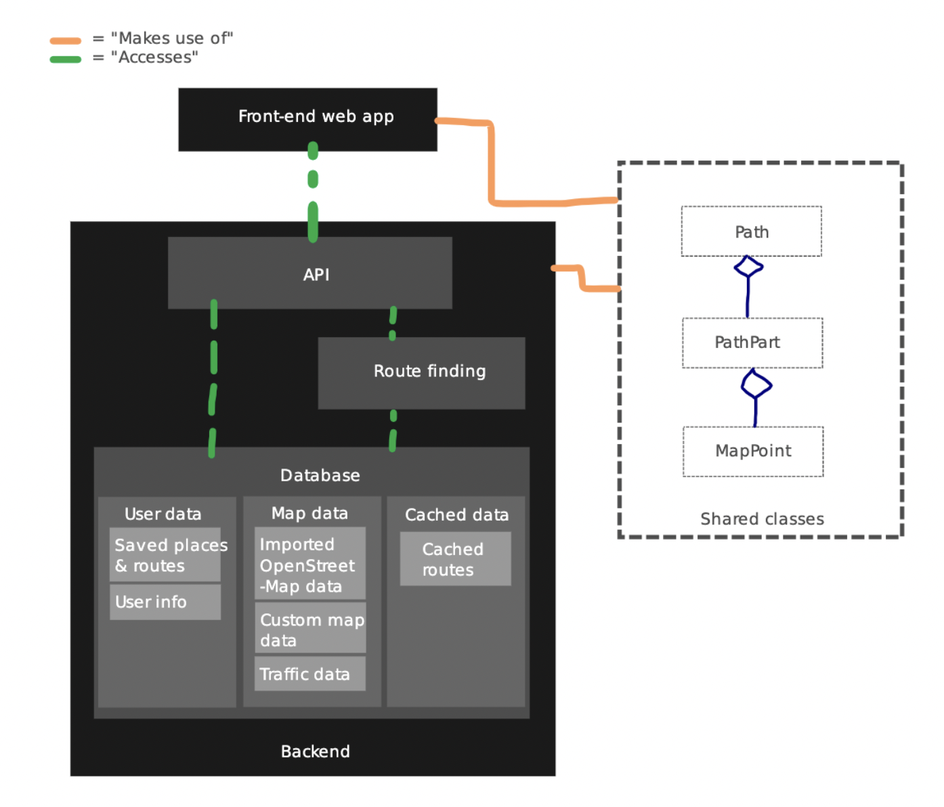

**The frontend**

The frontend will be a web app built using JavaScript, HTML5 and CSS3 technologies. It will

* Display a map that is scalable and translatable
* Communicate with the backend using an API
* Support a variety of devices such as desktops, tablets and smartphones

It will share many of the data structures that are used on the backend representing map elements and paths. It will require extensive testing to be able to ensure it can reliably perform these functions, where serving as a web app will make user testing easier.

**The backend**

The backend will be built in JavaScript using the Node.JS framework. At its most basic level, it will:

* Be able to read OpenStreetMap data that will be imported into a database
* Serve this data via an API to the frontend
* Calculate paths and serve this via an API to the frontend

It will therefore require a database and the use of path theory which I will have to research.

# Documented design

The design of my project is organised into three main components:

1. **convertFromOSM.js**

This is manually ran in order to convert data from a source OSM XML file into the custom database format (db.json) that the project uses. This can take up to around 5 minutes as it is often a large dataset. Throughout development I have been using OSM XML map data of Cambridgeshire that is imported using this script with success.

The resultant db.json is in a normalised form, and is significantly faster to process than just the OSM, as it does not have the same XML overhead and can be read natively into a JavaScript object on both the client and server, both of which use JavaScript.

1. **The server**

This is the largest part of the project and is responsible for operating an API from which the client requests views of the database using queries, as well as conducting searches and route finding. It is additionally responsible for hosting the web application.

1. **The web application**

This is responsible for requesting and displaying map data to the user, as well as presenting the user interface.

A diagram of these components and how they interact is shown below:

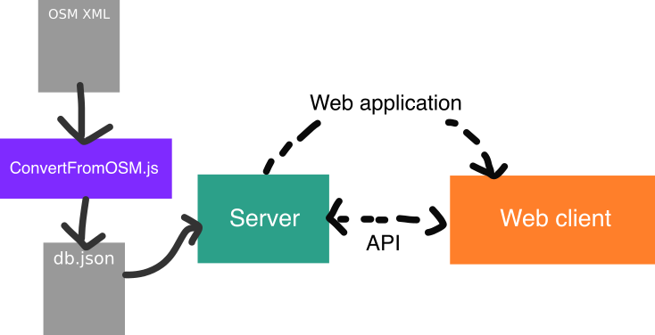

## Main data containers

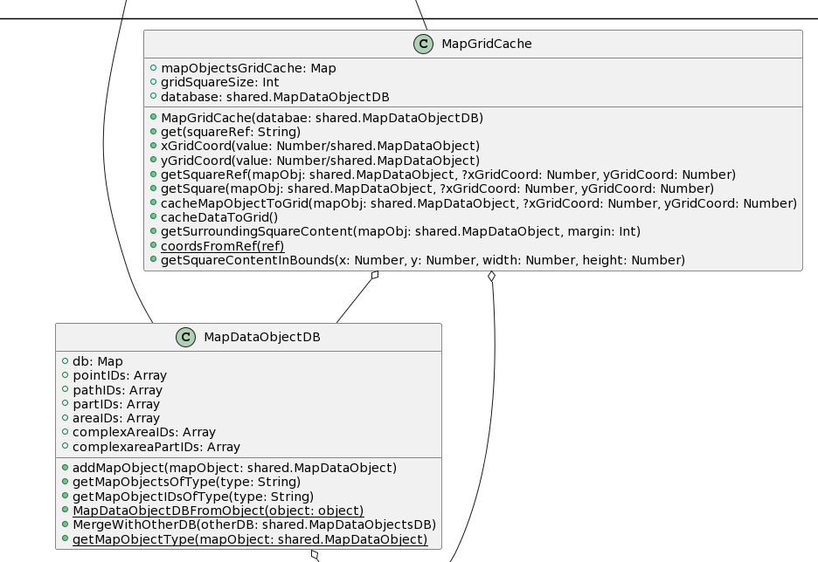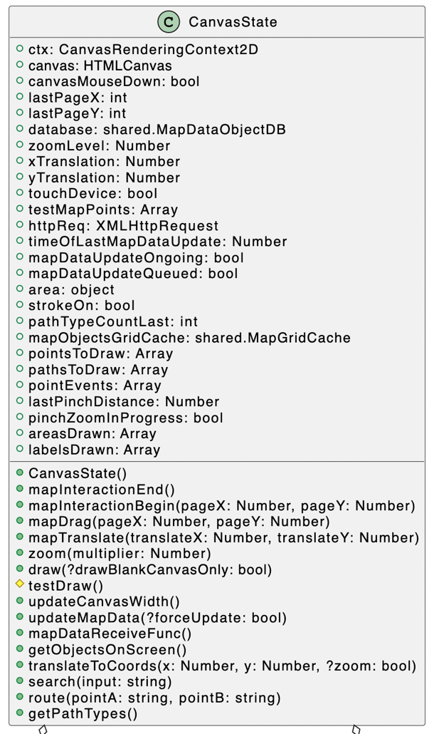



The CanvasState class is specific to the client and contains all the data and methods necessary to draw the map to the screen, with methods to request data from the server.

CanvasState augments MapGridCache and MapDataObjectDB, data structures that are also used on the server. The grid cache uses a hash map to map a square on a grid to the map objects currently being displayed on the grid, while the object DB is a custom database implementation that stores map objects so they can be accessed and queried, on both the server and client.

## Map objects

The shared map objects represent the server representation of map elements such as points and paths, with those properties and methods that are required by the server. The client inherits from these shared map objects to add those properties and methods necessary to draw them to screen, with the exception of ComplexAreaPart which has to be fully duplicated from the shared structures unlike the other classes, because otherwise it inherits shared.Area without drawing functions, rather than just Area with drawing functions.

## Database layout

The database used by my project is organised into keys, where each key is the unique ID of a map object, and the beginning of each ID indicates the table it is a part of. These are: POINT, PATH, PART, AREA, COMPLEX-AREA, and COMPLEX-AREA-PART. For example, an ID for a specific point might be POINT_123AbC. Where the last characters uniquely identify the point.

This database is in JSON key-value pairs as a file but is stored as a hash-map when loaded into memory both on the server and client.

The database caches the specific IDs that are in use for each map object type, so that all map objects of a specific type can quickly be iterated through, for example when conducting a search.

Map objects reference map objects in other “tables” using their IDs as foreign keys. For example, an Area contains an array of point IDs that make up that area.

## Path finding pseudocode

One of the key features of my project is route finding of real world map data. Pseudocode detailing the algorithm used in my implementation is explained below:

// This function is called when a API request to find a route between two points is

// received.

START FUNCTION findRoute(startingPointSearchTerm, destinationPointSearchTerm, database, gridCache)

// Conduct searches of the search terms to find their corresponding points

startingPointID = Search(startingPointSearchTerm, database)

destinationPointID = Search(destinationPointSearchTerm, database)

startingPoint = database.get(startingPointID)

destinationPoint = database.get(destinationPointID)

// Get the point nearest to found points that is on a highway

// From which we can conduct routing. We limit the types of highways

// that we can route using to decrease nodes and therefore

// decrease processing time into reasonable bounds

startingPoint = nearestHighwayPoint(startingPoint, database, gridCache)

destinationPoint = nearestHighwayPoint(destinationPoint, database, gridCache)

// Begin dijkstra's now that we have our starting and destination points finalised

// Define sets

visitedNodes = new HashMap()

unvisitedNodes = new HashMap()

// Set distance of starting point to 0

startingPoint.distance = 0

allDatabasePaths = database.getMapObjectsOfType("PATH")

FOR EACH path IN allDatabasePaths

IF isAcceptedHighway(path)

FOR EACH point IN path

// Set default properties for all nodes at start of dijkstra

point.distance = Infinity

point.visited = false

point.parentNode = None

unvisitedNodes[point.ID] = point

END FOR

END IF

END FOR

currentNode = startingPoint

WHILE destinationPoint.visited == false DO

// Get same points in same 10x10 square as currentNode

neighbours = []

neighbours += gridCache.get(currentNode.x, currentNode.y)

neighbours += getPathContainingPoint(currentNode).getPointAfter(currentNode)

neighbours += getPathContainingPoint(currentNode).getPointBefore(currentNode)

// If all neighbours have Infinite distance, a route has not been

// successfully found

IF EVERY neighbour IN neighbours HAS neighbour.distance == Infinity

return []

END IF

FOR EACH neighbour IN neighbours

// Calculate the distance to each neighbour, changing its recorded distance if this

// calculated value is less than that recorded

tentativeDistance = currentNode.distance + distanceToPoint(neighbour)

IF tentativeDistance < neighbour.distance THEN

neighbour.distance = tentativeDistance

END IF

// Set current node as the parent of the neighbour to allow for

// back-tracking

IF neighbour.ID != currentNode.ID THEN

neighbour.parentID = currentNode.ID

END IF

END FOR

// We have now examined all neighbours of this node, mark it as visited

currentNode.visited = true

// Remove from unvisitedNodes so we don't visit it again

unvisitedNodes.delete(currentNode.ID)

// Add to visited nodes so that we can back track later to find route

visitedNodes[currentNode.ID] = currentNode

// Set next current node to unvisited node with smallest distance

nextNode = EMPTY

FOR EACH node IN unvisitedNodes

IF nextNode == EMPTY OR node.distance < nextNode.distance THEN

nextNode = node

END IF

END FOR

currentNode = nextNode

END WHILE

// The algorithm should have now found a route, now we back-track in order

// to record this route

currentNode = destinationPoint

fastestPath = []

WHILE currentNode != startingPoint

fastestPath += currentNode

currentNode = visitedNodes[currentNode.parentID]

END WHILE

return fastestPath.reverse()

END FUNCTION

START FUNCTION Search(searchTerm, database)

searchResults = [];

// Iterate through search index, adding a score for each map object

// depending on its calculated relevance to search term.

FOR EACH mapObject IN this.searchIndex

searchConfidence = 0

// If the search term matches the exact ID of the object

// Rise this to the top of the results with a high

// search confidence

IF (mapObject.ID == searchTerm)

searchConfidence += 20;

ELSE

// Otherwise, score by the amount of times the term appears in the metadata

searchConfidence += OCCURRENCES OF searchTerm IN apObject.metadata;

END IF

// If the map object explicitly defines a place such as a town and

// It already matches the search term, increase its score so

// it shows up higher. This is because if someone searches for

// something like "Cambridge", we want to return the City, not

// some random location 15 miles away that happens to have

// "Cambridge" in its name.

IF (mapObject.metadata DESCRIBES AS "place" AND searchConfidence > 0)

searchConfidence += 15

END IF

ADD [mapObject, searchConfidence] to searchResults

END FOR

SORT searchResults by searchConfidence DESCENDING // Show highest scoring results first

result = FIRST entry IN searchResults WHERE entry.mapObject OF TYPE "POINT" || "PATH"

IF result == EMPTY

THROW ERROR

ELSE

IF result.mapObject OF TYPE "PATH"

result.mapObject = getPathMidpoint(result.mapObject)

END IF

RETURN result.mapObject.ID

END IF

END FUNCTION

## HCI

This section will demonstrate how a user interacts with the application, by using screenshots and explanations.

When the user first loads the website, the website will make its first request to the server for map data, which will then be displayed on screen, as shown below:

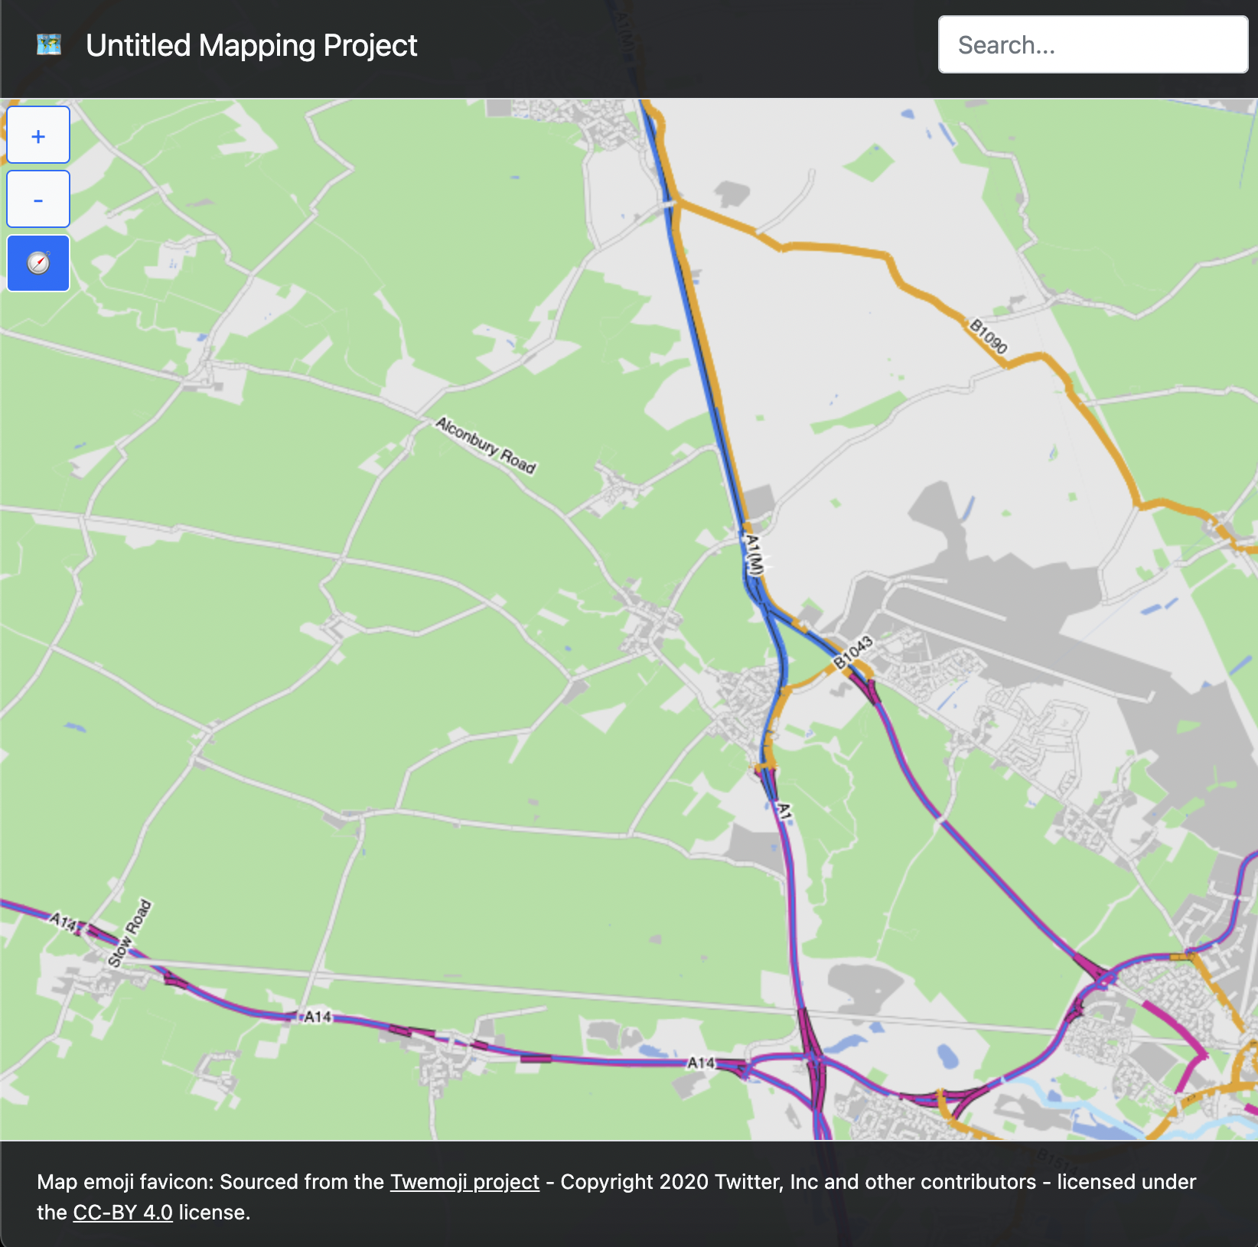

The user is free to pan and zoom this map using the +/- buttons to the left of the screen.

As the user moves about the map, new map data for this view is progressively loaded in from the server.

The user can use the search box at the top right of the screen to conduct a search of points and paths in the database, simply typing their search term and pressing enter, which will cause a draggable dialog box to appear, like that shown below:

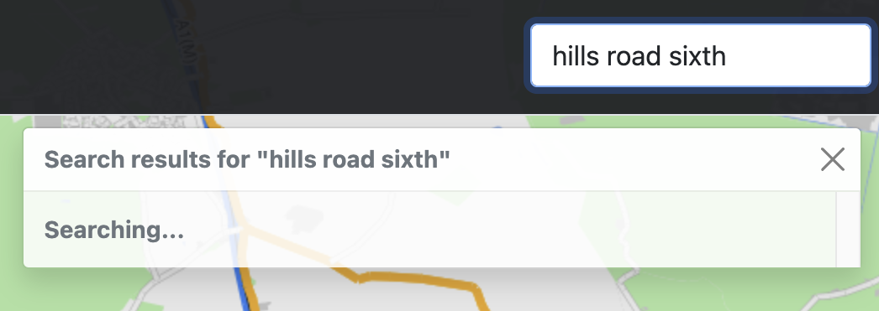

Results can then be displayed in the same dialog, translating the map to a view showing all the results:

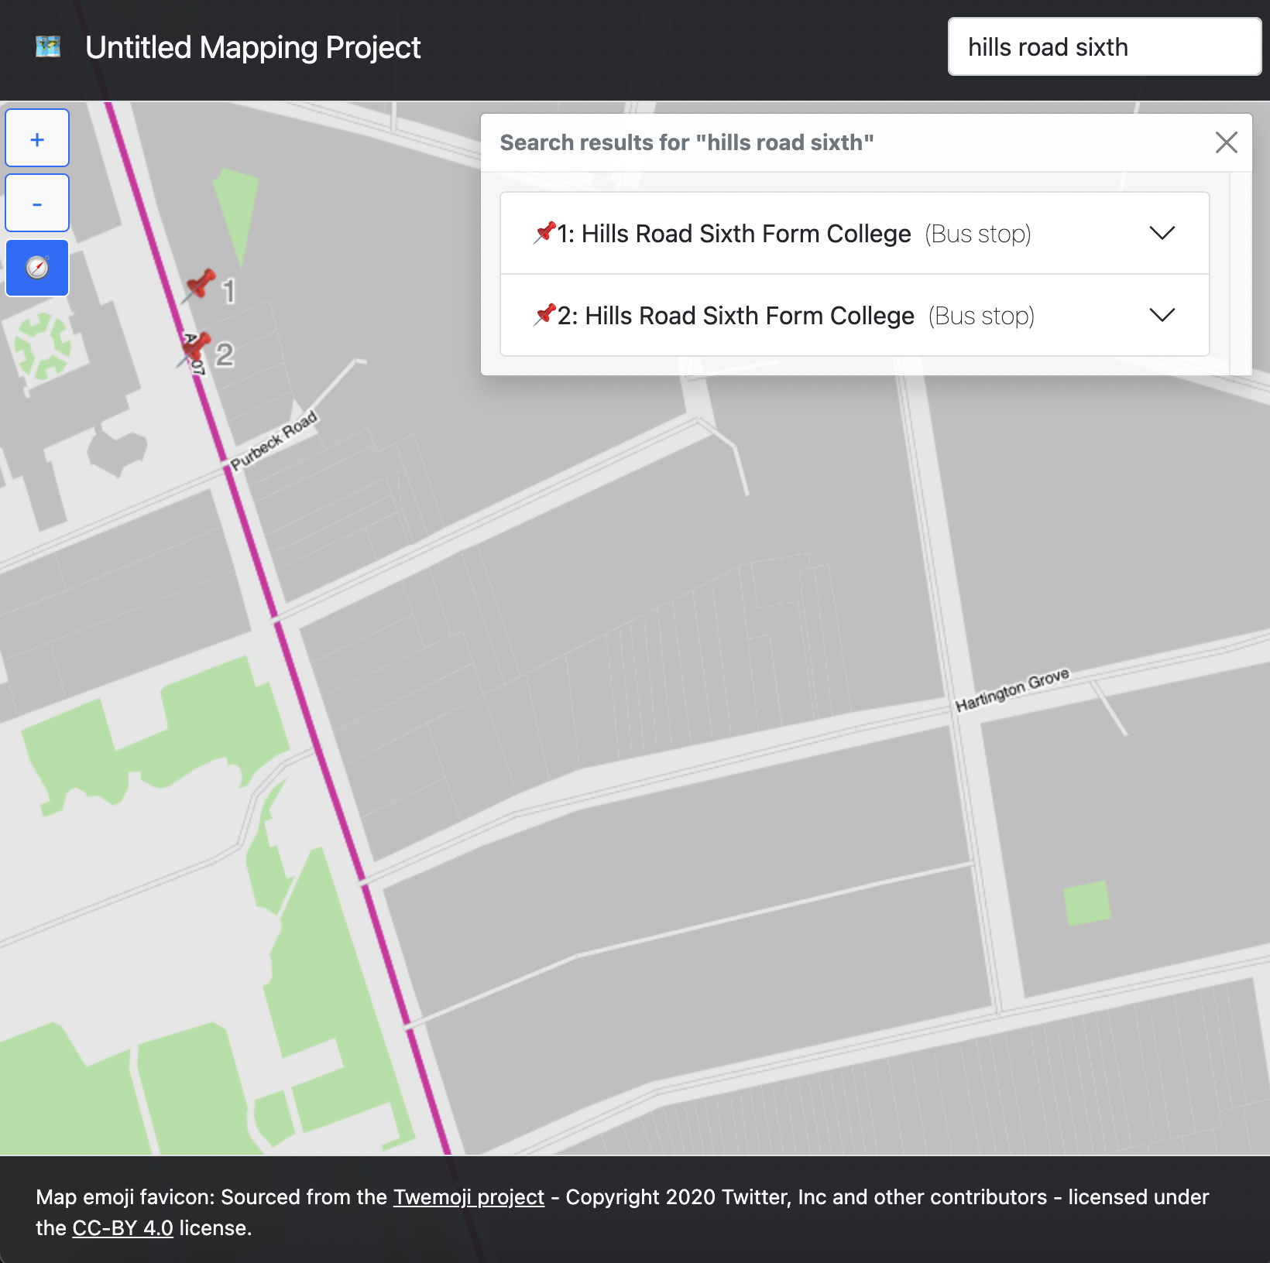

These results can then be selected to view additional information and translate the map to a specific point.

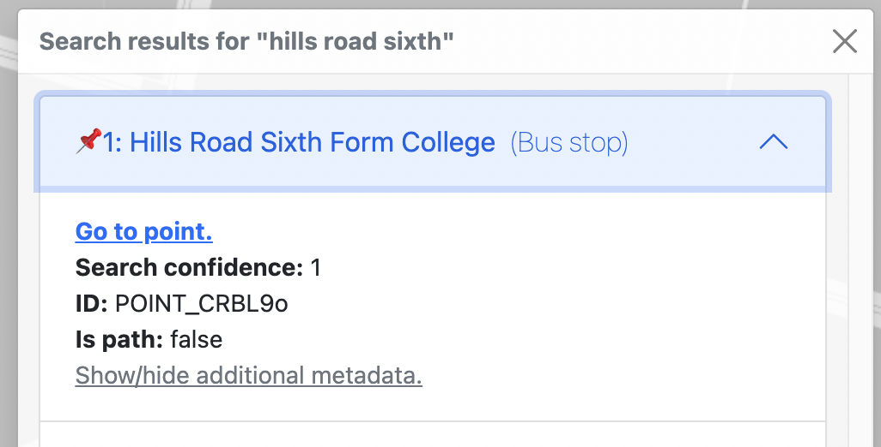

The “Show/hide additional metadata” button can be selected to show additional metadata, sourced from OSM.

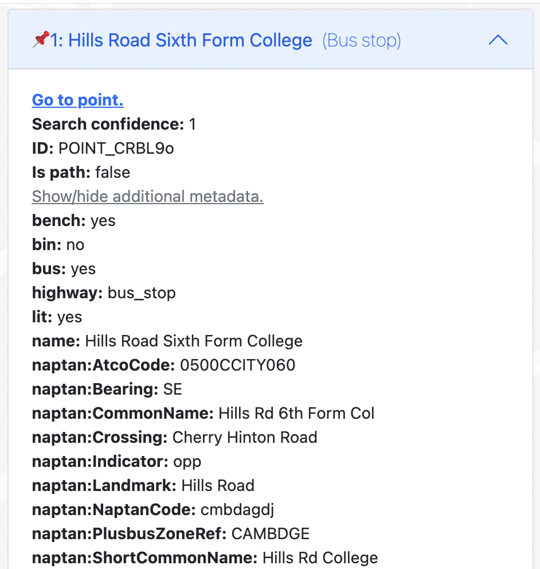

The compass button on the left of the display is used to show a dialog which allows the user to find a route between two points.

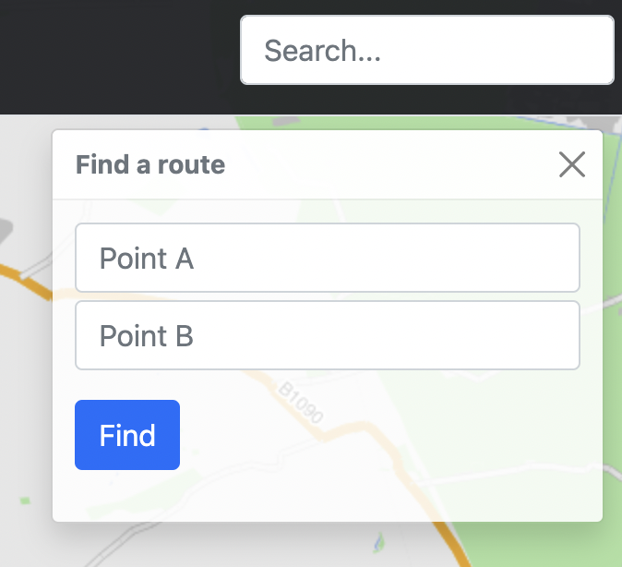

With search terms entered in both text boxes, the find button can be pressed and the status of the operation is displayed, while the server processes the request.

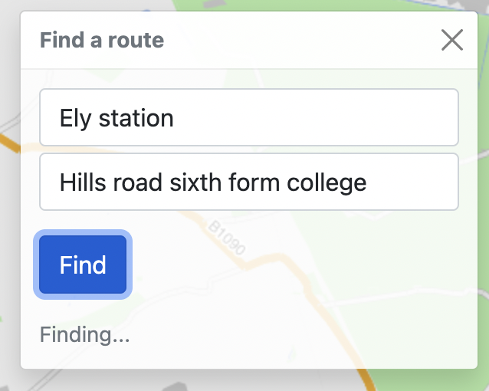

A route should then be displayed on the map.

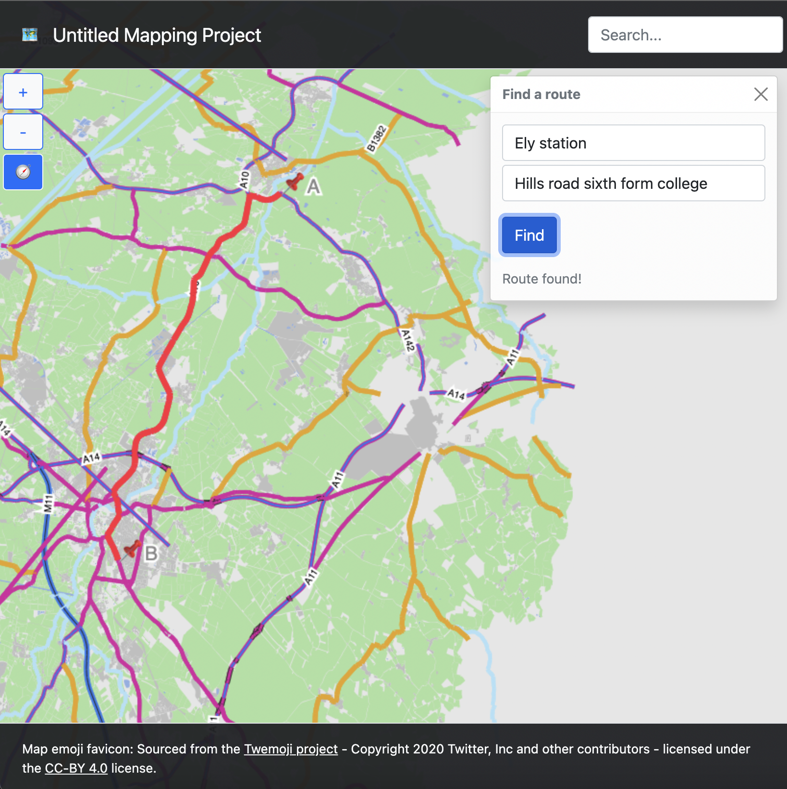

Both the search and route-find draggable dialogs can be displayed at the same time.

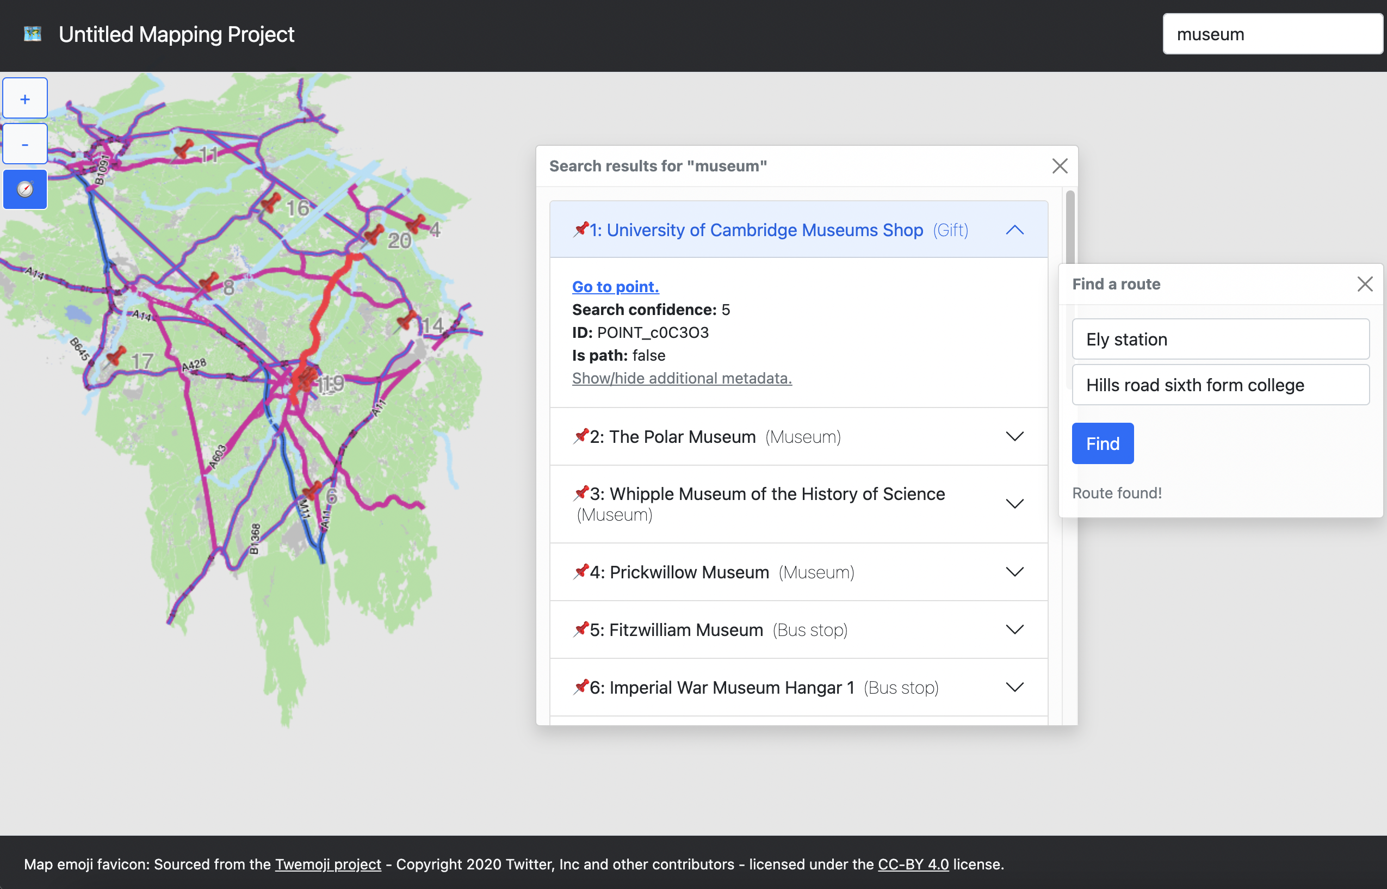

# Technical solution

## Shared (used by both server and client)

### src/shared/sharedStructures.js

shared = {};

// If running on backend, make accessible

try {

module.exports.shared = shared;

} catch {}

// Readable debug_on setting across both client and server

shared.debug_on = true;

/** A database model used to containerise map data using an ID system

* of the format [Type]_[UID]

* Contained map objects are accessed using database.db[id],

* map objects are added using database.addMapObject(mapObject).

*/

shared.MapDataObjectDB = class MapDataObjectDB {

/** Object, where key is the ID of the MapObject */

db = new Map();

/** Caches point IDs */

pointIDs = []

/** Caches path IDs */

pathIDs = []

/** Caches part IDs */

partIDs = []

/** Caches area IDs */

areaIDs = []

/** Caches complex area IDs */

complexAreaIDs = []

/** Caches complex area part IDs */

complexAreaPartIDs = []

/**

* Adds a map object to the database, generating a random ID.

* @param {MapDataObject} mapObject Map object to add

*/

addMapObject(mapObject) {

let ID = "";

if (mapObject.ID != null) {

ID = mapObject.ID;

} else {

ID += shared.MapDataObjectDB.getMapObjectType(mapObject);

ID += "_";

// Generate random characters for ID https://stackoverflow.com/a/1349426

var characters = 'ABCDEFGHIJKLMNOPQRSTUVWXYZabcdefghijklmnopqrstuvwxyz0123456789';

var charactersLength = characters.length;

for ( var i = 0; i < 6; i++ ) {

ID += characters.charAt(Math.floor(Math.random() * charactersLength));

}

}

// Add to DB

mapObject.ID = ID;

this.db.set(ID, mapObject);

// Cache ID

if (ID.indexOf("POINT_") == 0) this.pointIDs.push(ID);

if (ID.indexOf("PART_") == 0) this.partIDs.push(ID);

if (ID.indexOf("PATH_") == 0) this.pathIDs.push(ID);

if (ID.indexOf("AREA_") == 0) this.areaIDs.push(ID);

if (ID.indexOf("COMPLEX-AREA_") == 0) this.complexAreaIDs.push(ID);

if (ID.indexOf("COMPLEX-AREA-PART_") == 0) this.complexAreaPartIDs.push(ID);

return mapObject;

}

getMapObjectsOfType(type) {

let mapObjects = [];

let objectIDs = this.getMapObjectIDsOfType(type);

objectIDs.forEach((objectID) => mapObjects.push(this.db.get(objectID)));

return mapObjects;

}

/**

* Gets map object IDs of ID matching type.

* @param {array or string} type

* @returns

*/

getMapObjectIDsOfType(type) {

if (typeof type == "string") type = [type];

let ids = [];

type.forEach(type => {

switch (type) {

case "POINT":

ids = ids.concat(this.pointIDs);

break;

case "PATH":

ids = ids.concat(this.pathIDs);

break;

case "PART":

ids = ids.concat(this.partIDs);

break;

case "AREA":

ids = ids.concat(this.areaIDs);

break;

case "COMPLEX-AREA":

ids = ids.concat(this.complexAreaIDs);

break;

case "COMPLEX-AREA-PART":

ids = ids.concat(this.complexAreaPartIDs);

break;

default:

ids = ids.concat(this.db.keys().filter(id => id.indexOf(type + "_") == 0)); // Slow fallback

break;

}

});

return ids;

}

/**

* Converts a un-instanciated object into a database.

* @param {*} object Un-instanciated object detailing a database

* @returns {MapDataObjectDB}

*/

static MapDataObjectDBFromObject(object) {

var database = new shared.MapDataObjectDB();

var db = object.db;

var pointIDs = Object.keys(db).filter(id => id.indexOf("POINT_") == 0);

var pathPartIDs = Object.keys(db).filter(id => id.indexOf("PART_") == 0);

var pathIDs = Object.keys(db).filter(id => id.indexOf("PATH_") == 0);

var areaIDs = Object.keys(db).filter(id => id.indexOf("AREA_") == 0);

var complexAreaIDs = Object.keys(db).filter(id => id.indexOf("COMPLEX-AREA_") == 0);

var complexAreaPartIDs = Object.keys(db).filter(id => id.indexOf("COMPLEX-AREA-PART_") == 0);

pointIDs.forEach(pointID => {

let point = shared.MapPoint.mapPointFromObject(db[pointID]);

point.options = new shared.MapPoint().options; // Strip options, replace with default

database.addMapObject(point);

});

pathPartIDs.forEach(pathPartID => {

let pathPart = shared.PathPart.pathPartFromObject(db[pathPartID]);

database.addMapObject(pathPart);

});

pathIDs.forEach(pathID => {

let path = shared.Path.pathFromObject(db[pathID]);

database.addMapObject(path);

});

areaIDs.forEach(areaID => {

let area = shared.Area.areaFromObject(db[areaID]);

database.addMapObject(area);

});

complexAreaPartIDs.forEach(complexAreaPartID => {

let complexAreaPart = shared.ComplexAreaPart.complexAreaPartFromObject(db[complexAreaPartID]);

database.addMapObject(complexAreaPart);

});

complexAreaIDs.forEach(complexAreaID => {

let complexArea = shared.ComplexArea.complexAreaFromObject(db[complexAreaID]);

database.addMapObject(complexArea);

})

return database;

}

/**

* Copy another database's items into this db.

* @param {MapDataObjectDB} otherDB

*/

mergeWithOtherDB(otherDB) {

let otherDBitems = Array.from(otherDB.db.values());

for (let i = 0; i < otherDBitems.length; i++) {

const item = otherDBitems[i];

if (this.db.get(item.ID) == undefined)

this.addMapObject(item);

}

}

static getMapObjectType(mapObject) {

if (mapObject instanceof shared.MapPoint)

return "POINT";

else if (mapObject instanceof shared.PathPart)

return "PART";

else if (mapObject instanceof shared.Path)

return "PATH";

else if (mapObject instanceof shared.ComplexAreaPart)

return "COMPLEX-AREA-PART"

else if (mapObject instanceof shared.Area)

return "AREA";

else if (mapObject instanceof shared.ComplexArea)

return "COMPLEX-AREA";

else

return "GENERIC";

}

}

shared.MapGridCache = class MapGridCache {

/** Maps objects onto a grid made of 10x10 squares so can be queried more quickly */

mapObjectsGridCache = new Map();

/** Grid square size */

gridSquareSize = 10;

/** Pointer to database from which to cache map data */

database

constructor(database) {

this.database = database;

}

get(squareRef) {

return this.mapObjectsGridCache.get(squareRef);

}

xGridCoord(value) {

let x;

if (value.x != undefined) x = value.x;

else x = value;

return Math.floor(x/this.gridSquareSize) * this.gridSquareSize;

}

yGridCoord(value) {

let y;

if (value.y != undefined) y = value.y;

else y = value;

return Math.floor(y/this.gridSquareSize) * this.gridSquareSize;

}

getSquareRef(mapObj, xGridCoord=this.xGridCoord(mapObj), yGridCoord=this.yGridCoord(mapObj)) {

return `${xGridCoord}x${yGridCoord}`;

}

getSquare(mapObj, xGridCoord=this.xGridCoord(mapObj), yGridCoord=this.yGridCoord(mapObj)) {

return this.get(this.getSquareRef(mapObj, xGridCoord, yGridCoord));

}

cacheMapObjectToGrid(mapObject, xGridCoord=this.xGridCoord(mapObject), yGridCoord=this.yGridCoord(mapObject)) {

let square = this.get(this.getSquareRef(mapObject, xGridCoord, yGridCoord));

if (square == undefined)

square = [];

if (square.find(mapObjId => mapObjId == mapObject.ID) == undefined)

square.push(mapObject.ID);

this.mapObjectsGridCache.set(this.getSquareRef(mapObject, xGridCoord, yGridCoord), square);

}

/**

* Caches data to a hashmap grid, so that the queries for

* which points are on screen can be conducted faster.

* (JS Objects are typically implemented as hashmaps, but

* aren't explicitly referred to as such.)

*/

cacheDataToGrid() {

this.mapObjectsGridCache.clear();

let points = this.database.getMapObjectsOfType("POINT");

for (let i = 0; i < points.length; i++) {

const point = points[i];

this.cacheMapObjectToGrid(point);

}

let pathParts = this.database.getMapObjectsOfType("PART");

for (let i = 0; i < pathParts.length; i++) {

const part = pathParts[i];

this.cacheMapObjectToGrid(part,

this.xGridCoord(part.getPoint(this.database)),

this.yGridCoord(part.getPoint(this.database)));

}

let paths = this.database.getMapObjectsOfType("PATH");

for (let i = 0; i < paths.length; i++) {

const path = paths[i];

path.getAllPointsOnPath(this.database).forEach(point => {

this.cacheMapObjectToGrid(path, this.xGridCoord(point), this.yGridCoord(point));

});

}

let areas = this.database.getMapObjectsOfType(["AREA", "COMPLEX-AREA-PART"]);

for (let i = 0; i < areas.length; i++) {

const area = areas[i];

area.getAllPoints(this.database).forEach(point => {

this.cacheMapObjectToGrid(area, this.xGridCoord(point), this.yGridCoord(point));

})

}

let complexAreas = this.database.getMapObjectsOfType("COMPLEX-AREA");

for (let i = 0; i < complexAreas.length; i++) {

const complexArea = complexAreas[i];

let areas = complexArea.innerAreaIDs.map(id => this.database.db.get(id));

areas.push(this.database.db.get(complexArea.outerAreaID));

for (let j = 0; j < areas.length; j++) {

const area = areas[j];

if (area != undefined)

area.getAllPoints(this.database).forEach(point => {

this.cacheMapObjectToGrid(complexArea, this.xGridCoord(point), this.yGridCoord(point));

})

}

}

}

getSurroundingSquareContent(mapObj, margin) {

let xGridCoord = this.xGridCoord(mapObj);

let yGridCoord = this.yGridCoord(mapObj);

let returnSquare = [];

let squares = [this.getSquare(mapObj, xGridCoord, yGridCoord)];

let currentDistanceFromRootSquare = 1;

while (currentDistanceFromRootSquare <= margin) {

let offset = this.gridSquareSize * currentDistanceFromRootSquare;

squares = squares.concat([

this.getSquare(mapObj, xGridCoord, yGridCoord),

this.getSquare(mapObj, xGridCoord, yGridCoord - offset),

this.getSquare(mapObj, xGridCoord, yGridCoord + offset),

this.getSquare(mapObj, xGridCoord - offset, yGridCoord),

this.getSquare(mapObj, xGridCoord - offset, yGridCoord - offset),

this.getSquare(mapObj, xGridCoord - offset, yGridCoord + offset),

this.getSquare(mapObj, xGridCoord + offset, yGridCoord),

this.getSquare(mapObj, xGridCoord + offset, yGridCoord - offset),

this.getSquare(mapObj, xGridCoord + offset, yGridCoord + offset)

]);

currentDistanceFromRootSquare++;

}

squares.forEach(square =>

returnSquare = returnSquare.concat(square)

);

return returnSquare.filter(item => item != undefined);

}

static coordsFromRef(ref) {

let xGridCoordString = ref.slice(0, ref.indexOf('x'));

let yGridCoordString = ref.slice(ref.indexOf('x') + 1);

let x = Number(xGridCoordString);

let y = Number(yGridCoordString);

return {x, y}

}

getSquareContentInBounds(x, y, width, height) {

let currentCoords = {};

let squareContent = [];

currentCoords.y = this.yGridCoord(y);

while (currentCoords.y < y + height) {

currentCoords.x = this.xGridCoord(x);

while (currentCoords.x < x + width) {

let square = this.get(`${currentCoords.x}x${currentCoords.y}`);

if (square != undefined)

square.forEach(id => squareContent.push(id));

currentCoords.x += this.gridSquareSize;

}

currentCoords.y += this.gridSquareSize;

}

return squareContent;

}

}

shared.MapDataObject = class MapDataObject {

/** String for the ID of the data object */

ID = null;

/** Additional metadata, e.g. place name */

metadata = {osm: {}}

}

shared.MapPoint = class MapPoint extends shared.MapDataObject {

/** Fixed x position of point in relation to others */

x

/** Fixed y position of point in relation to others */

y

/**

* Creates a point that can form part of a path and be displayed on a canvas.

* @param {int} x Fixed x position of point in relation to others

* @param {int} y Fixed y position of point in relation to others

* @param {object} metadata Optional metadata such as name

*/

constructor (x, y, metadata={}) {

super();

this.x = x;

this.y = y;

this.metadata = metadata;

}

get label() {

let metadata = this.metadata;

if (metadata.path != undefined && metadata.path.osm != undefined) metadata = metadata.path.osm;

let label = `${this.ID}`;

if (metadata.wikipedia != undefined && metadata.wikipedia.indexOf("en:") == 0)

label = metadata.wikipedia.slice(metadata.wikipedia.indexOf("en:")+3);

else if (metadata.name != undefined)

label = metadata.name;

else if (metadata["addr:street"] != undefined && metadata["addr:housenumber"] != undefined)

label = `${metadata["addr:housenumber"]} ${metadata["addr:street"]}`;

else if (metadata.prow_ref != undefined)

label = metadata.prow_ref;

else if (metadata.ref != undefined)

label = metadata.ref;

return encodeHTML(label);

}

get metadataHTML() {

let html = "";

let metadata = this.metadata;

if (metadata.path != undefined && metadata.path.osm != undefined) metadata = metadata.path.osm;

Object.keys(metadata).forEach(key => {

html += `<strong>${encodeHTML(key)}:</strong> ${encodeHTML(metadata[key])}<br/>`;

})

return html;

}

get locationType() {

let metadata = this.metadata;

let type = "Location";

if (metadata.path != undefined && metadata.path.osm != undefined) metadata = metadata.path.osm;

if (metadata.highway != undefined && this.metadata.path != undefined)

type = `Road: ${metadata.highway}`;

else if (metadata.highway != undefined && this.metadata.path == undefined)

type = `${metadata.highway}`;

else if (metadata.waterway != undefined)

type = `Waterway: ${metadata.waterway}`

else if (metadata.railway == "site")

type = `Rail station`;

else if (metadata.tourism != undefined)

type = `${metadata.tourism}`;

else if (metadata.leisure != undefined)

type = `${metadata.leisure}`;

else if (metadata.place != undefined)

type = `${metadata.place}`;

else if (metadata.shop != undefined)

type = `${metadata.shop}`;

else if (metadata.amenity != undefined)

type = `${metadata.amenity}`;

else if (metadata.public_transport != undefined)

type = `Transport ${metadata.public_transport}`;

else if (metadata.barrier)

type = `${metadata.barrier}`;

else if (metadata["addr:housenumber"] != undefined)

type = `House`

return (type[0].toUpperCase() + type.slice(1)).replaceAll("_", " ");

}

/**

* Converts a simple object representing a MapPoint (such as that returned from an API)

* to a MapPoint.

* @param {Object} object the MapPoint represented as a simple object to convert

* @returns MapPoint

*/

static mapPointFromObject(object) {

var mapPoint = new shared.MapPoint(object.x, object.y, object.metadata);

mapPoint.ID = object.ID;

mapPoint.metadata = object.metadata;

return mapPoint;

}

distanceToPoint(pointB) {

let pointA = this;

let distance = Math.sqrt( Math.abs(pointB.x - pointA.x)**2 + Math.abs(pointB.y - pointA.y)**2);

return distance;

}

}

/**

* Defines a "edge" between two nodes

*/

shared.PathPart = class PathPart extends shared.MapDataObject {

/** The id of the {Point} referenced by this path part */

pointID

/** The IDs of the path parts this connects to */

nextPathPartIDs = []

/**

* @param {string} pointID The ID of the point referenced by this path part

* @param {string[]} nextPathPartIDs Array of next part IDs in the path

*/

constructor (pointID=null, nextPathPartIDs=[], metadata={}) {

super();

this.pointID = pointID;

this.nextPathPartIDs = nextPathPartIDs;

this.metadata = metadata

}

/**

* Converts a simple object representing a PathPart (such as that returned from an API)

* to a PathPart.

* @param {Object} object the path part represented as a simple object to convert

* @returns PathPart

*/

static pathPartFromObject (object) {

var pathPart = new shared.PathPart(object.pointID, object.nextPathPartIDs, object.metadata);

pathPart.ID = object.ID;

pathPart.metadata = object.metadata;

return pathPart;

}

static getPartByStepsAway(database, pathPart, steps) {

// Base case

if (steps == 0 || pathPart.nextPathPartIDs.length == 0)

return pathPart;

else {

var nextPathPart = database.db.get(pathPart.nextPathPartIDs[0]);

return this.getPartByStepsAway(database, nextPathPart, steps-1);

}

}

connectingTo(IDofPointConnectingTo, database) {

var connectingPathPart = new PathPart(IDofPointConnectingTo);

var pathPart = database.addMapObject(IDofPointConnectingTo);

this.nextPathPartIDs.push(pathPart.ID);

return pathPart;

}

getPoint(database) {

return database.db.get(this.pointID);

}

getNextPart(database) {

if (this.nextPathPartIDs.length == 0) return false;

return database.db.get(this.nextPathPartIDs[0]);

}

getNextPoint(database) {

let nextPathPart = this.getNextPart(database);

if (!nextPathPart) return false;

return nextPathPart.getPoint(database);

}

}

shared.Path = class Path extends shared.MapDataObject {

/** The {PathPart} object ID that begins the path */

startingPathPartID

/**

* Creates a path using a starting points

* @param {string} startingPathPartID The ID of {PathPart} object that begins the path

* @param {object} data Data, including options for the path when drawing to screen

*/

constructor (startingPathPartID) {

super();

this.startingPathPartID = startingPathPartID;

}

/**

* Converts a simple object representing a Path (such as that returned from an API)

* to a Path.

* @param {Object} object the path represented as a simple object to convert

* @returns Path

*/

static pathFromObject(object) {

var path = new shared.Path(object.startingPathPartID, object.data);

path.ID = object.ID;

path.metadata = object.metadata;

return path;

}

/**

* Converts a tree of connecting points to a array of all points (for drawing individual points unconnectedly).

* @returns {MapPoint[]}

*/

getAllPointsOnPath(database) {

let pointArray = [];

let currentPathPartID = this.startingPathPartID;

while (database.db.get(currentPathPartID) != undefined) {

pointArray.push(database.db.get(currentPathPartID).getPoint(database));

currentPathPartID = database.db.get(currentPathPartID).nextPathPartIDs[0];

}

return pointArray;

}

copyPathContentsToDB(fromDB, toDB, currentPathPartID=this.startingPathPartID) {

var currentPathPart = fromDB.db.get(currentPathPartID);

toDB.addMapObject(currentPathPart);

toDB.addMapObject(fromDB.db.get(fromDB.db.get(currentPathPartID).pointID));

if (currentPathPart.nextPathPartIDs != null && currentPathPart.nextPathPartIDs.length != 0)

for (var i=0; i < currentPathPart.nextPathPartIDs.length; i++)

this.copyPathContentsToDB(fromDB, toDB, currentPathPartID=currentPathPart.nextPathPartIDs[i]);

}

/**

* Converts a sequential array of points to a path

* @param {MapPoint[]} pathArray A sequential array of {MapPoint}s

* @returns {Path} {Path} of connecting points

*/

static connectSequentialPoints(pathArray, database) {

var pathIdArray = [];

for (let i = 0; i < pathArray.length; i++) {

const point = pathArray[i];

database.addMapObject(point);

pathIdArray.push(point.ID);

}

// Set up path parts

var startingPathPart;

var previousPathPart;

for (let i = 0; i < pathArray.length; i++) {

var currentPathPart = new shared.PathPart(pathIdArray[i]);

database.addMapObject(currentPathPart);

if (i == 0)

startingPathPart = currentPathPart;

if (previousPathPart != undefined)

previousPathPart.nextPathPartIDs = [currentPathPart.ID];

previousPathPart = currentPathPart;

}

var newPath = new shared.Path(startingPathPart.ID);

return newPath;

}

}

/**

* Used to define polygons to drawn on map, such as bodies of water, and

* buildings.

*/

shared.Area = class Area extends shared.MapDataObject {

/** Sequential list of map point IDs that make up area */

mapPointIDs

/** Contains optional data

* Such as borderStyle, fillStyle

*/

data

metadata = {

areaType: {

"first_level_descriptor": "land",

"second_level_descriptor": ""

}

}

constructor (mapPointIDs, data={}) {

super();

this.mapPointIDs = mapPointIDs;

this.data = data;

}

getAllPoints(database) {

return this.mapPointIDs.map(id => database.db.get(id));

}

static areaFromObject(object) {

let area = new shared.Area(object.mapPointIDs, object.data);

area.ID = object.ID;

area.metadata = object.metadata;

return area;

}

}

shared.ComplexAreaPart = class ComplexAreaPart extends shared.Area {

/**

* {string} indicating whether the complex area part is an inner or outer part

* of a complex area.

*/

outerOrInner = "unknown"

constructor (mapPointIDs, outerOrInner, data={}) {

super();

this.mapPointIDs = mapPointIDs;

this.outerOrInner = outerOrInner;

if (this.outerOrInner == "inner")

this.metadata.areaType["second_level_descriptor"] = "none";

this.data = data;

}

static complexAreaPartFromObject(object) {

let complexAreaPart = new shared.ComplexAreaPart(object.mapPointIDs, object.outerOrInner, object.data);

complexAreaPart.ID = object.ID;

complexAreaPart.metadata = object.metadata;

return complexAreaPart;

}

}

/**

* Used to define area made of multiple areas

*/

shared.ComplexArea = class ComplexArea extends shared.MapDataObject {

outerAreaID

innerAreaIDs

constructor(outerAreaID, innerAreaIDs) {

super();

this.outerAreaID = outerAreaID;

this.innerAreaIDs = innerAreaIDs;

}

static complexAreaFromObject(object) {

let complexArea = new shared.ComplexArea(object.outerAreaID, object.innerAreaIDs);

complexArea.ID = object.ID;

complexArea.metadata = object.metadata;

return complexArea;

}

}

// Used to sanitize labels, etc for adding to DOM https://stackoverflow.com/a/2794366

function encodeHTML(s) {

return s.replace(/&/g, '&amp;').replace(/</g, '&lt;').replace(/"/g, '&quot;');

}

shared.getPathMidpoint = (path, database) => {

let pathPoints = path.getAllPointsOnPath(database);

// Sum distance of path so we can find mid point

let distanceTotal = 0;

let lastPoint = pathPoints[0];

pathPoints.forEach(pathPoint => {

distanceTotal += Math.sqrt( Math.abs(pathPoint.x - lastPoint.x)**2 + Math.abs(pathPoint.y - lastPoint.y)**2)

lastPoint = pathPoint;

});

// Find point nearest to midpoint, use this as point

let distanceTraversed = 0;

lastPoint = pathPoints[0];

for (let j = 0; j < pathPoints.length; j++) {

const pathPoint = pathPoints[j];

distanceTraversed += Math.sqrt( Math.abs(pathPoint.x - lastPoint.x)**2 + Math.abs(pathPoint.y - lastPoint.y)**2);

if (distanceTraversed >= distanceTotal/2) {

return pathPoint;

}

lastPoint = pathPoint;

}

}

shared.getBoundsOfPointArray = (pointArray) => {

let minX;

let minY;

let maxX;

let maxY;

pointArray.forEach(point => {

if (minY == undefined || point.y < minY) minY = point.y;

if (minX == undefined || point.x < minX) minX = point.x;

if (maxY == undefined || point.y > maxY) maxY = point.y;

if (maxX == undefined || point.x > maxX) maxX = point.x;

});

let maxDistance = Math.sqrt( Math.abs(maxX - minX)**2 + Math.abs(maxY - minY)**2 );

let zoomLevel = (400/maxDistance < 10) ? 400/maxDistance : 10;

return {minX, minY, maxX, maxY, maxDistance, zoomLevel};

}

## Web client

Index.html and index.css are included in the Appendix instead of this section as they do not demonstrate algorithms or data structures but may be useful for reference.

### src/web/index/index.js

canvasState = undefined;

debug_displayAreasDrawn = false;

debug_drawAllHighwayLabelsTest = true;

debug_drawHighwayLabels_smart = true;

debug_testDB = false;

globalPoint=null;

class CanvasState {

/** The {CanvasRenderingContext2D} that is used on the canvas */

ctx

/** The canvas element that displays the map */

canvas

/** Indicates whether the mouse button is down */

canvasMouseDown = false

/** Indicates the last recorded mouse position relative to the page in X */

lastPageX = -1

/** Indicates the last recorded mouse position relative to the page in Y */

lastPageY = -1

/** The database containing map points */

database = new shared.MapDataObjectDB()

/** A {int} multiplier to represent the zoom level */

zoomLevel = 1

/** {int} representing how the map has been translated in x */

xTranslation = 0

/** {int} representing how the map has been translated in y */

yTranslation = 0

touchDevice = false

/** An array of test nodes that should be drawn to screen, and nothing else, when draw() is called if not null */

testMapPoints = null

/** Http request */

httpReq

/** Time of last map data update */

timeOfLastMapDataUpdate = 0;

/** Map data update ongoing flag */

mapDataUpdateOngoing = false

/** Map data update queued flag */

mapDataUpdateQueued = false;

/** Contains details about last/current area drawn to screen */

area

/** Indicates wether stroke is on */

stokeOn = false;

/** Stores the value of the last number of path types drawn */

pathTypeCountLast = 0;

/** Maps objects onto a grid made of 10x10 squares so can be queried more quickly */

mapObjectsGridCache;

/** Array of points to draw (e.g, search markers are added to this) */

pointsToDraw = []

/** Array of paths to draw over other paths (e.g. routes) */

pathsToDraw = []

/** Stores Events for pinch gestures */

pointEvents = []

/** Store previous distance between digits */

lastPinchDistance = 0;

/** Indicates wether a pinch zoom is in progress */

pinchZoomInProgress = false;

/** Stores details of areas drawn to screen */

areasDrawn = [];

/** Drawn labels */

labelsDrawn = [];

constructor () {

this.canvas = document.getElementById("mapCanvas");

this.ctx = this.canvas.getContext('2d');

this.canvas.style.cursor = "default";

// Zoom functionality

document.getElementById("zoom-in").onclick = (event) => {

this.zoom(1);

};

document.getElementById("zoom-out").onclick = (event) => {

this.zoom(-1);

};

// Translation functionality

this.canvas.ontouchstart = (event) => {

this.touchDevice = true;

this.mapInteractionBegin(event.targetTouches[0].pageX, event.targetTouches[0].pageY);

}

this.canvas.onmousedown = (event) => {

if (!this.touchDevice) {

this.mapInteractionBegin(event.pageX, event.pageY);

}

}

this.canvas.ontouchend = () => this.mapInteractionEnd();

this.canvas.onmouseup = () => this.mapInteractionEnd();

this.canvas.ontouchmove = (event) => {

if (event.targetTouches.length == 1 && !this.pinchZoomInProgress)

this.mapDrag(event.targetTouches[0].pageX, event.targetTouches[0].pageY);

}

this.canvas.onmousemove = (event) => {

if (this.canvasMouseDown && !this.pinchZoomInProgress)

this.mapDrag(event.pageX, event.pageY);

}

this.canvas.onmouseenter = (event) => {

this.canvas.style.cursor = "grab";

}

this.canvas.onmouseleave = (event) => {

this.canvas.style.cursor = "default";

}

// Code to support pinch zoom based on https://developer.mozilla.org/en-US/docs/Web/API/Pointer_events/Pinch_zoom_gestures by Mozilla Contributors, licensed under CC-BY-SA 2.5

this.canvas.onpointerdown = (event) => {

canvasState.pointEvents.push(event)

}

this.canvas.onpointermove = (event) => {

// Find this event in the cache and update its record with this event

for (var i = 0; i < canvasState.pointEvents.length; i++) {

if (event.pointerId == canvasState.pointEvents[i].pointerId) {

canvasState.pointEvents[i] = event;

break;

}

}

// If 2 fingers zooming

if (canvasState.pointEvents.length == 2) {

canvasState.pinchZoomInProgress = true;

var curDiff = Math.abs(canvasState.pointEvents[0].clientX - canvasState.pointEvents[1].clientX);

if (this.lastPinchDistance != 0) {

canvasState.zoomLevel *= (curDiff/canvasState.lastPinchDistance);

console.log((curDiff/canvasState.lastPinchDistance));

canvasState.draw();

}

canvasState.lastPinchDistance = curDiff;

}

}

this.canvas.onpointerup = (eventA) => {

canvasState.pointEvents = canvasState.pointEvents.filter(eventB => eventA.pointerId != eventB.pointerId);

if (canvasState.pointEvents.length == 0) {

canvasState.updateMapData();

canvasState.pinchZoomInProgress = false;

};

}

// Redraw on window resize to make sure canvas is right size

window.addEventListener('resize', () => this.draw());

// Set up map grid cache

this.mapObjectsGridCache = new shared.MapGridCache(this.database)

}

mapInteractionEnd() {

this.lastPageX = -1;

this.lastPageY = -1;

this.canvasMouseDown = false;

if (this.canvas.style.cursor == "grabbing")

this.canvas.style.cursor = "grab";

this.updateMapData();

}

mapInteractionBegin(pageX, pageY) {

this.lastPageX = pageX;

this.lastPageY = pageY;

this.canvasMouseDown = true;

if (this.canvas.style.cursor == "grab")

this.canvas.style.cursor = "grabbing";

}

mapDrag(pageX, pageY) {

var relativeMouseX = pageX - this.lastPageX;

var relativeMouseY = pageY - this.lastPageY;

this.mapTranslate(relativeMouseX, relativeMouseY);

this.lastPageX = pageX;

this.lastPageY = pageY;

this.draw();

}

mapTranslate(translateX, translateY) {

this.xTranslation += (translateX / this.zoomLevel);

this.yTranslation += (translateY / this.zoomLevel);

}

/**

* Method to change the zoom level of the displayed map

* @param {int} multiplier The multiplier to change the zoom by, normally either -1 or 1

*/

zoom(multiplier) {

let zoomChange = 1 + (0.3 * multiplier);

if (this.zoomLevel + zoomChange < 0)

return;

this.zoomLevel *= zoomChange;

this.draw();

this.updateMapData();

}

/**

* Calls functions to draw path to screen

*/

draw(drawBlankCanvasOnly=false) {

// Update canvas width

this.updateCanvasWidth();

// Clear canvas

this.ctx.clearRect(0, 0, this.canvas.width, this.canvas.height);

// Fill background

this.ctx.fillStyle = "#e6e6e6";

this.ctx.fillRect(0, 0, this.canvas.width, this.canvas.height);

if (drawBlankCanvasOnly) return;

let objectsOnScreen = this.getObjectsOnScreen();

let topLayerAreas = [];

let areas = objectsOnScreen["AREA"];

// Draw lower layer areas, adding lower layer areas to topLayerAreas to draw later

if (areas != undefined)

for (let i = 0; i < areas.length; i++) {

const area = areas[i];

if (area.metadata.areaType["first_level_descriptor"] == "land") // TODO: Create "layer" property and read from this instead

area.draw(this);

else

topLayerAreas.push(area);

}

for (let i = 0; i < topLayerAreas.length; i++) {

const area = topLayerAreas[i];

area.draw(this);

}

let complexAreas = objectsOnScreen["COMPLEX-AREA"];

if (complexAreas != undefined)

for (let i = 0; i < complexAreas.length; i++) {

const complexArea = complexAreas[i];

complexArea.draw();

}

if (this.testMapPoints != null) {

// Halt drawing, call test draw function instead, typical drawing will not be executed

this.#testDraw();

return;

}

let paths = objectsOnScreen["PATH"];

if (paths != undefined)

for (let i = 0; i < paths.length; i++) {

let path = paths[i];

let acceptedPathTypes = this.getPathTypes();

// Only plot line if is one of accepted path types for zoom level

if (acceptedPathTypes.includes(path.metadata.pathType["second_level_descriptor"])

|| acceptedPathTypes.includes(path.metadata.pathType["first_level_descriptor"]))

path.plotLine(this);

}

// this.database.getMapObjectsOfType("POINT").forEach(point => point.drawPoint(this));

// Clear drawn labels

this.labelsDrawn = [];

// Draw highway labels

if (paths != undefined)

for (let i = 0; i < paths.length; i++) {

const path = paths[i];

path.drawLabel();

}

// Draw points and paths to draw

this.pointsToDraw.forEach(point => point.drawPoint());

this.pathsToDraw.forEach(path => path.plotLine());

if (debug_displayAreasDrawn) debug_displayAreasDrawnFunc();

}

#testDraw() {

this.testMapPoints.forEach(mapPoint => {

mapPoint.drawPoint(this);

});

}

/**

* Updates the width of the canvas displayed on screen

*/

updateCanvasWidth() {

// Resize to 100% (html decleration does not work)

this.canvas.width = window.innerWidth;

this.canvas.height = window.innerHeight;

}

updateMapData(forceUpdate=false) {

// Assemble types of paths to query based on zoom level

let pathTypes = this.getPathTypes();

if (pathTypes.length > this.pathTypeCountLast) {

this.pathTypeCountLast = pathTypes.length;

// Force an update as more path types have been requested

forceUpdate = true;

}

// Only continue if forceUpdate flag is set, or more than 500ms since last map data update and mapDataUpdateOngoing flag is not set

if (!forceUpdate && (this.mapDataUpdateOngoing || Date.now() - this.timeOfLastMapDataUpdate < 500)) {

if (!this.mapDataUpdateQueued) {

// Try again in 1s time

setTimeout(() => {

this.mapDataUpdateQueued = false;

this.updateMapData();

}, 1000);

this.mapDataUpdateQueued = true;

}

return;

}

this.mapDataUpdateOngoing = true;

canvasState.area = {

x: -canvasState.xTranslation - 500,

y: -canvasState.yTranslation - 500,

height: (getAbsoluteHeight(canvasState.canvas)/canvasState.zoomLevel) + 500,

width: (getAbsoluteWidth(canvasState.canvas)/canvasState.zoomLevel) + 500,

pathTypeCount: pathTypes.length

};

// Check map area hasn't already been drawn

let hasBeenDrawn = false;

for (let i = 0; i < this.areasDrawn.length; i++) {

const areaDrawn = this.areasDrawn[i];

hasBeenDrawn = hasBeenDrawn || (areaDrawn.pathTypeCount >= canvasState.area.pathTypeCount &&

(canvasState.area.x >= areaDrawn.x && canvasState.area.x + canvasState.area.width <= areaDrawn.x + areaDrawn.width

&& canvasState.area.y >= areaDrawn.y && canvasState.area.y + canvasState.area.height <= areaDrawn.y + areaDrawn.height))

if (hasBeenDrawn) break;

}

if (forceUpdate || !hasBeenDrawn) {

// Make request

let testingDBurl = `/api/GetTestDB`;

let wholeDBurl = `/api/GetDBfromFile`;

let testURLnoMapArea = `/api/GetDBfromQuery?pathTypes=[%22motorway%22,%22primary%22,%22trunk%22,%22primary_link%22,%22trunk_link%22,%22river%22]&&noMapAreaFilter=true`;

let testURLlimitedArea = `/api/GetDBfromQuery?pathTypes=[%22motorway%22,%22primary%22,%22trunk%22,%22primary_link%22,%22trunk_link%22,%22river%22]&x=48.1699954728&y=9784.703958946639&height=1317.4001900055023&width=1271.3921765555658&excludeAreas=[]`;

let normalURL = `/api/GetDBfromQuery?pathTypes=${JSON.stringify(pathTypes)}&area=${JSON.stringify(canvasState.area)}`;

let currentURL;

if (debug_testDB) currentURL = testingDBurl;

else currentURL = normalURL;

this.httpReq.open("GET", currentURL);

this.httpReq.send();

// Display loading indicator

document.getElementById("loading-indicator-container").style.display = "block";

} else {

this.mapDataUpdateOngoing = false;

}

}

mapDataReceiveFunc = () => {

// Request returns db as uninstanciated object

// we need to convert this

var simpleDB = JSON.parse(canvasState.httpReq.response);

if(shared.debug_on)

console.log(`Received JSON has ${Object.keys(simpleDB.db).length} items.`)

var database = shared.MapDataObjectDB.MapDataObjectDBFromObject(simpleDB);

canvasState.database.mergeWithOtherDB(database);

this.mapObjectsGridCache.cacheDataToGrid();

if(shared.debug_on)

console.log(`Computed database currently has ${canvasState.database.getMapObjectsOfType("PATH").length} paths.`);

// Draw

canvasState.draw();

// Add area drawn to list of areas drawn

canvasState.areasDrawn.push(Object.assign({}, canvasState.area));

// Update time since last map data update

canvasState.timeOfLastMapDataUpdate = Date.now();

// Update map data update ongoing flag

canvasState.mapDataUpdateOngoing = false;

// Hide loading indicator

document.getElementById("loading-indicator-container").style.display = "none";

}

/**

* Returns those map objects on screen as per mapObjectsGridCache.

*/

getObjectsOnScreen() {

var objectsOnScreen = {};

let xTranslation = canvasState.xTranslation;

let yTranslation = canvasState.yTranslation;

let zoomLevel = canvasState.zoomLevel;

let gridSquareSize = canvasState.mapObjectsGridCache.gridSquareSize;

let xInitial = Math.floor((-xTranslation)/gridSquareSize)*gridSquareSize - 2*gridSquareSize;

let xIncrement = gridSquareSize;

let xLimit = Math.floor(((canvasState.canvas.width/(zoomLevel*1.5)) - xTranslation)/gridSquareSize)*gridSquareSize + 2*gridSquareSize;

let yInitial = Math.floor((-yTranslation)/gridSquareSize)*gridSquareSize - 2*gridSquareSize;

let yIncrement = gridSquareSize;

let yLimit = Math.floor(((canvasState.canvas.height/zoomLevel) - yTranslation)/gridSquareSize)*gridSquareSize + 2*gridSquareSize;

var objectIDsAdded = new Map();

for (let x = xInitial;

x < xLimit;

x += xIncrement) {

for (let y = yInitial;

y < yLimit;

y += yIncrement) {

let square = canvasState.mapObjectsGridCache.get(`${x}x${y}`);

if (square != undefined) {

for (let i = 0; i < square.length; i++) {

const mapObjectID = square[i];

if (!objectIDsAdded.get(mapObjectID)) {

let type = mapObjectID.slice(0, mapObjectID.indexOf("_"));

if (objectsOnScreen[type] == undefined) objectsOnScreen[type] = [];

objectsOnScreen[type].push(this.database.db.get(mapObjectID));

objectIDsAdded.set(mapObjectID, true);

}

}

}

}

}

return objectsOnScreen;

}

translateToCoords(x,y,zoom=true) {

if (zoom) canvasState.zoomLevel = 4;

canvasState.xTranslation = -x + (75 / canvasState.zoomLevel);

canvasState.yTranslation = -y + (200 / canvasState.zoomLevel);

canvasState.draw();

}

/**

* Initiates a search

* @param {string} input search term

*/

search = (input) => {

var resultsAccordion = document.getElementById("results-accordion");

resultsAccordion.innerHTML = "<strong class='text-muted'>Searching...</strong>";

document.getElementById("results-title").innerText = `Search results for "${input}"`;

// Make search results draggable

$("#results").draggable({cancel: "#results-accordion"});

// Show results dialog

let resultsEl = document.getElementById("results");

(new bootstrap.Toast(resultsEl)).show();

let http = new XMLHttpRequest();

http.addEventListener("load", () => {

if (http.responseText.indexOf("error") == 0) {

resultsAccordion.innerHTML = "<strong class='text-muted'>An error occurred :-(</strong>";

return;

};

try {

let responseArray = JSON.parse(http.responseText);

canvasState.pointsToDraw = [];

// Display search results

let points = [];

for (let i = 0; i < responseArray.length; i++) {

const mapObject = responseArray[i].mapObject;

let point;

if (mapObject.ID.indexOf("POINT") == 0)

point = MapPoint.mapPointFromObject(mapObject);

else if (mapObject.ID.indexOf("PATH") == 0) {

let path = Path.pathFromObject(mapObject);

path.midpoint = MapPoint.mapPointFromObject(mapObject.midpoint);

point = path.midpoint;

// Add metadata of path to point

point.metadata.path = path.metadata;

}

point.searchScore = responseArray[i].score;

// // If no label available, don't display if search confidence is below % of max

// if (points.length > 0 && point.label == point.ID && point.searchScore < points[0].searchScore * 0.6) continue;

points.push(point);

}

resultsAccordion.innerHTML = "";

if (points.length == 0) resultsAccordion.innerHTML = "<strong class='text-muted'>No results found :-(</strong>";

else resultsAccordion.innerHTML = "";

for (let i = 0; i < points.length; i++) {

const point = points[i];

let pointToDraw = MapPoint.generatePointWithLabel(point.x, point.y, `${i+1}`);

if (!canvasState.pointsToDraw.includes(pointToDraw));

canvasState.pointsToDraw.push(pointToDraw);

resultsAccordion.innerHTML += `

<div class="accordion-item">

<h2 class="accordion-header">

<button class="accordion-button collapsed" type="button" data-bs-toggle="collapse" data-bs-target="#collapse${i}">

<div>📌${i+1}: ${point.label} <span class="fw-lighter">&nbsp;(${point.locationType})</span></div>

</button>

</h2>

<div id="collapse${i}" class="accordion-collapse collapse">

<div class="accordion-body">

<a href="javascript:canvasState.translateToCoords(${point.x},${point.y})">

<strong>Go to point.</strong></a>

<br/><strong>Search confidence:</strong> ${point.searchScore}

<br/><strong>ID:</strong> ${point.ID}

<br/><strong>Is path:</strong> ${point.metadata.path != undefined}

<br/>

<a class="link-secondary" data-bs-toggle="collapse" href="#metadata-collapse-${i}" role="button">

Show/hide additional metadata.

</a>

<div class="collapse" id="metadata-collapse-${i}">

${point.metadataHTML}

</div>

</div>

</div>

</div>`;

if (point.metadata.path != undefined) point.metadata.path = undefined;

}

if (points.length > 0) {

let bounds = shared.getBoundsOfPointArray(points);

canvasState.zoomLevel = bounds.zoomLevel;

canvasState.translateToCoords(bounds.minX, bounds.minY, false);

canvasState.draw();

canvasState.updateMapData();

}

} catch (err) {console.log(err)}

});

http.open("GET", `/api/PointSearch?searchTerm="${input}"`);

http.send();

}

route(pointA, pointB) {

let http = new XMLHttpRequest();

http.addEventListener("load", () => {

if (http.responseText.indexOf("error") == 0 || http.responseText == "[]") {

let errorText = "An error occurred.";

if (http.responseText == "error: input")

errorText = "Could not find points.";

if (http.responseText.indexOf("error: highway point undefined.") == 0)

errorText = "One or more of the points is not near enough to an accepted highway to be able to find a route.";

if (http.responseText == "[]")

errorText = "Unable to find route.";

document.getElementById("route-status").innerText = errorText + " :-(";

return

};

let responseArray = JSON.parse(http.responseText);

let pointArray = responseArray.map(simplePoint => shared.MapPoint.mapPointFromObject(simplePoint));

let path = Path.connectSequentialPoints(pointArray, canvasState.database);

path.metadata.pathType = {};

path.metadata.pathType["second_level_descriptor"] = "returned_route";

canvasState.pathsToDraw = [path];

let bounds = shared.getBoundsOfPointArray(path.getAllPointsOnPath(canvasState.database));

canvasState.zoomLevel = bounds.zoomLevel;

canvasState.translateToCoords(bounds.minX, bounds.minY, false);

let pointA = MapPoint.generatePointWithLabel(pointArray[0].x, pointArray[0].y, `A`);

let pointB = MapPoint.generatePointWithLabel(pointArray[pointArray.length - 1].x, pointArray[pointArray.length - 1].y, `B`);

canvasState.pointsToDraw = [];

if (!canvasState.pointsToDraw.includes(pointA));

canvasState.pointsToDraw.push(pointA);

if (!canvasState.pointsToDraw.includes(pointB));

canvasState.pointsToDraw.push(pointB);

canvasState.updateMapData();

canvasState.draw();

document.getElementById("route-status").innerText = "Route found!";

});

http.open("GET", `/api/FindRoute?startingPointTerm="${pointA}"&destinationPointTerm="${pointB}"`);

http.send();

document.getElementById("route-status").innerText = "Finding...";

}

/**

* Returns an array of the path types to display based on zoom level

*/

getPathTypes() {

let pathsToDisplay = ["motorway", "primary", "trunk", "primary_link", "trunk_link", "river", "returned_route"];

if (this.zoomLevel > 0.05)

pathsToDisplay = pathsToDisplay.concat(["secondary", "secondary_link"]);

if (this.zoomLevel > 0.2)

pathsToDisplay = pathsToDisplay.concat(["tertiary", "tertiary_link"]);

if (this.zoomLevel > 0.4)

pathsToDisplay = pathsToDisplay.concat(["unclassified", "residential"]);

return pathsToDisplay;

}

}

class Path extends shared.Path {

/** Data, including options for the path when drawing to screen */

data = {

borderWidth: 0,

lineWidth: 0,

borderStyle: "none",

fillStyle: "none"

}

/**

*

* @param {string} startingPathPartID The ID of the path part that starts the path

* @param {CanvasState} canvasState

* @param {object} data Options, etc

*/

constructor (startingPathPartID=null, data={}) {

super();

this.startingPathPartID = startingPathPartID;

this.data = {...this.data, ...data};

}

/**

* Plots line by traversing tree.

*/

plotLine() {

if (canvasState == null) {

console.warn("Canvas state not defined, unable to plot path.");

return;

}

this.getPathStyle();

// Initialize array containing the initial PathParts to draw

let startingPathPartsToDraw = [canvasState.database.db.get(this.startingPathPartID)];

const skipOneInEveryNo = 1;

// Iterate through startingPathPartsToDraw

for (let i = 0; i < startingPathPartsToDraw.length; i++) {

const startingPathPart = startingPathPartsToDraw[i];

canvasState.database.db.get(startingPathPart.pointID).canvasState = canvasState;

// Move to the starting point

let startX = canvasState.database.db.get(startingPathPart.pointID).displayedX;

let startY = canvasState.database.db.get(startingPathPart.pointID).displayedY;

// If we get to a branch, push the other branches to startingPathPartsToDraw to iterate through later

let currentPathPart = startingPathPart;

while (currentPathPart.nextPathPartIDs.length >= 0) {

canvasState.database.db.get(currentPathPart.pointID).canvasState = canvasState;

// Advance pointer to next connecting point in the closest branch

// Or if skipping, skip to the one after that if not at the end of the path

let nextPointer = shared.PathPart.getPartByStepsAway(canvasState.database, currentPathPart, 3);

let endX = canvasState.database.db.get(currentPathPart.pointID).displayedX;

let endY = canvasState.database.db.get(currentPathPart.pointID).displayedY;

// Plot a line from the last plotted point to the point at currentPathPart

canvasState.ctx.beginPath();

canvasState.ctx.lineWidth = this.data.borderWidth + this.data.lineWidth;

canvasState.ctx.strokeStyle = this.data.borderStyle;

canvasState.ctx.moveTo(startX, startY);

canvasState.ctx.lineTo(endX, endY);

canvasState.ctx.stroke();

canvasState.ctx.beginPath();

canvasState.ctx.lineWidth = this.data.lineWidth;

canvasState.ctx.strokeStyle = this.data.fillStyle;

canvasState.ctx.moveTo(startX, startY);

canvasState.ctx.lineTo(endX, endY);

canvasState.ctx.stroke();

startX = endX;

startY = endY;

for (let j = 1; j < currentPathPart.nextPathPartIDs.length; j++) {

startingPathPartsToDraw.push(canvasState.database.db.get(currentPathPart).nextPathPartIds[j]);

}

if (currentPathPart.nextPathPartIDs.length == 0) break;

currentPathPart = nextPointer;

}

}

}

/**

* Plots points contained in tree.

*/

plotPoints(canvasState=canvasState) {

this.getAllPointsOnPath().forEach(point => point.drawPoint(canvasState));

}

/**

* Apply a key to the style of the path. Called while drawing.

*/

getPathStyle() {

switch (this.metadata.pathType["first_level_descriptor"]) {

case "water_way":

this.data.borderWidth = 0;

this.data.lineWidth = 4;

this.data.borderStyle = "none";

this.data.fillStyle = "#b0e1f7";

break;

default:

break;

}

switch (this.metadata.pathType["second_level_descriptor"]) {

case "returned_route":

this.data.borderWidth = 0;

this.data.lineWidth = 6;

this.data.borderStyle = "none";

this.data.fillStyle = "#ff293b"; // Red

break;

case "motorway":

this.data.borderWidth = 4;

this.data.lineWidth = 1;

this.data.borderStyle = "#347aeb"; // Blue

this.data.fillStyle = "#2b2b2b";

break;

case "motorway_link":

this.data.borderStyle = "#347aeb";

this.data.fillStyle = "#2b2b2b";

break;

case "trunk":

this.data.borderWidth = 2;

this.data.lineWidth = 2;

this.data.borderStyle = "#d622a0"; // Pink

this.data.fillStyle = "#347aeb"; // Blue

break;

case "trunk_link":

this.data.borderWidth = 2;

this.data.lineWidth = 3;

this.data.borderStyle = "#2b2b2b";

this.data.fillStyle = "#d622a0";

break;

case "primary":

this.data.borderWidth = 4;

this.data.lineWidth = 0;

this.data.borderStyle = "#d622a0"; // Pink

break;

case "primary_link":

this.data.lineWidth = 0;

this.data.borderStyle = "#d622a0";

break;

case "secondary":

this.data.borderWidth = 0;

this.data.lineWidth = 5;

this.data.fillStyle = "#e6a31e"; // Orange

break;

case "secondary_link":

this.data.borderWidth = 1;

this.data.lineWidth = 4;

this.data.borderStyle = "#2b2b2b";

this.data.fillStyle = "#e6a31e";

break;

case "tertiary_link":

case "tertiary":

case "unclassified":

case "residential":

this.data.borderWidth = 1,

this.data.lineWidth = 3,

this.data.borderStyle = "#adadad",

this.data.fillStyle = "#e6e6e6" // Gray

break;

default:

break;

}

if (this.data.borderWidth == 0 && this.data.lineWidth == 0) {

this.data.borderWidth = 1,

this.data.lineWidth = 3,

this.data.borderStyle = "#adadad",

this.data.fillStyle = "#e6e6e6" // Gray

}

}

drawLabel() {

canvasState.ctx.font = '10px sans-serif';

canvasState.ctx.fillStyle = "black";

canvasState.ctx.strokeStyle = "white";

if (!debug_drawHighwayLabels_smart && debug_drawAllHighwayLabelsTest && this.metadata.osm.ref != undefined) {

let startingPoint = canvasState.database.db.get(canvasState.database.db.get(this.startingPathPartID).pointID);

canvasState.ctx.fillText(this.metadata.osm.ref, startingPoint.displayedX, startingPoint.displayedY);

}

if (debug_drawHighwayLabels_smart) {

let startingPathPart = canvasState.database.db.get(this.startingPathPartID);

let startingPoint = startingPathPart.getPoint(canvasState.database);

// Get label text

let labelText;

if (this.metadata.osm.ref != undefined) labelText = this.metadata.osm.ref;

else if (this.metadata.osm.name != undefined) labelText = this.metadata.osm.name;

if (labelText == undefined) return;

let textWidth = labelText.length * 6.5;

let nextPart = startingPathPart.getPartByDistanceAway(canvasState.database, textWidth);

if (!nextPart) return; // Don't draw if there isn't a suitable point to measure angle for

let nextPoint = nextPart.getPoint(canvasState.database);

// Get angle between startingPoint and nextPoint

let changeInX = startingPoint.x - nextPoint.x;

let changeInY = startingPoint.y - nextPoint.y;

let angle = Math.atan(changeInY/changeInX);

let newLabel = {text: labelText,

x: startingPoint.displayedX + 3,

y: startingPoint.displayedY + 3,

angle: angle};

// Only draw if there isn't another label close by and the coords are on screen.

// Check by iterating through labels drawn

for (let i = 0; i < canvasState.labelsDrawn.length; i++) {

const oldLabel = canvasState.labelsDrawn[i];

let minDistanceAwayFromOtherLabels = textWidth;

if (Math.abs(newLabel.x - oldLabel.x) < minDistanceAwayFromOtherLabels || Math.abs(newLabel.y - oldLabel.y) < minDistanceAwayFromOtherLabels)

return;

}

// Move origin to starting point (rotation is done about origin)

canvasState.ctx.translate(newLabel.x, newLabel.y);

// Set angle of label drawing

canvasState.ctx.rotate(newLabel.angle);

// Draw label

canvasState.ctx.strokeText(newLabel.text, 0, 0);

canvasState.ctx.fillText(newLabel.text, 0, 0);

// Reset angle and translation

canvasState.ctx.setTransform(1, 0, 0, 1, 0, 0);

// Add label to labels drawn

if (!canvasState.labelsDrawn.includes(newLabel))

canvasState.labelsDrawn.push(newLabel);

}

}

}

// This is needed so that references to Paths in shared.js reference Paths with the client functionality defined here

shared.Path = Path;

class PathPart extends shared.PathPart {

/**

* @param {string} pointID The ID of the point referenced by this path part

* @param {string} nextPathPartIDs Array of IDs of the next part(s) in the path

*/

constructor (pointID=null, nextPathPartIDs=[], metadata={}) {

super();

this.pointID = pointID;

this.nextPathPartIDs = nextPathPartIDs;

this.metadata = metadata

}

/**

* Get the nearest part at least distance away

* @param {MapDataObjectDB} database

* @param {Number} distance

* @returns {PathPart} or false if not found.

*/

getPartByDistanceAway(database, distance) {

let possiblePart = this;

let getDistance = () =>

MapPoint.displayedDistanceBetweenPoints(

possiblePart.getPoint(database),

this.getPoint(database));

while (getDistance() < distance) {

let nextPart = possiblePart.getNextPart(database);

if (!nextPart) return false;

else possiblePart = nextPart;

}

return possiblePart;

}

}

shared.PathPart = PathPart;

class MapPoint extends shared.MapPoint {

canvasState

/** Options for the point when drawing to screen */

options = {

pointDrawMethod: "none",

pointText: "📍",

pointFont: "sans-serif",

pointFontWidth: 16,

pointFillStyle: "#878787",

pathDrawPointX: 3,

pathDrawPointY: -6

}

/**

* Creates a point that can form part of a path and be displayed on a canvas.

* @param {int} x Fixed x position of point in relation to others

* @param {int} y Fixed y position of point in relation to others

* @param {object} options Options for the point when drawing to screen

* @param {object} metadata Optional metadata

*/

constructor (x, y, metadata={}) {

super();

this.x = x;

this.y = y;

this.metadata = metadata;

}

/** Gets the x position relative to the canvas */

get displayedX() {

return (this.x + canvasState.xTranslation) * 1.5 * canvasState.zoomLevel;

}

/** Gets the y position relative to the canvas */

get displayedY() {

return (this.y + canvasState.yTranslation) * canvasState.zoomLevel;

}

/**

* Function to draw the point to the screen

*/

drawPoint() {

if (canvasState == null) {

console.warn("Canvas state not defined, unable to draw point.");

return;

}

if (this.options.pointDrawMethod == "text") {

// Draw point

canvasState.ctx.fillStyle = this.options.pointFillStyle;

canvasState.ctx.font = `${this.options.pointFontWidth}px ${this.options.pointFont}`;

canvasState.ctx.fillText(this.options.pointText, this.displayedX, this.displayedY);

// Draw label

let xOffset = canvasState.ctx.measureText(this.options.pointText).width + 3;

canvasState.ctx.fillStyle = this.options.pointFillStyle;

canvasState.ctx.strokeStyle = this.options.labelBorderStyle;

canvasState.ctx.font = `${this.options.labelFontWidth}px ${this.options.pointFont}`;

canvasState.ctx.strokeText(this.options.labelText, this.displayedX + xOffset, this.displayedY);

canvasState.ctx.fillText(this.options.labelText, this.displayedX + xOffset, this.displayedY);

}

}

static displayedDistanceBetweenPoints(a, b) {

return Math.sqrt((a.displayedX - b.displayedX)**2 + (a.displayedY - b.displayedY)**2);

}

static generatePointWithLabel(x, y, label) {

let point = new MapPoint(x, y);

point.options = {

pointDrawMethod: "text",

pointText: `📌`,

labelText: `${label}`,

labelFontWidth: 20,

pointFont: "sans-serif",

pointFontWidth: 25,

pointFillStyle: "#878787",

labelBorderStyle: "white",

pathDrawPointX: 3,

pathDrawPointY: -6

}

return point;

}

}

// This is needed so that references to MapPoints in shared.js references MapPoints with the client functionality defined here

shared.MapPoint = MapPoint;

class Area extends shared.Area {

constructor (mapPointIDs, data={}) {

super();

this.mapPointIDs = mapPointIDs;

this.data = data;

}

draw() {

this.setAreaDrawStyle(canvasState);

canvasState.ctx.beginPath();

this.plotPath();

Area.finishFillArea();

}

plotPath(reverse=false) {

/** Might need to reverse in order to plot hole.

* This is because JS canvas only draws a hole

* if one polygon is drawn in opposite direction

* to the other (e.g. anticlockwise and clockwise).

*/

let mapPointIDs = this.mapPointIDs.slice(0); // Clone array

if (reverse) mapPointIDs = mapPointIDs.reverse();

for (let i = 0; i < mapPointIDs.length; i++) {

const mapPointID = mapPointIDs[i];

const mapPoint = canvasState.database.db.get(mapPointID);

if (i==0) canvasState.ctx.moveTo(mapPoint.displayedX, mapPoint.displayedY);

else canvasState.ctx.lineTo(mapPoint.displayedX, mapPoint.displayedY);

}

canvasState.ctx.closePath();

}

static finishFillArea() {

canvasState.ctx.fill();

if (canvasState.strokeOn) {

canvasState.ctx.stroke();

canvasState.strokeOn = false;

}

}

static isClockwise(pointIDs) {

// https://stackoverflow.com/a/1165943

let areaSum = 0;

for (let i = 0; i < pointIDs.length - 1; i++) {

const point = canvasState.database.db.get(pointIDs[i]);

const pointAfter = canvasState.database.db.get(pointIDs[i+1]);

areaSum += (pointAfter.x - point.x) * (pointAfter.y + pointAfter.y);

}

return areaSum >= 0;

}

isClockwise() {

return Area.isClockwise(this.mapPointIDs);

}

isAreaOnScreen() {

let isApointOnScreen = false;

for (let i = 0; !isApointOnScreen && i < this.mapPointIDs.length; i++) {

const mapPoint = canvasState.database.db.get(this.mapPointIDs[i]);

if (!isApointOnScreen) isApointOnScreen = areCoordsOnScreen(mapPoint.displayedX, mapPoint.displayedY, canvasState);

}

return isApointOnScreen;

}

/**

* Sets properties of how an area should be drawn to screen (such as fill colour)

* to be called before drawing this area.

* @param {2D canvas context thing from HTML standard} ctx

*/

setAreaDrawStyle(canvasState) {

let ctx = canvasState.ctx;

if (this.metadata.areaType != undefined && this.metadata.areaType["first_level_descriptor"] != undefined)

switch (this.metadata.areaType["first_level_descriptor"]) {

case "water_area":

ctx.fillStyle = "#8fafe3";

break;

case "land":

ctx.fillStyle = "#bfbfbf";

break;

default:

ctx.fillStyle = "#ffffff";

break;

}

if (this.metadata.areaType != undefined && this.metadata.areaType["second_level_descriptor"] != undefined)

switch (this.metadata.areaType["second_level_descriptor"]) {

case "allotments":

case "farmland":

case "farmyard":

case "flowerbed":

case "forest":

case "meadow":

case "orchard":

case "vineyard":

case "grass":

case "recreation_ground":

case "village_green":

case "plant_nursery":

ctx.fillStyle = "#ace0a1";

break;

case "basin":

case "reservoir":

case "salt_pond":

ctx.fillStyle = "#8fafe3";

break;

case "none":

ctx.fillStyle = "rgba(255, 255, 255, 0)";

break;

default:

break;

}

}

}

shared.Area = Area;

class ComplexArea extends shared.ComplexArea {

constructor(outerAreaID, innerAreaIDs) {

super();

this.outerAreaID = outerAreaID;

this.innerAreaIDs = innerAreaIDs;

}

get outerArea() {

return canvasState.database.db.get(this.outerAreaID);

}

get innerAreas() {

return this.innerAreaIDs.map(id => canvasState.database.db.get(id));

}

draw() {

if (this.outerArea == undefined) return;

this.outerArea.setAreaDrawStyle(canvasState);

canvasState.ctx.beginPath();

this.outerArea.plotPath();

let isOuterAreaClockwise = this.outerArea.isClockwise();

// Draw inner areas that require empty hole, electing those

// that are filled to simply be draw over the larger shape

let innerAreasFilled = [];

this.innerAreas.forEach(innerArea => {

if (innerArea != undefined)

if (innerArea.metadata.areaType["second_level_descriptor"] != "none")

innerAreasFilled.push(innerArea);

else {

let drawInReverse = isOuterAreaClockwise == innerArea.isClockwise();

innerArea.plotPath(drawInReverse);

}

});

Area.finishFillArea();

// Draw filled inner areas

innerAreasFilled.forEach(area => area.draw());

}

}

shared.ComplexArea = ComplexArea;

/** Unfortunately this class has to be fully duplicated from

* sharedStructures unlike the other classes, otherwise it

* inherits shared.Area (without drawing functions) not Area

* (with drawing functions).

*/

ComplexAreaPart = class ComplexAreaPart extends Area {

/**

* {string} indicating whether the complex area part is an inner or outer part

* of a complex area.

*/

outerOrInner = "unknown"

constructor (mapPointIDs, outerOrInner, data={}) {

super();

this.mapPointIDs = mapPointIDs;

this.outerOrInner = outerOrInner;

this.data = data;

}

static complexAreaPartFromObject(object) {

let complexAreaPart = new shared.ComplexAreaPart(object.mapPointIDs, object.outerOrInner, object.data);

complexAreaPart.ID = object.ID;

complexAreaPart.metadata = object.metadata;

return complexAreaPart;

}

}

shared.ComplexAreaPart = ComplexAreaPart;

/**

* Function called at page load

*/

function main() {

// Create canvas state

canvasState = new CanvasState();

// Set up search event listener

document.getElementById("search_input").addEventListener("keypress", function (e) {

if (e.key == "Enter") {

canvasState.search(document.getElementById("search_input").value);

}

});

// Import test nodes

// Translate graph so does not overlap header

canvasState.mapTranslate(15, getAbsoluteHeight(document.getElementById("header")) + 15);

// Drawing test overrides

canvasState.xTranslation = 2292.886051499995;

canvasState.yTranslation = -7349.380475070653;

canvasState.zoomLevel = 0.5000000000000001;

if (debug_testDB == true) debug_func_viewOrigin();

// Load correct canvas width

canvasState.updateCanvasWidth();

// Display blank canvas

canvasState.draw(true);

// Get test db from server

canvasState.httpReq = new XMLHttpRequest();

canvasState.httpReq.addEventListener("load", canvasState.mapDataReceiveFunc);

// if(shared.debug_on) debug_viewWholeMap(canvasState);

canvasState.updateMapData();

routeSubmitFunction = () => {

let pointA_input = document.getElementById("pointA_input").value;

let pointB_input = document.getElementById("pointB_input").value;

canvasState.route(pointA_input, pointB_input);

}

document.getElementById("pointB_input").addEventListener("keypress", function (e) {

if (e.key == "Enter") {

routeSubmitFunction();

}

});

$("#route-search-toast").draggable({cancel: "#route-search-body"});

document.getElementById("route-ui-show-btn").onclick = () => (new bootstrap.Toast($("#route-search-toast"))).show();

document.getElementById("route-submit-btn").onclick = () => {routeSubmitFunction()};

}

/**

* Function that can be called for debug purposes to view the whole map.

* Useful to verify that map data is being loaded correctly.

* @param {*} canvasState

*/

function debug_viewWholeMap(canvasState) {

canvasState.xTranslation = -4021.6666666666615;

canvasState.yTranslation = -2433.8333333333303;

canvasState.zoomLevel = 0.10000000000000014;

}

function debug_func_viewOrigin() {

canvasState.xTranslation = 0;

canvasState.yTranslation = 0;

canvasState.zoomLevel = 1;

canvasState.draw()

}

/**

* Display canvasState.areasDrawn on map for debug purposes.

*/

function debug_displayAreasDrawnFunc() {

canvasState.areasDrawn.forEach(areaDrawn => {

canvasState.ctx.beginPath();

canvasState.ctx.lineWidth = "6";

canvasState.ctx.strokeStyle = "red";

canvasState.ctx.rect(

(areaDrawn.x + canvasState.xTranslation) * canvasState.zoomLevel,

(areaDrawn.y + canvasState.yTranslation) * canvasState.zoomLevel,

areaDrawn.width * canvasState.zoomLevel,

areaDrawn.height * canvasState.zoomLevel

);

canvasState.ctx.stroke();

})

}

function areCoordsOnScreen(x, y) {

return x > 0 && x < canvasState.canvas.width

&& y > 0 && y < canvasState.canvas.height;

}

// Once the page has fully loaded, call main

document.addEventListener('DOMContentLoaded', main, false);

// Libraries

// https://stackoverflow.com/a/23749355/

function getAbsoluteHeight(el) {

// Get the DOM Node if you pass in a string

el = (typeof el === 'string') ? document.querySelector(el) : el;

var styles = window.getComputedStyle(el);

var margin = parseFloat(styles['marginTop']) +

parseFloat(styles['marginBottom']);

return Math.ceil(el.offsetHeight + margin);

}

function getAbsoluteWidth(el) {

// Get the DOM Node if you pass in a string

el = (typeof el === 'string') ? document.querySelector(el) : el;

var styles = window.getComputedStyle(el);

var margin = parseFloat(styles['marginRight']) +

parseFloat(styles['marginLeft']);

return Math.ceil(el.offsetWidth + margin);

}

## Server

### src/index.js

//Load HTTP module

var express = require('express');

var fs = require('fs');

var app = express();

const hostname = 'localhost';

const port = 80;

const options = {index: "index/index.html"};

const path = require("path");

const JSONStream = require('JSONStream');

var shared = require('./shared/sharedStructures.js').shared;

var logger = new (require('./logging.js').Logger)();

logger.log("Server is starting...");

// Using https://stackoverflow.com/a/29371929

app.use(function (req, res, next) {

var filename = "/" + path.basename(req.url);

logger.log(filename + " was requested.");

next();

});

logger.log("Loading db.");

getData(() => {

logger.log("Loaded db.");

app.get("/api/GetTestDB", (req, res) => require("./api/getTestDB.js").getTestDB(shared, req, res));

app.get("/api/GetTestOSMpoints", (req, res) => require("./api/getTestOSMpoints.js").getTestOSMpoints(shared, req, res));

app.get("/api/GetDBfromFile", (req, res) => require("./api/getDBfromFile.js").getDBfromFile(shared, req, res));

app.get("/api/GetDBfromQuery", (req, res) => require("./api/dbFromQuery.js").getDBfromQuery(shared, req, res));

app.get("/api/PointSearch", (req, res) => require("./api/pointSearch.js").pointSearchAPI(shared, req, res));

app.get("/api/FindRoute", (req, res) => require("./api/findRoute.js").findRoute(shared, req, res));

app.use(express.static('web', options));

app.use(express.static('shared', options));

// Error handler

app.use((err, req, res, next) => {

logger.log(err.stack)

res.status(500).send("error: misc");

})

app.listen(port);

logger.log(`Server has started at http://${hostname}:${port}`);

});

function getData(callback) {

// Read file

data = fs.readFileSync('db.json', 'utf8');

// Convert from JSON to MapDataObjectDB

let simpleDB = JSON.parse(data);

shared.database = shared.MapDataObjectDB.MapDataObjectDBFromObject(simpleDB);

// Cache database data to grid

shared.mapObjectsGridCache = new shared.MapGridCache(shared.database);

shared.mapObjectsGridCache.gridSquareSize = 10;

shared.mapObjectsGridCache.cacheDataToGrid();

// Create search index

let SearchIndex = require("./api/pointSearch.js").SearchIndex;

shared.searchIndex = new SearchIndex(shared.database);

callback();

}

// // Read JSON (based on https://stackoverflow.com/a/49298376)

// function getData(callback) {

// let readStream = fs.createReadStream('db.json', 'utf8');

// let parser = JSONStream.parse(readStream);

// readStream.pipe(parser);

// parser.on('data', (simpleDB) => {

// shared.database = shared.MapDataObjectDB.MapDataObjectDBFromObject(simpleDB);

// // shared.highwayPaths = require("./api/dbFromQuery.js").getHighwayPaths(shared);

// // Cache database data to grid

// shared.mapObjectsGridCache = new shared.MapGridCache(shared.database);

// shared.mapObjectsGridCache.gridSquareSize = 10;

// shared.mapObjectsGridCache.cacheDataToGrid();

// callback();

// });

// }

### src/convertFromOSM.js

const fs = require('fs');

var convert = require('xml-js');

var shared = require('./shared/sharedStructures.js').shared;

var mapDatabase = new shared.MapDataObjectDB();

var osmData;

var cachedOSMdataAvailable = process.argv.includes("--cacheRead") && fs.existsSync(".osmToJS_osmData.json");

if (cachedOSMdataAvailable) {

console.log("Reading OSM-JS cache...")

osmData = JSON.parse(fs.readFileSync(".osmToJS_osmData.json"));

console.log("\tOSM-JS cache read complete");

} else {

console.log("Beginning conversion from OSM to OSM-JS - This might take a while...");

let data = fs.readFileSync('../docs/cambridgeshire-latest.osm', 'utf8');

osmData = convert.xml2js(data, {compact: false});

console.log("\tOSM to OSM-JS conversion complete.");

}

// Cache osmData

try {

if (!process.argv.includes("--noCacheWrite") && !cachedOSMdataAvailable)

fs.writeFile(".osmToJS_osmData.json", JSON.stringify(osmData), function(err) {

if(err) {

return console.log(err);

}

console.log("Background process: OS-JS data been cached");

});

} catch (e) {

// Error most likely occurs because osmData is too large for JSON.stringify

console.log(`Unable to cache OS-JS data. ${e.name}: ${e.message}. Continuing anyway...`);

}

console.log("Extracting ways, nodes and relations...");

var cachedNodedataAvailable = process.argv.includes("--cacheRead") && fs.existsSync(".osmToJS_nodes.json");

var allWays = [];

var nodes = {};

var relations = [];

for (let i = 0; i < osmData.elements[0].elements.length; i++) {

const element = osmData.elements[0].elements[i];

if (element.name == "node" && !cachedNodedataAvailable) nodes[element.attributes.id] = element;

if (element.name == "way") allWays.push(element);

if (element.name == "relation") relations.push(element);

}

if (cachedNodedataAvailable) {

console.log("\tReading cached node data:");

nodes = JSON.parse(fs.readFileSync(".osmToJS_nodes.json"));

console.log("\t\tCached node data read completed.");

}

console.log("\tWay, node and relation extraction complete.");

// Cache nodes

try {

if (!process.argv.includes("--noCacheWrite") && !cachedNodedataAvailable)

fs.writeFile(".osmToJS_nodes.json", JSON.stringify(nodes), function(err) {

if(err) {

return console.log(err);

}

console.log("Background process: Nodes have been cached");

});

} catch (e) {

// Error most likely occurs because osmData is too large for JSON.stringify

console.log(`Unable to cache nodes. ${e.name}: ${e.message}. Continuing anyway...`);

}

// Extract ways with <tag k="highway" ...>

var filteredWays = [];

var cachedwaysAvailable = process.argv.includes("--cacheRead") && fs.existsSync(".osmToJS_ways.json");

if (cachedwaysAvailable) {

console.log("Reading cached ways...");

allWays = JSON.parse(fs.readFileSync(".osmToJS_ways.json"));

console.log("\tCached way read complete.")

} else {

console.log("Extracting ways...");

for (let w = 0; w < allWays.length; w++) {

const way = allWays[w];

const wayType = getWayType(way);

if (wayType != "no_way")

filteredWays.push(way);

}

console.log("\tWay extraction complete.");

}

// Cache ways

try {

if (!process.argv.includes("--noCacheWrite") && !cachedwaysAvailable)

fs.writeFile(".osmToJS_ways.json", JSON.stringify(filteredWays), function(err) {

if(err) {

return console.log(err);

}

console.log("Background process: Ways have been cached");

});

} catch (e) {

// Error most likely occurs because osmData is too large for JSON.stringify

console.log(`Unable to cache ways. ${e.name}: ${e.message}. Continuing anyway...`);

}

// Extract multi-polygons, identifying way areas that make up mutli-polygons

class Multipolygon {

outerWayId

innerWayIds

relation

constructor(outerWayId, innerWayIds, relation) {

this.outerWayId = outerWayId;

this.innerWayIds = innerWayIds;

this.relation = relation;

}

}

var multipolygons = [];

relations.forEach(relation => {

let isMultipolygon = false;

let outerWayId;

let innerWayIds = [];

relation.elements.forEach(element => {

if (element.name == "tag" && element.attributes.k == "type" && element.attributes.v == "multipolygon")

isMultipolygon = true;

else if (element.name == "member" && element.attributes.type == "way")

if (element.attributes.role == "outer") outerWayId = element.attributes.ref;

else if (element.attributes.role == "inner") innerWayIds.push(element.attributes.ref);

});

if (isMultipolygon && outerWayId != undefined && innerWayIds.length > 0)

multipolygons.push(new Multipolygon(outerWayId, innerWayIds, relation));

});

// Identify those ways that compose multipolygons so can be efficiently

// queried later.

var wayIDsComposingMultipolygons = [];

multipolygons.forEach(multipolygon => {

wayIDsComposingMultipolygons.push(multipolygon.outerWayId);

wayIDsComposingMultipolygons = wayIDsComposingMultipolygons.concat(multipolygon.innerWayIds);

let complexArea = new shared.ComplexArea();

Object.assign(complexArea.metadata, {"osm": extractMetadata(multipolygon.relation)});

complexArea.metadata.osm.outerWayId = multipolygon.outerWayId;

complexArea.metadata.osm.innerWayIds = multipolygon.innerWayIds;

mapDatabase.addMapObject(complexArea);

})

let complexAreas = mapDatabase.getMapObjectsOfType("COMPLEX-AREA");

// Extract nodes for each way and creating paths

console.log("Generating DB...");

var wLength = filteredWays.length;

var refsAddedToDb = [];

// var wLength = 100;

for (let w = 0; w < wLength; w++) {

const way = filteredWays[w];

const wayType = getWayType(way, wayIDsComposingMultipolygons);

if (wayType == "other") continue;

// Extract node references to add

var nodeRefsOfWay = [];

for (let e = 0; e < way.elements.length; e++) {

const element = way.elements[e];

if (element.name == "nd") nodeRefsOfWay.push(element.attributes.ref);

}

// Extract nodes from node references to add

var mapPointsOfWay = [];

for (let r = 0; r < nodeRefsOfWay.length; r++) {

const ref = nodeRefsOfWay[r];

let node = nodes[ref];

let mapPoint = addNodeToDb(node, mapDatabase);

// Add map point to array

mapPointsOfWay.push(mapPoint);

refsAddedToDb.push(ref);

}

if (wayType == "highway" || wayType == "water_way") {

// Generate path

let path = shared.Path.connectSequentialPoints(mapPointsOfWay, mapDatabase);

// Extract all metadata of path

Object.assign(path.metadata, {"osm": extractMetadata(way)});

// Add path type

if (wayType == "highway")

path.metadata.pathType = {"first_level_descriptor": "highway", "second_level_descriptor": path.metadata.osm.highway};

else if (wayType == "water_way")

path.metadata.pathType = {"first_level_descriptor": "water_way", "second_level_descriptor": path.metadata.osm.waterway};

mapDatabase.addMapObject(path);

} else if (["water_area", "land", "inner", "outer"].includes(wayType)) {

// Add mapPoints to DB and extract IDs

let mapPointIDs = [];

mapPointsOfWay.forEach(mapPoint => {

mapPoint = mapDatabase.addMapObject(mapPoint);

mapPointIDs.push(mapPoint.ID);

});

// Construct area and add to db

let area;

if (wayType == "inner" || wayType == "outer")

area = new shared.ComplexAreaPart(mapPointIDs, wayType);

else

area = new shared.Area(mapPointIDs);

// Add metadata to area mapObject

Object.assign(area.metadata, {"osm": extractMetadata(way)});

if (wayType != "inner" && wayType != "outer")

area.metadata.areaType = {"first_level_descriptor": wayType};

if (area.metadata.osm.waterway != undefined)

area.metadata.areaType["second_level_descriptor"] = area.metadata.osm.waterway;

else if (area.metadata.osm.landuse != undefined)

area.metadata.areaType["second_level_descriptor"] = area.metadata.osm.landuse;

else if (wayType == "outer") {

area.metadata.areaType["first_level_descriptor"] = "land";

} else if (wayType == "inner")

area.metadata.areaType["second_level_descriptor"] = "none";

mapDatabase.addMapObject(area);

}

process.stdout.cursorTo(0);

process.stdout.write(`${Math.round(((w+1)/wLength)*10000)/100}% (${w+1}/${wLength}) of ways added to db.`);

}

// Associate complex area parts with complex areas

let complexAreaParts = mapDatabase.getMapObjectsOfType("COMPLEX-AREA-PART");

console.log("\nProcessing complex areas...");

let complexAreasLength = complexAreas.length;

for (let i = 0; i < complexAreasLength; i++) {

const complexArea = complexAreas[i];

complexArea.outerAreaID = complexAreaParts.find(part => part.metadata.osm.id == complexArea.metadata.osm.outerWayId).ID;

complexArea.innerAreaIDs = complexAreaParts.filter(part => complexArea.metadata.osm.innerWayIds.includes(part.metadata.osm.id)).map(part => part.ID);

process.stdout.cursorTo(0);

process.stdout.write(`${Math.round(((i+1)/complexAreasLength)*10000)/100}% (${i+1}/${complexAreasLength}) of complex areas processed.`);

}

console.log("\nComplex areas processed.");

// Add all nodes to db

console.log("Adding all nodes to db...");

let nodesFullArray = Object.values(nodes);

let nodesLength = nodesFullArray.length;

for (let i = 0; i < nodesLength; i++) {

const node = nodesFullArray[i];

addNodeToDb(node, mapDatabase);

process.stdout.cursorTo(0);

process.stdout.write(`${Math.round(((i+1)/nodesLength)*10000)/100}% (${i+1}/${nodesLength}) of nodes added to db.`);

}

console.log("\nAdded all nodes to db...");

console.log("Database generated. Writing to file...");

// Write database to file

var dbFilename = `db-${Date.now()}.json`;

try {

let dbKeys = Array.from(mapDatabase.db.keys());

let writeStream = fs.createWriteStream(dbFilename);

writeStream.write(`{"db":{`);

for (let i = 0; i < dbKeys.length; i++) {

const dbKey = dbKeys[i];

writeStream.write(`"${dbKey}":${JSON.stringify(mapDatabase.db.get(dbKey))}`);

if (i+1 < dbKeys.length) writeStream.write(`,`);

process.stdout.cursorTo(0);

process.stdout.write(`${Math.round(((i+1)/dbKeys.length)*10000)/100}% (${i+1}/${dbKeys.length}) database items written to file.`);

}

writeStream.write("}}");

writeStream.end();

console.log(`\nMap database has been saved to ${dbFilename}!`);

} catch (err) {

console.log(err);

}

function convertNodeToMapPoint(node) {

if (node.attributes == undefined || node.attributes.lon == undefined || node.attributes.lat == undefined)

return null;

// We have to convert latitude and longitude to x,y coordinates

// Meaning we have to use triganometry, as lat and lon are

// defined in terms of angle

// This uses the mercator projection as defined at https://gis.stackexchange.com/a/314225 CC BY-SA 4.0

// Radius of earth

var radius = 6371;

// Convert longitude to x

var x = radius * (node.attributes.lon);

// Convert latitude to y

var y = radius * Math.log(Math.abs(Math.tan((Math.PI/4) + (node.attributes.lat / 2))));

var MapPoint = new shared.MapPoint(x, y);

return MapPoint;

}

/**

* @returns {string} the type of way

*/

function getWayType(way, wayIDsComposingMultipolygons=[]) {

let wayId = "";

if (way.attributes.id != undefined) wayId = way.attributes.id;

else if (way.attributes.ref != undefined) wayId = way.attributes.ref;

if (wayIDsComposingMultipolygons.includes(wayId)) {

for (let i = 0; i < multipolygons.length; i++) {

const multipolygon = multipolygons[i];

if (multipolygon.outerWayId == wayId) return "outer";

else if (multipolygon.innerWayIds.includes(wayId)) return "inner";

}

}

for (let i = 0; i < way.elements.length; i++) {

const element = way.elements[i];

if (element.name == "tag" && element.attributes.k == "highway") return "highway";

if (element.name == "tag" && element.attributes.k == "waterway") return "water_way";

if (element.name == "tag" && element.attributes.k == "natural" && element.attributes.v == "water") return "water_area";

if (element.name == "tag" && element.attributes.k == "landuse") return "land";

}

if (way.name != "way") return "no_way";

return "other";

}

/**

* Extracts the metadata for a simple db way.

* @param {object} way way from simple db

* @returns object containing tag key:value pairs

*/

function extractMetadata(way) {

let metadata = {};

for (let e = 0; e < way.elements.length; e++) {

const element = way.elements[e];

if (element.name == "tag")

metadata[element.attributes.k] = element.attributes.v;

}

if (way.attributes.id != undefined) metadata.id = way.attributes.id;

else if (way.attributes.ref != undefined) metadata.id = way.attributes.ref;

return metadata;

}

function addNodeToDb(node, mapDatabase) {

let mapPoint = convertNodeToMapPoint(node);

// Extract all metadata of node

if (node.elements != undefined)

for (let e = 0; e < node.elements.length; e++) {

const element = node.elements[e];

if (element.name == "tag")

mapPoint.metadata[element.attributes.k] = element.attributes.v;

}

mapDatabase.addMapObject(mapPoint);

return mapPoint;

}

### src/logging.js

const fs = require('fs');

const consts = require('./consts.js')

/**

* Logger class, instanciated once to provide logging functionality

*/

module.exports.Logger = class Logger {

/**

* Logfile location

*/

logfile

/**

* Instanciates the logger, creating a log file if it does not exist

*/

constructor() {

this.logfile = `logs/map-${Date.now()}.log`;

var message = `Logger has started.`;

// Create 'logs' folder if it doesn't exist

if (!fs.existsSync('logs')){

fs.mkdirSync('logs');

}

this.log(message);

}

/**

* Generates a log stamp that is added at the beginning of log messages, to indicate project name and timestamp

* @param {bool} logError Optional flag, if true, adds a note to log stamps to indicate that only console logging is being used.

* @returns {string} A log stamp that is added at the beginning of log messages

*/

generateLogStamp = () => `[${consts.projectName}, ${Date.now()}]`;

/**

* Used to write a log message to console and file.

* @param {string} message Message to write to log

*/

log(message) {

var stampedMessage = `${this.generateLogStamp()} ${message}`;

console.log(stampedMessage);

fs.appendFile(this.logfile, stampedMessage + "\n", err => {

if (err) console.log("Logging error: " + err.name);

});

}

}

### src/dbFromQuery.js

fs = require('fs');

logger = new (require('../logging.js').Logger)();

// Used to count number of items filtered via pathTypes for debugging

var debug_pathTypeFilterCount = 0;

// Used to count number of items filtered via search term for debugging

var debug_searchFilterCount = 0;

/**

* Querys the database stored in a file based on parameters passed to API.

* @param {Object} shared The shared structures

* @param {*} req

* @param {*} res

*/

module.exports.getDBfromQuery = function (shared, req, res) {

var databaseToReturn = new shared.MapDataObjectDB();

let startTime = Date.now();

// Get map db for area

var areaDB = filterByMapArea(req, res, shared.database, shared);

// Filter paths

paths = [];

rootDBpaths = areaDB.getMapObjectsOfType("PATH");

for (let i = 0; i < rootDBpaths.length; i++) {

const path = rootDBpaths[i];

var meetsCriteria = true;

// These filter function calls return undefined if unsuccesful, where bool && undefined == undefined

// Filter by pathTypes

meetsCriteria = meetsCriteria && filterByPathType(req, res, path, shared);

if (meetsCriteria) {

paths.push(path)

} else if (meetsCriteria == undefined) return;

}

paths.forEach(path => {

path.copyPathContentsToDB(areaDB, databaseToReturn);

databaseToReturn.addMapObject(path);

});

areaDB.getMapObjectsOfType(["AREA", "COMPLEX-AREA-PART"]).forEach(area => {

databaseToReturn.addMapObject(area);

area.mapPointIDs.forEach(mapPointID => {

let point = shared.database.db.get(mapPointID);

if (point != undefined)

databaseToReturn.addMapObject(point);

});

});

areaDB.getMapObjectsOfType("COMPLEX-AREA").forEach(area => {

databaseToReturn.addMapObject(area);

});

let returnString = "";

let dbKeys = Array.from(databaseToReturn.db.keys());

returnString += `{"db":{`;

for (let i = 0; i < dbKeys.length; i++) {

const dbKey = dbKeys[i];

returnString += `"${dbKey}":${JSON.stringify(databaseToReturn.db.get(dbKey))}`;

if (i+1 < dbKeys.length) returnString += `,`;

}

returnString += "}}";

res.send(returnString);

}

function filterByPathType(req, res, path, shared) {

var pathTypeError = false;

// var acceptedPathTypes = ["motorway","primary","trunk"];

var acceptedPathTypes = [];

try {

if (req.query.pathTypes != undefined)

acceptedPathTypes = JSON.parse(req.query.pathTypes);

} catch {

pathTypeError = true;

}

if (pathTypeError || !(acceptedPathTypes instanceof Array))

return throwParamError("INVALID_PARAM: pathTypes (dbFromQuery)", res);

containsSecondLevelDescriptor = path.metadata.pathType != undefined && path.metadata.pathType["second_level_descriptor"] != undefined && acceptedPathTypes.includes(path.metadata.pathType["second_level_descriptor"]);

containsFirstLevelDescriptor = path.metadata.pathType != undefined && path.metadata.pathType["first_level_descriptor"] != undefined && acceptedPathTypes.includes(path.metadata.pathType["first_level_descriptor"]);

let result = (acceptedPathTypes.length == 0

|| containsSecondLevelDescriptor

|| containsFirstLevelDescriptor);

if (shared.debug_on && result) debug_pathTypeFilterCount++;

return result;

}

function filterByMapArea(req, res, db, shared) {

if (req.query.noMapAreaFilter) return db;

// Filter by map area

var x;

var y;

var height;

var width;

var mapAreaError = false;

try {

let area = req.query.area;

if (area == undefined) mapAreaError = true;

area = JSON.parse(area);

if (area.x != undefined)

x = parseInt(area.x);

else mapAreaError = true;

if (area.y != undefined)

y = parseInt(area.y);

else mapAreaError = true;

if (area.height != undefined)

height = parseInt(area.height);

else mapAreaError = true;

if (area.width != undefined)

width = parseInt(area.width);

else mapAreaError = true;

} catch (err) {

mapAreaError = true;

}

if (mapAreaError) return throwParamError("INVALID_PARAMS: mapArea (dbFromQuery)", res);

var filteredDB = new shared.MapDataObjectDB();

// Find objects in map area

var idsInArea = shared.mapObjectsGridCache.getSquareContentInBounds(x, y, width, height);

for (let i = 0; i < idsInArea.length; i++) {

const objectID = idsInArea[i];

let mapObject = db.db.get(objectID);

if (mapObject == undefined)

continue;

filteredDB.addMapObject(mapObject);

// If path, add whole path, its parts and points to db

if (mapObject instanceof shared.Path) {

let path = mapObject;

path.copyPathContentsToDB(db, filteredDB);

}

}

return filteredDB;

}

function throwParamError(errorDesc, res) {

res.status(400).send(errorDesc);

return undefined;

}

### src/findRoute.js

logger = new (require('../logging.js').Logger)();

PointSearch = require("./pointSearch.js");

/**

* Uses path finding to find the shortest route from a starting point

* to a destination, returning this to the client.

* @param {*} shared

* @param {*} req

* @param {*} res

*/

module.exports.findRoute = (shared, req, res) => {

var startingPointTerm;

var destinationPointTerm;

let inputError = false;

if (req.query.startingPointTerm != undefined && req.query.destinationPointTerm != undefined) {

// Convert search terms from json

try {

startingPointTerm = JSON.parse(decodeURI(req.query.startingPointTerm));

destinationPointTerm = JSON.parse(decodeURI(req.query.destinationPointTerm));

} catch {inputError = true}

} else inputError = true;

if (inputError) {

res.end("error: input");

return;

}

let startingPointID = quickSearch(startingPointTerm, shared);

let destinationPointID = quickSearch(destinationPointTerm, shared);

if (startingPointID == undefined || destinationPointID == undefined) {

res.end("error: input");

return;

}

let startingPoint = shared.database.db.get(startingPointID);

let destinationPoint = shared.database.db.get(destinationPointID);

// Find point on highway nearest to starting point. We only route on major

// highways to decrease nodes and therefore improve performance.

let startingHighway = nearestHighwayPoint(startingPoint, shared);

let destinationHighway = nearestHighwayPoint(destinationPoint, shared);

if (startingHighway.error || destinationHighway.error) {

res.end(`error: highway point undefined. error: {a:${startingHighway.error}, b:${destinationHighway.error}}`);

return;

}

let route = dijkstras(startingHighway, destinationHighway, shared);

res.send(route);

};

function quickSearch(term, shared) {

let database = shared.database;

let result = PointSearch.pointSearch(term, shared).find(result => result.mapObject.ID.indexOf("POINT") == 0 || result.mapObject.ID.indexOf("PATH") == 0);

if (result == undefined) return undefined;

if (result.mapObject.ID.indexOf("PATH") == 0) {

let path = database.db.get(result.mapObject.ID)

return shared.getPathMidpoint(path, database).ID;

}

return result.mapObject.ID;

}

function isAcceptedPath(path) {

return ["motorway", "motorway_link", "trunk", "trunk_link", "primary", "primary_link", "secondary", "secondary_link"]

.includes(path.metadata.pathType["second_level_descriptor"]);

}

function nearestHighwayPoint(pointA, shared) {

let squaresToExamine = [shared.mapObjectsGridCache.getSurroundingSquareContent(pointA, 10)];

let closestPoint;

let closestPath;

for (let i = 0; i < squaresToExamine.length; i++) {

const square = squaresToExamine[i];

// Find paths in square

for (let j = 0; j < square.length; j++) {

const mapObjA = shared.database.db.get(square[j]);

if (!(mapObjA instanceof shared.Path && isAcceptedPath(mapObjA))) continue;

let path = mapObjA;

// Get points on path

let pathPoints = path.getAllPointsOnPath(shared.database);

for (let k = 0; k < pathPoints.length; k++) {

const pointB = pathPoints[k];

if (closestPoint == undefined || pointA.distanceToPoint(pointB) < pointA.distanceToPoint(closestPoint)) {

closestPoint = pointB;

closestPath = path;

}

}

}

}

if (closestPoint == undefined) return {error: true};

return {point: closestPoint, path: closestPath};

}

function getNeighbours(shared, currentNode, nodeList) {

let square = shared.mapObjectsGridCache.getSquare(currentNode);

let neighbours = square.map(id => nodeList.get(id)).filter(node => node != undefined);

let nearbyPaths = square.filter(id => id.indexOf("PATH_") == 0).map(id => shared.database.db.get(id));

nearbyPaths.forEach(path => {

let pointsOnPath = path.getAllPointsOnPath(shared.database);

let currentNodeOnPathIndex = pointsOnPath.findIndex(point => point.ID == currentNode.ID);

if (currentNodeOnPathIndex != -1 && pointsOnPath[currentNodeOnPathIndex + 1] != undefined && nodeList.get(pointsOnPath[currentNodeOnPathIndex + 1].ID) != undefined)

neighbours.push(pointsOnPath[currentNodeOnPathIndex + 1]);

if (currentNodeOnPathIndex != -1 && pointsOnPath[currentNodeOnPathIndex - 1] != undefined && nodeList.get(pointsOnPath[currentNodeOnPathIndex - 1].ID) != undefined)

neighbours.push(pointsOnPath[currentNodeOnPathIndex - 1]);

});

return neighbours;

}

function dijkstras(startingHighway, destinationHighway, shared) {

class NodeProps {

visited = false;

distance = Infinity;

parentID = null;

}

// Define sets

let visitedNodes = new Map();

let unvisitedNodes = new Map();

let nodeProps = new Map();

shared.database.getMapObjectsOfType("PATH").filter(path =>

isAcceptedPath(path)

).forEach(path =>

path.getAllPointsOnPath(shared.database).forEach(node =>{

unvisitedNodes.set(node.ID, node);

nodeProps.set(node.ID, new NodeProps());

}));

nodeProps.set(startingHighway.point.ID, new NodeProps());

nodeProps.set(destinationHighway.point.ID, new NodeProps());

nodeProps.get(startingHighway.point.ID).distance = 0;

let currentNode = startingHighway.point;

while (!nodeProps.get(destinationHighway.point.ID).visited) {

let neighbours = getNeighbours(shared, currentNode, unvisitedNodes);

if (neighbours.every(node => nodeProps.get(node.ID).distance == Infinity))

return [];

neighbours.forEach(node => {

let tentativeDistance = nodeProps.get(currentNode.ID).distance + currentNode.distanceToPoint(node);

if (tentativeDistance < nodeProps.get(node.ID).distance) nodeProps.get(node.ID).distance = tentativeDistance;

if (node.ID != currentNode.ID) nodeProps.get(node.ID).parentID = currentNode.ID;

});

nodeProps.get(currentNode.ID).visited = true;

unvisitedNodes.delete(currentNode.ID);

visitedNodes.set(currentNode.ID, currentNode);

let nextNode;

for (let node of unvisitedNodes) {

if ((nextNode == undefined || nodeProps.get(node[0]).distance < nodeProps.get(nextNode.ID).distance)) {

nextNode = node[1];

};

}

if (nextNode == undefined) return [];

currentNode = nextNode;

}

// Backtrack to find fastest path

currentNode = destinationHighway.point;

let fastestPath = [];

while (currentNode.ID != startingHighway.point.ID) {

let parentID = nodeProps.get(currentNode.ID).parentID;

fastestPath.push(currentNode);

currentNode = visitedNodes.get(parentID);

}

return fastestPath.reverse();

}

### src/pointSearch.js

logger = new (require('../logging.js').Logger)();

class SearchResult {

mapObject

score

constructor (mapObject, score) {

this.mapObject = mapObject;

this.score = score;

}

}

/**

* Conducts a search on points in root db, returning those that match

* search params.

* @param {*} shared

* @param {*} req

* @param {*} res

*/

module.exports.pointSearchAPI = (shared, req, res) => {

// Get search params

var searchTerm;

let inputError = false;

if (req.query.searchTerm != undefined) {

// Convert search terms from json

try {

searchTerm = JSON.parse(decodeURI(req.query.searchTerm));

if (!(typeof searchTerm == "string")) inputError = true

} catch {inputError = true}

} else inputError = true;

if (inputError) {

res.end("error");

return;

}

let searchResults = module.exports.pointSearch(searchTerm, shared);

res.send(searchResults);

};

module.exports.pointSearch = (searchTerm, shared) => {

// Returned database will just contain points, should not just be merged into client db

var searchResults = [];

let searchIndex = shared.searchIndex.map;

for (const [id, field] of searchIndex) {

// let regexWholeWord = new RegExp(`(\s|^|{|")+(${searchTerm})(\s|$|")+`, "gi");

// let matchesWholeWord = [...metadataAsString.matchAll(regexWholeWord)];

// let regexMatchNoWhitespace = new RegExp(`${searchTerm}`, "gi");

// let matchesNoWhitespace = [...metadataAsString.matchAll(regexMatchNoWhitespace)];

let regexMatchSimple = new RegExp(`${searchTerm}`, "gi");

let matchesSimple = [...field.metadataAsString.matchAll(regexMatchSimple)];

let matchesIDscore = (id == searchTerm) ? 20 : 0;

let isPlaceScore = (field.mapObject.metadata.place != undefined && matchesSimple.length != 0) ? 15 : 0;

let score = isPlaceScore + matchesIDscore + matchesSimple.length;

if (score > 0) {

let result = new SearchResult(field.mapObject, score);

searchResults.push(result);

}

}

searchResults.sort((a,b) => {

return b.score - a.score;

});

searchResults = searchResults.slice(0, 20);

return searchResults;

}

/**

* This creates a search index which is created at start of runtime that

* enables stringified metadata to be searched and read from fast.

*/

module.exports.SearchIndex = class SearchIndex {

/** Maps a map object ID onto its stringified map data */

map = new Map();

/** Initializes the index */

constructor (database) {

let rootDBmapObjects = database.getMapObjectsOfType(["POINT", "PATH"]);

rootDBmapObjects.forEach(mapObject => {

let metadataAsString = JSON.stringify(mapObject.metadata);

if (mapObject instanceof shared.Path) mapObject.midpoint = shared.getPathMidpoint(mapObject, shared.database);

this.map.set(mapObject.ID, {metadataAsString, mapObject});

});

}

}

### src/getDBfromFile.js

fs = require('fs');

/**

* Sends test points from JSON as JSON data back to the client.

* @param {Object} shared The shared structures

* @param {*} req

* @param {*} res

*/

module.exports.getDBfromFile = function (shared, req, res) {

// Read file

fs.readFile('db.json', 'utf8' , (err, data) => {

if (err) {

const error='FILE_READ_ERROR (getDBfromFile)';

res.status(500).send(error);

module.exports.Logger.log(error + "\n" + err.toString());

return;

}

res.send(data);

});

}

### src/getTestDB.js

/**

* Sends test database containing test paths as JSON data back to the client.

* @param {Object} shared The shared structures

* @param {*} req

* @param {*} res

*/

module.exports.getTestDB = function (shared, req, res) {

var database = new shared.MapDataObjectDB();

// Create path 1

var pointsPath1 = [

new shared.MapPoint(50, 50),

new shared.MapPoint(60, 55),

new shared.MapPoint(100, 70),

new shared.MapPoint(110, 100)

]

var path1 = shared.Path.connectSequentialPoints(pointsPath1, database);

path1.metadata.pathType = {"first_level_descriptor": "highway", "second_level_descriptor": "primary"};

database.addMapObject(path1);

// Create path 2

var pointsPath2 = [

new shared.MapPoint(30, 200),

new shared.MapPoint(400, 170),

new shared.MapPoint(300, 250),

new shared.MapPoint(270, 20),

new shared.MapPoint(120, 100),

new shared.MapPoint(160, 160)

];

var path2 = shared.Path.connectSequentialPoints(pointsPath2, database);

path2.metadata.pathType = {"first_level_descriptor": "highway", "second_level_descriptor": "primary"};

database.addMapObject(path2);

var polygonOuterPoints = [

new shared.MapPoint(30, 210),

new shared.MapPoint(100, 210),

new shared.MapPoint(100, 240),

new shared.MapPoint(30, 240)

]

var polygonInnerPoints = [

new shared.MapPoint(35, 215),

new shared.MapPoint(95, 215),

new shared.MapPoint(95, 235),

new shared.MapPoint(35, 235)

]

var combinedComplexPoints = polygonInnerPoints.concat(polygonOuterPoints);

for (let i = 0; i < combinedComplexPoints.length; i++) {

const point = combinedComplexPoints[i];

database.addMapObject(point);

}

var polygonOuterIDs = polygonOuterPoints.map(point => point.ID);

var polygonOuterArea = new shared.ComplexAreaPart(polygonOuterIDs, "outer");

polygonOuterArea.metadata.areaType = {"first_level_descriptor": "land", "second_level_descriptor": "grass"};

database.addMapObject(polygonOuterArea);

var polygonInnerIDs = polygonInnerPoints.map(point => point.ID);

var polygonInnerArea = new shared.ComplexAreaPart(polygonInnerIDs, "inner");

polygonInnerArea.metadata.areaType = {"first_level_descriptor": "land", "second_level_descriptor": "none"};

database.addMapObject(polygonInnerArea);

var testComplexArea = new shared.ComplexArea(polygonOuterArea.ID, [polygonInnerArea.ID]);

database.addMapObject(testComplexArea);

res.send(database);

}

## Abandoned – Tile mapping

The following code was abandoned and should not be considered as fully working. It is not utilised as part of the final codebase.

It was a partially completed attempt at implementing tile mapping, which produced accurate map tiles, but where not all map tiles of the map were written to file by the program, and which while could be displayed on the client, were not aligned correctly. It was abandoned as I did not believe it to realistically be completed in time.

This is not a complete listing of all associated tile mapping files, but identifies the main algorithms and data structures.

### src/MapAreaToImage.js [excerpt]

This is only an excerpt, as the rest of the file just copies canvas data structures from the web index.js.

// Initialize CanvasState

canvasState = new CanvasState();

// Read file

console.log("Reading from db.json...");

data = fs.readFileSync('db.json', 'utf8');

// Convert from JSON to MapDataObjectDB

let simpleDB = JSON.parse(data);

canvasState.database = shared.MapDataObjectDB.MapDataObjectDBFromObject(simpleDB);

console.log("DB read complete.");

// Set up canvas on canvasState

let squareLength = 1000;

canvasState.canvas = canvasLib.createCanvas(squareLength, squareLength);

canvasState.ctx = canvasState.canvas.getContext('2d');

// let zoomLevels = [0.05, 0.1, 0.2, 0.5, 1, 2, 3];

let zoomLevels = [0.5];

for (let i = 0; i < zoomLevels.length; i++) {

canvasState.zoomLevel = zoomLevels[i];

// Find maximum and minimum coords in database to set canvas bounds

var minY;

var minX;

var maxY;

var maxX;

canvasState.database.getMapObjectsOfType("POINT").forEach(point => {

if (minY == undefined || point.y < minY) {minY = point.y}

if (minX == undefined || point.x < minX) {minX = point.x}

if (maxY == undefined || point.y > maxY) {maxY = point.y}

if (maxX == undefined || point.x > maxX) {maxX = point.x}

});

canvasState.yTranslation = -(minY * canvasState.zoomLevel);

var currentSquareY = minY;

while (-canvasState.yTranslation < maxY * canvasState.zoomLevel) {

var currentSquareX = minX;

canvasState.xTranslation = -(minX * 1.5 * canvasState.zoomLevel);

while (-canvasState.xTranslation < maxX * canvasState.zoomLevel * 1.5) {

// Draw objects

canvasState.ctx.clearRect(0, 0, squareLength, squareLength);

canvasState.database.getMapObjectsOfType("AREA").forEach(area => area.draw());

let acceptedPathTypes = canvasState.getPathTypes();

canvasState.database.getMapObjectsOfType("PATH").forEach(path => {

// Only plot line if is one of accepted path types for zoom level

if (acceptedPathTypes.includes(path.metadata.pathType["second_level_descriptor"])

|| acceptedPathTypes.includes(path.metadata.pathType["first_level_descriptor"]))

path.plotLine(this);

});

// Write canvas to png

let fileName = `./mapAreaImages/${currentSquareX}x${currentSquareY}_${canvasState.zoomLevel}x.png`;

let buffer = canvasState.canvas.toBuffer();

fs.writeFileSync(fileName, buffer);

console.log(`Canvas has been written to "${fileName}".`);

currentSquareX += squareLength * 1.5 * canvasState.zoomLevel;

canvasState.xTranslation -= squareLength;

}

currentSquareY += squareLength * canvasState.zoomLevel;

canvasState.yTranslation -= squareLength;

}

}

### src/shared/sharedStructures.js [excerpt]

/**

* Used to define tiles to be drawn to screen.

*/

shared.Tile = class Tile extends this.shared.MapDataObject {

x

y

lengthX

lengthY

zoomLevel

element

constructor(x, y, lengthX, lengthY, zoomLevel) {

super();

this.x = x

this.y = y

this.lengthX = lengthX

this.lengthY = lengthY

this.zoomLevel = zoomLevel

}

get fileName() {

return `${this.x}x${this.y}_${this.zoomLevel}x.png`;

}

static tileFromObject(object) {

let tile = new shared.Tile(object.x, object.y, object.lengthX, object.lengthY, object.zoomLevel);

tile.ID = object.ID;

tile.metadata = object.metadata;

return tile;

}

}

# Testing

This section outlines tests carried out on the final version of my project to assess how it meets my planned objectives.

## Testing video

Testing from the web app can be seen on YouTube at <https://www.youtube.com/watch?v=HuN0bmUCLlY>, from the perspective of an end user interacting with the application.

**00:00** Server started from terminal

Expected outcome: Server starts successfully.

Remarks: This outcome is achieved, and takes 40 seconds to achieve, which does not result in delays for the end-user in a normal set-up, where the server is constantly available.

**00:40** Map web app is started in browser, map data is then loaded, panned and zoomed to show Cambridge

Expected outcome: Map data is loaded and can be easily panned and zoomed to show the city.

Remarks: This outcome is successfully achieved, though does face noticeable latency.

**01:30** Search for "museum" is initiated

Expected outcome: Up to 20 results for Cambridgeshire museums are returned, where all points are shown in the resultant map view.

Remarks: The outcome is successfully achieved, with search results appearing quickly.

**01:50** Result is selected and "go to point" is pressed to automatically translate and zoom map to point - Map is then panned and zoomed again.

Expected outcome: Result shows corresponding metadata and is successfully translated and zoomed to.

Remarks: This is successfully achieved, where at this closer zoom level there is no noticeable latency and appears very smooth.

**02:00** Route is then requested between "Grand arcade" and "the grafton"

**02:30** Route is displayed, and the resultant view is panned and zoomed

Expected outcome: The route is successfully displayed, translated and zoomed automatically to an appropriate zoom level, and can be panned and zoomed manually as expected.

Remarks: The found route is not particularly useful, as the starting point is by residential streets yet can only route via major roadways. A comparison between the generated route and that from Google Maps is displayed below, with my project’s generated route shown in red.

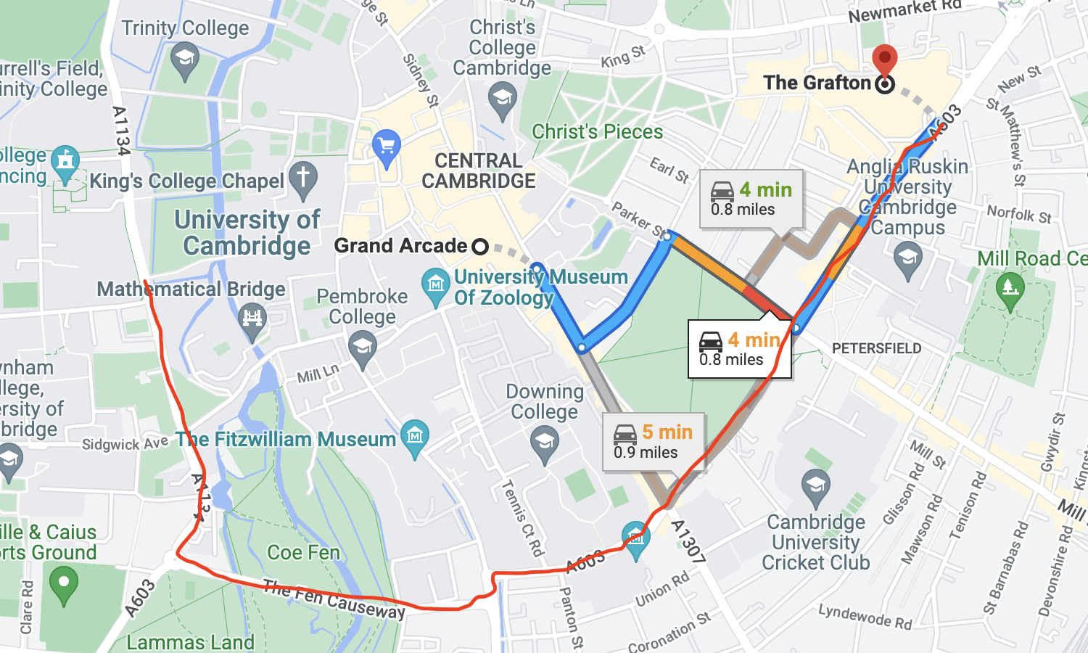

**02:45** Route find between two gibberish locations is initiated

Expected outcome: An error is displayed in the “find route” dialog.

Remarks: This outcome is successfully achieved.

**02:55** Route find between "Histon" and "Hills road sixth form college"

**03:30** Route is displayed

Expected outcome: Route is successfully displayed.

Remarks: This outcome is successfully achieved, with the project displaying a useful and efficient route, due to the nearby main roads for both points. A comparison with Google Maps is again included below:

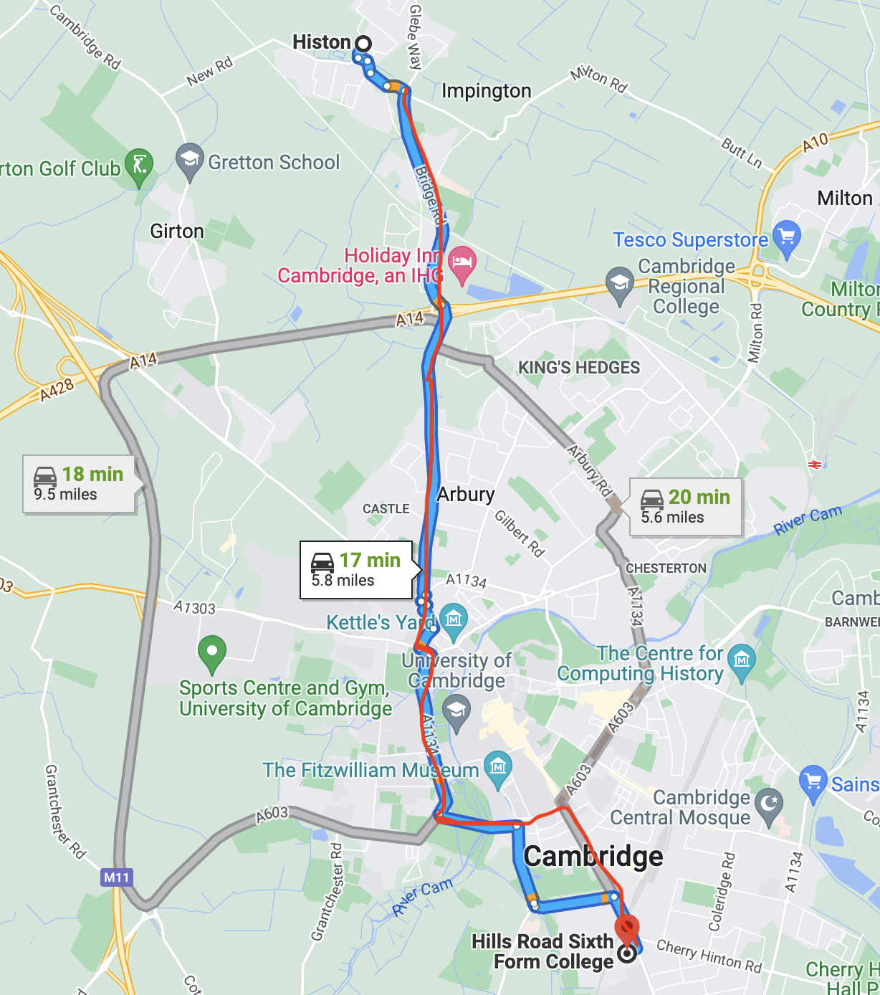

**03:35** Search request for gibberish is initiated

Expected outcome: Error is displayed in search dialog.

Remarks: This outcome is successfully achieved.

## Objective 1 (“Web client is able to send requests and receive appropriate data back to/from backend”)

### Server successfully starts up

Action: Start server with command “node --max-old-space-size=16384 index.js” within src directory.

Expected output: The server outputs “Server has started at http://localhost:80” after loading database into memory and conducting indexing.

Actual output:

[Mapping project, 1646226818950] Logger has started.

[Mapping project, 1646226818953] Server is starting...

[Mapping project, 1646226818954] Loading db.

[Mapping project, 1646226860547] Logger has started.

[Mapping project, 1646226866401] Loaded db.

[Mapping project, 1646226866420] Server has started at http://localhost:80

### Web application successfully loads

Action: Load http://localhost in browser.

Expected output: Web application successfully loads a view of the map, and requests are logged in the server log.

Actual output:

Successfully loads, with no errors shown in developer console.

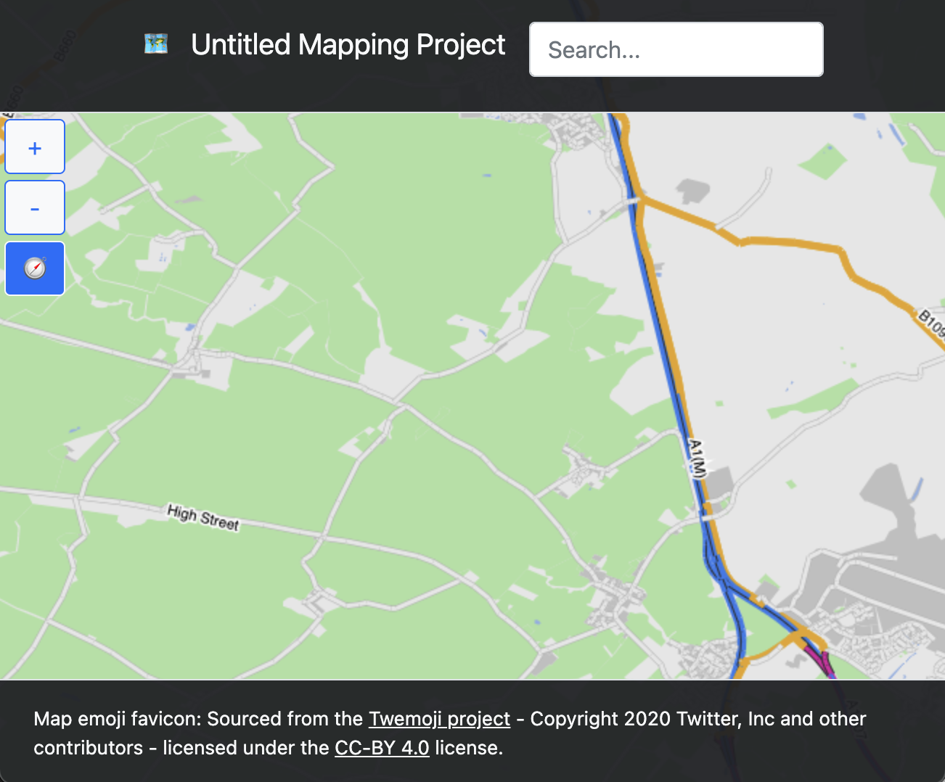

[Mapping project, 1646227062188] / was requested.

[Mapping project, 1646227062376] /index.css was requested.

[Mapping project, 1646227062399] /sharedStructures.js was requested.

[Mapping project, 1646227062401] /index.js was requested.

[Mapping project, 1646227062419] /spinner.gif was requested.

[Mapping project, 1646227062642] /GetDBfromQuery?pathTypes=[%22motorway%22,%22primary%22,%22trunk%22,%22primary_link%22,%22trunk_link%22,%22river%22,%22returned_route%22,%22secondary%22,%22secondary_link%22,%22tertiary%22,%22tertiary_link%22,%22unclassified%22,%22residential%22]&area={%22x%22:-2792.886051499995,%22y%22:6849.380475070653,%22height%22:2103.9999999999995,%22width%22:3859.999999999999,%22pathTypeCount%22:13} was requested.

[Mapping project, 1646227062646] Logger has started.

[Mapping project, 1646227067916] /favicon.ico was requested.

Success.

### Corresponding JSON data is returned for requests to GET /api/GetDBfromQuery

**(Large map view containing all map data for specified highways)**

Action: CURL initiated GET request to /api/GetDBfromQuery?pathTypes=[%22motorway%22,%22primary%22,%22trunk%22,%22primary_link%22,%22trunk_link%22,%22river%22]&&noMapAreaFilter=true

Expected output: Corresponding JSON map data in custom database format is returned to the client.

Actual output:

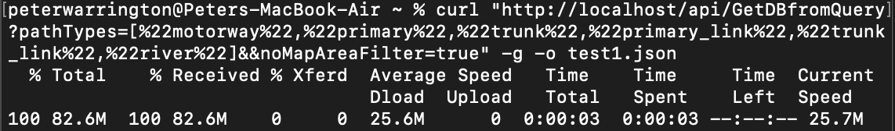

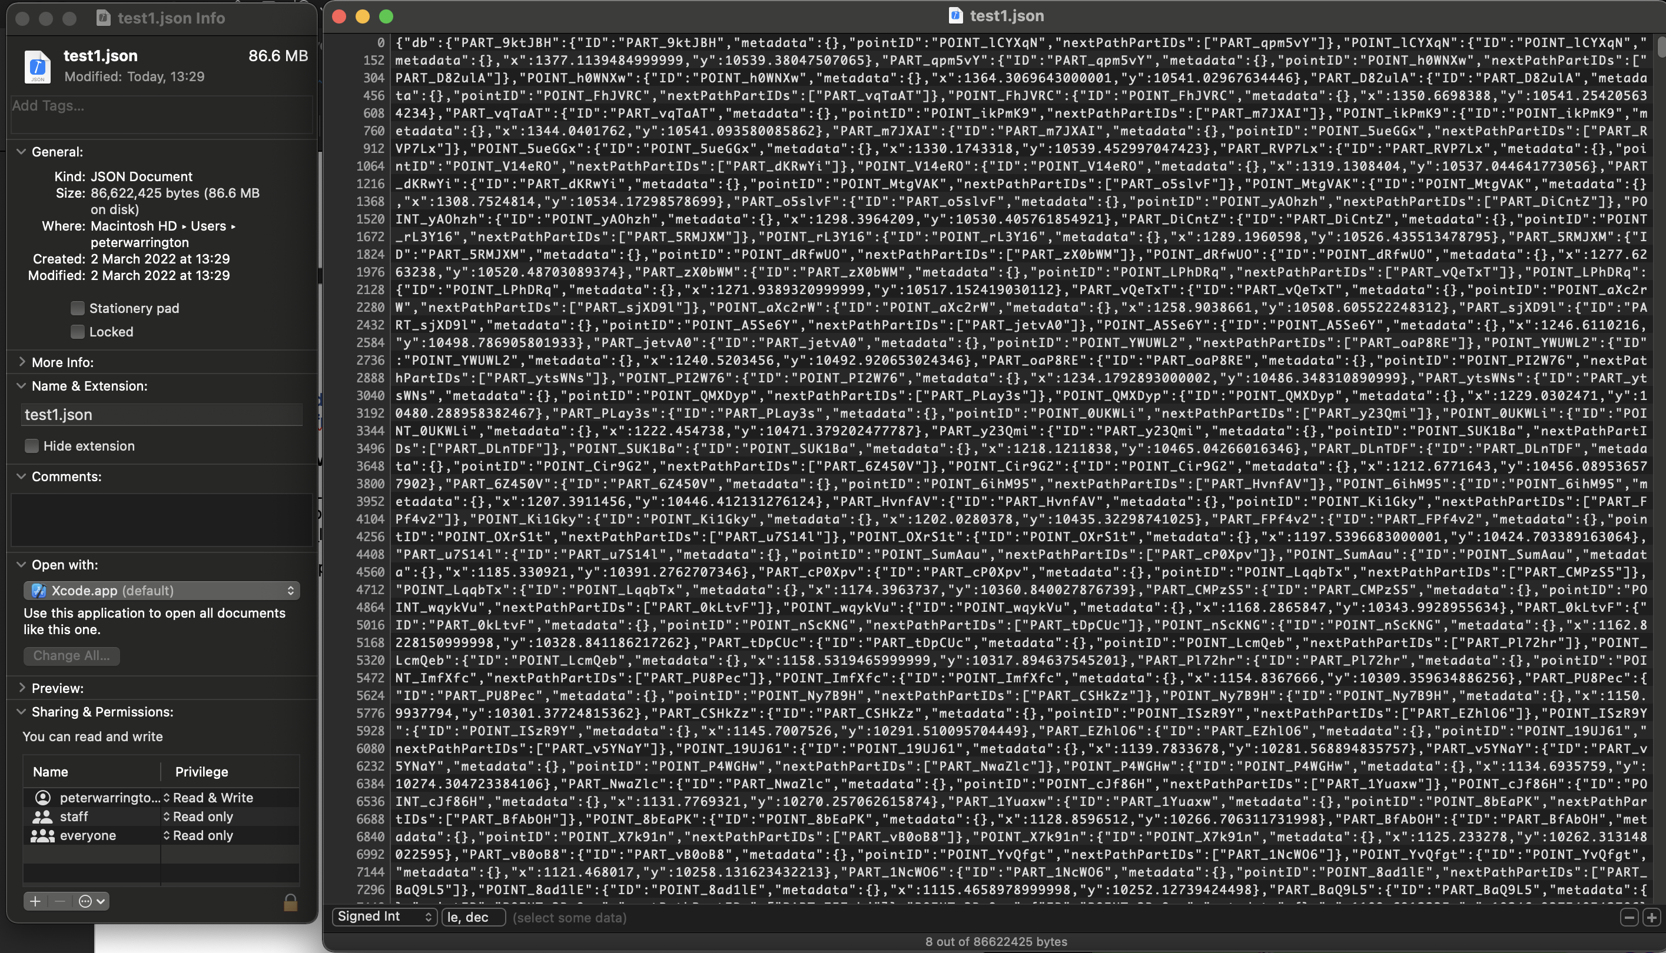

Success.

Action: Force the client to download from this URL by hardcoding it to request it.

Expected output: All map data is loaded and displayed on the client

Actual output:

(After zoomed out)

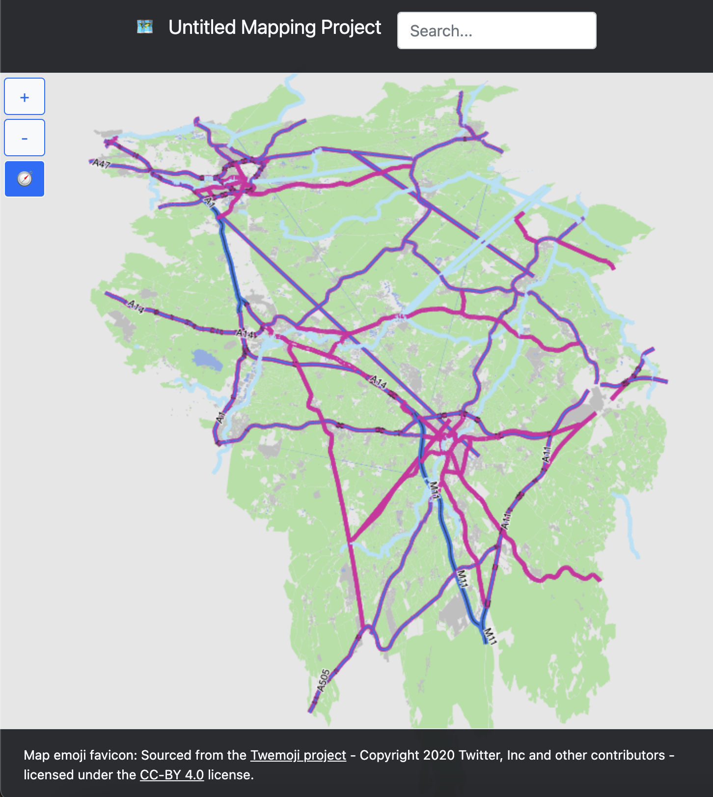

Success.

**(Small map view containing map data specified by bounds)**

Action: CURL initiated GET request to /api/GetDBfromQuery?pathTypes=[%22motorway%22,%22primary%22,%22trunk%22,%22primary_link%22,%22trunk_link%22,%22river%22,%22returned_route%22,%22secondary%22,%22secondary_link%22,%22tertiary%22,%22tertiary_link%22,%22unclassified%22,%22residential%22]&area={%22x%22:-2792.886051499995,%22y%22:6849.380475070653,%22height%22:2135.9999999999995,%22width%22:1961.9999999999998,%22pathTypeCount%22:13}

Expected output: Corresponding JSON data.

Actual output:

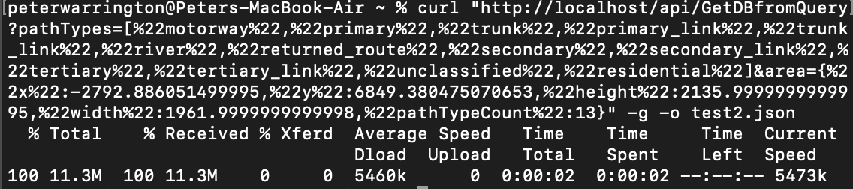

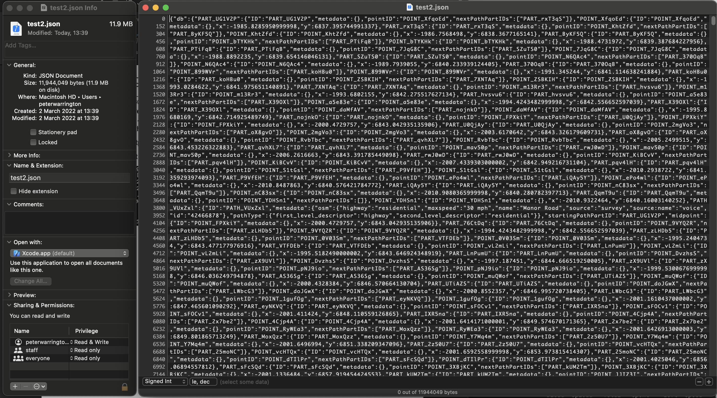

Success.

Action: Map initiated GET request to same URL.

Expected output: Map data displayed on map.

Actual output:

Same screenshot as in first test – Success.

## Objective 2 (“The backend is able to read from OpenStreetMap data and return this to clients via this API”)

### convertFromOSM.js on OSM data for Cambridgeshire

Action: Initiate convertFromOSM.js from command line using “node --max-old-space-size=16384 convertFromOSM.js”, and with data contained in docs/cambridgeshire-latest.osm (the path to this file is hardcoded into convertFromOSM.js).

Cambridgeshire OSM data is sourced from <https://download.geofabrik.de/europe/great-britain/england/cambridgeshire.html#:~:text=cambridgeshire%2Dlatest.osm.bz2%2C%20yields%20OSM%20XML%20when%20decompressed>

Expected output: The process outputs a success message, producing a JSON database file that can then be read by the server.

Actual output:

Beginning conversion from OSM to OSM-JS - This might take a while...

OSM to OSM-JS conversion complete.

Unable to cache OS-JS data. RangeError: Invalid string length. Continuing anyway...

Extracting ways, nodes and relations...

Way, node and relation extraction complete.

Extracting ways...

Way extraction complete.

Generating DB...

100% (444278/444278) of ways added to db.b.

Processing complex areas...

100% (653/653) of complex areas processed.d.

Complex areas processed.

Adding all nodes to db...

100% (2516313/2516313) of nodes added to db.b.

Added all nodes to db...

Database generated. Writing to file...

100% (4911617/4911617) database items written to file.e.

Map database has been saved to db-1646255299286.json!

Background process: Nodes have been cached

Background process: Ways have been cached

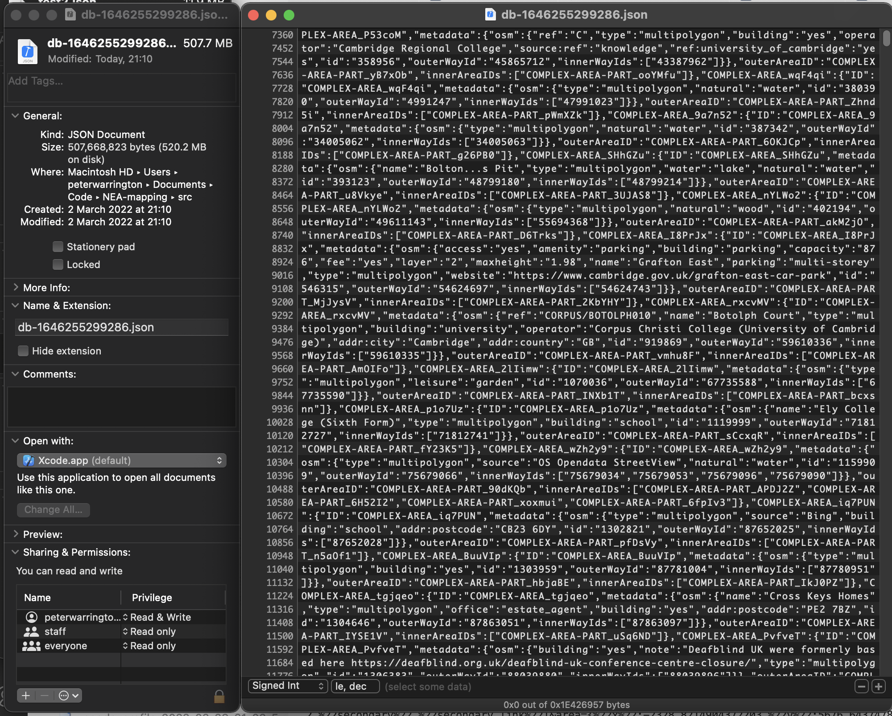

The resultant map database was loaded in for use in the other tests, as shown in their respective screenshots.

The “unable to cache OSM.js data” error means that the generated JS object representation of the raw XML data was too large to be cached to file, something that is not crucial to the script, but can make run time faster when re-processing map data, for example when adding features during development. My objectives are therefore met.

Success

## Objective 3 (“The web client is then able to display and represent data returned from the server on a map that can be panned and zoomed”)

### Pan without zoom to map extreme

Action: Pan map from top left initial position to bottom right without zooming, using Cambridgeshire map data.

Expected output: Map is successfully panned, progressively loading map data which is displayed on screen.

Actual output:

Initial position

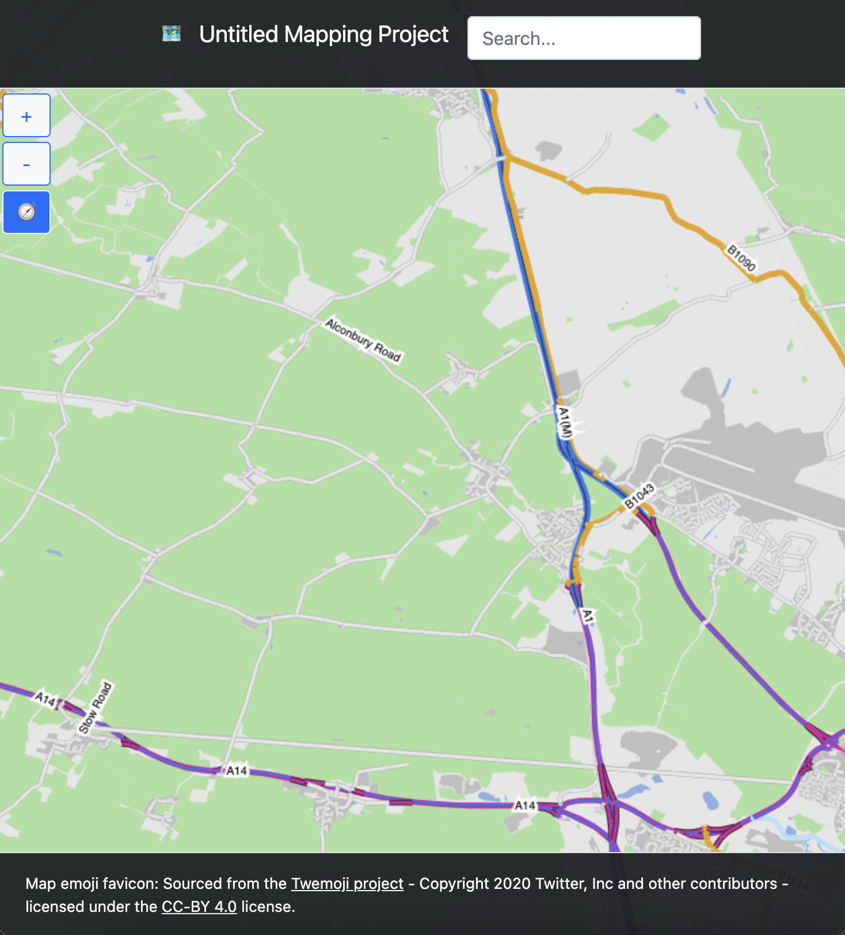

Mid-position

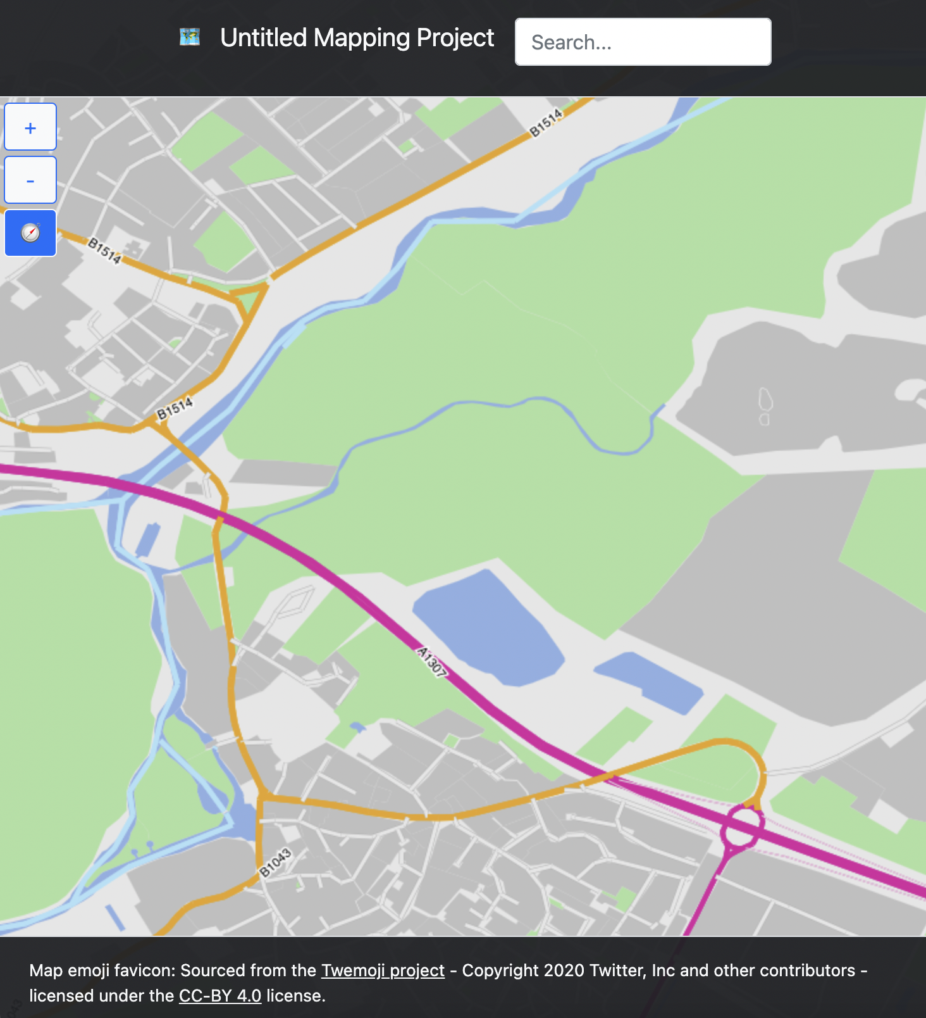

Final position

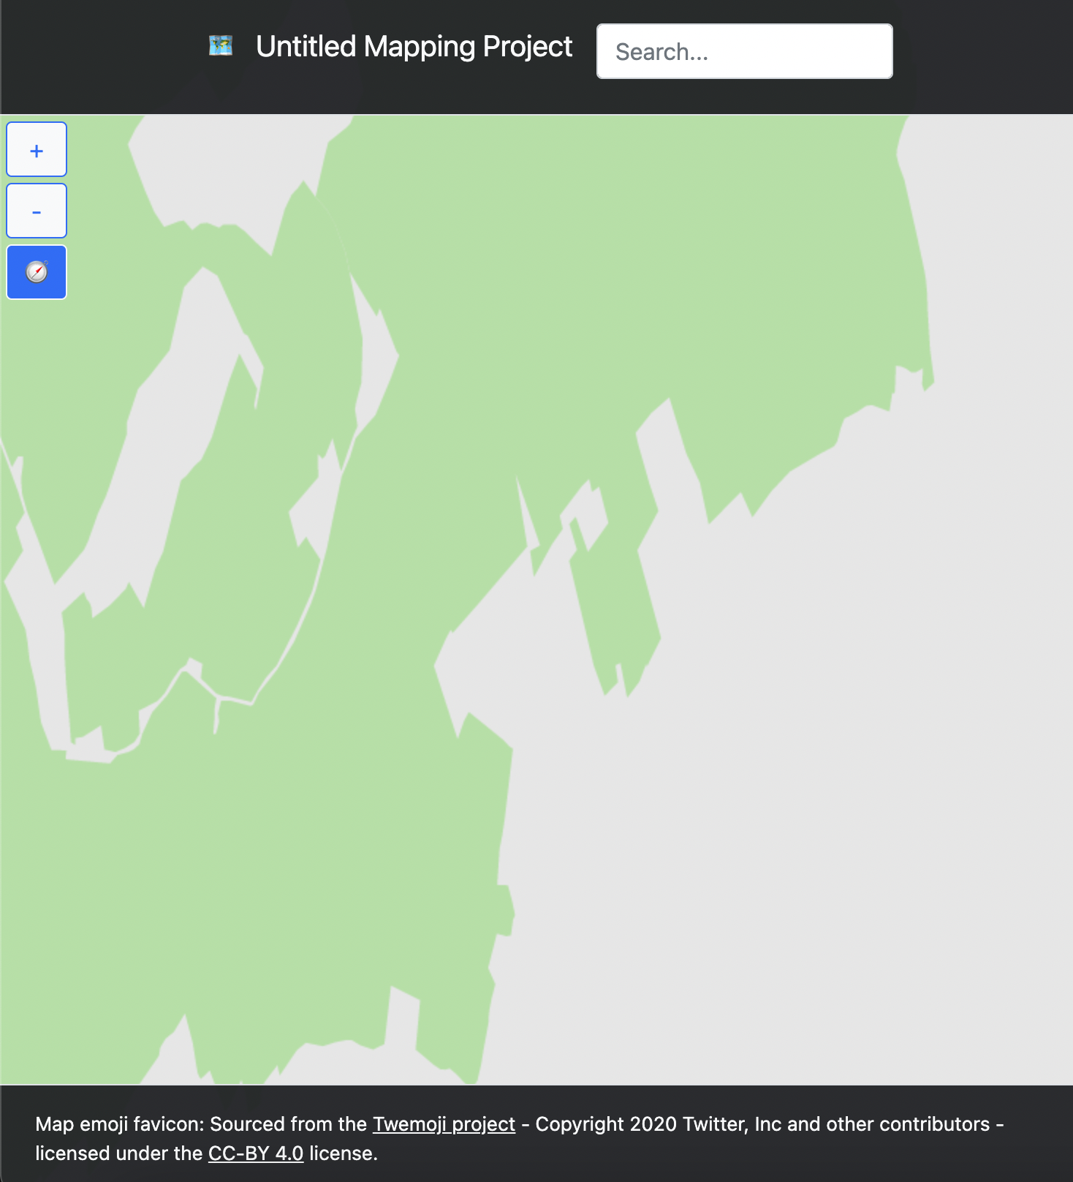

Success.

### Zoom out to show whole of map

Action: From initial position, zoom out so that the entire map is displayed in the view.

Expected output: Map is successfully displayed, with only the most major of highways displayed.

Actual output:

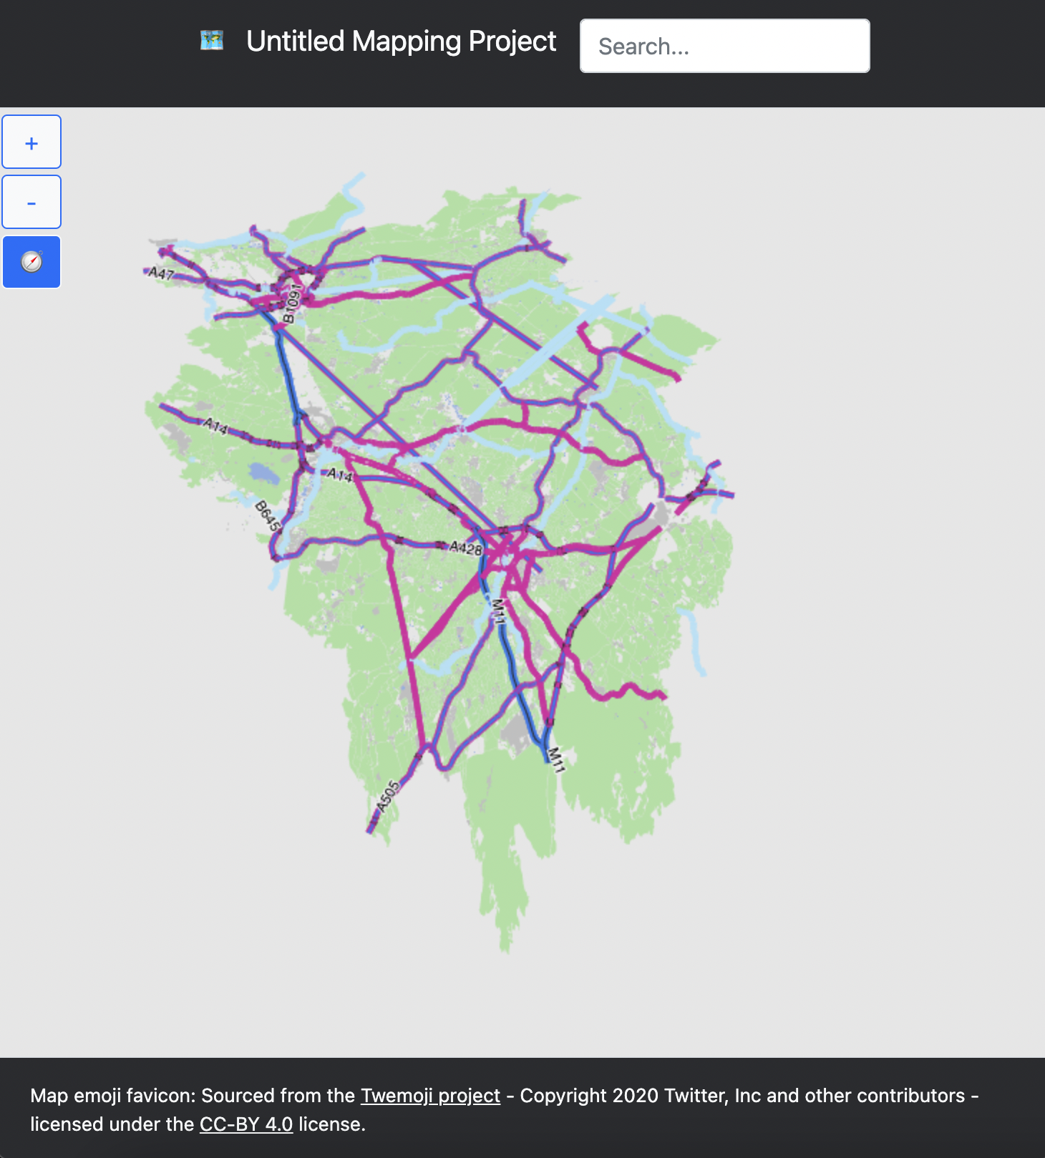

Success

### Zoom in from initial position

Action: From initial position, zoom in until no discernible map features can be found. Then zoom out back to initial zoom level.

Expected output: Map successfully displays, though only the background of the map area zoomed into.

Actual output:

Initial

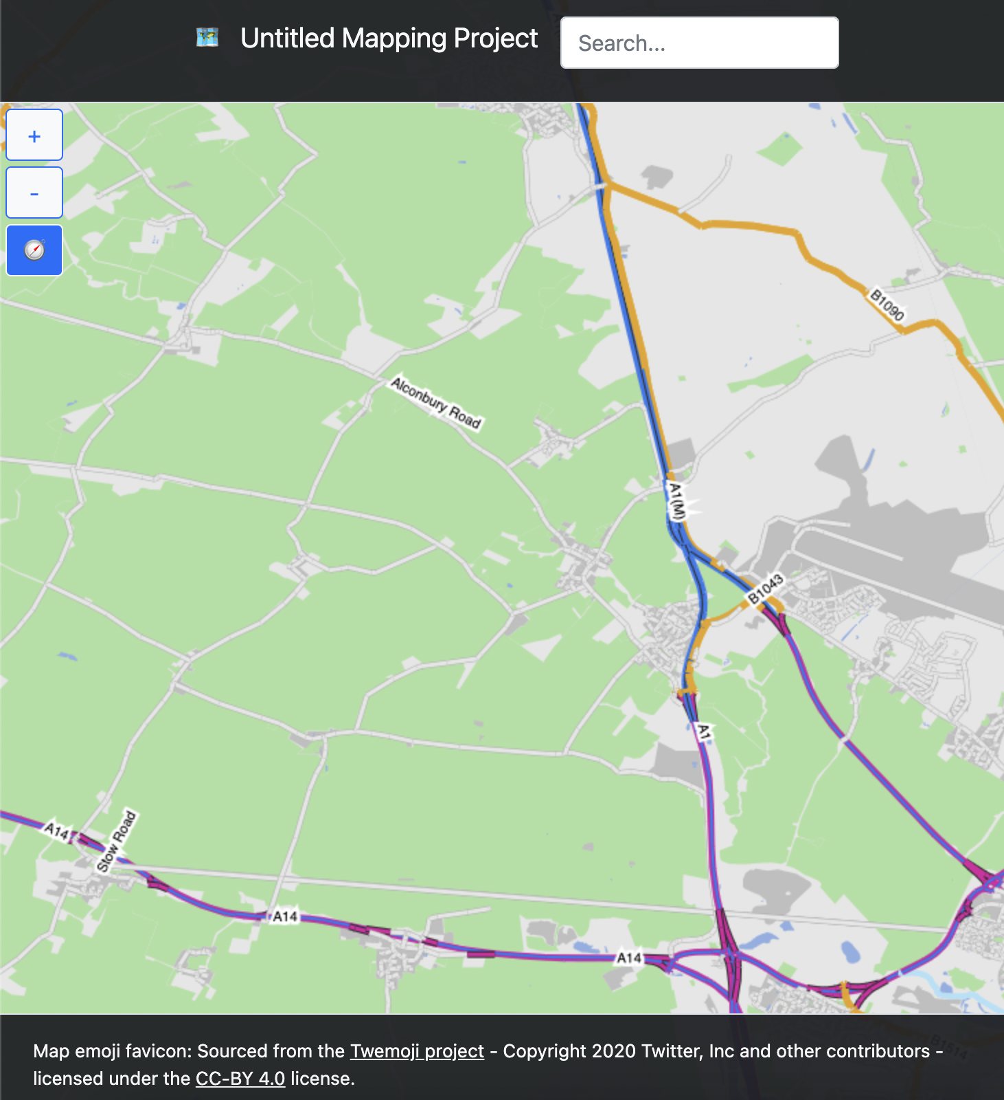

Partial zoom in

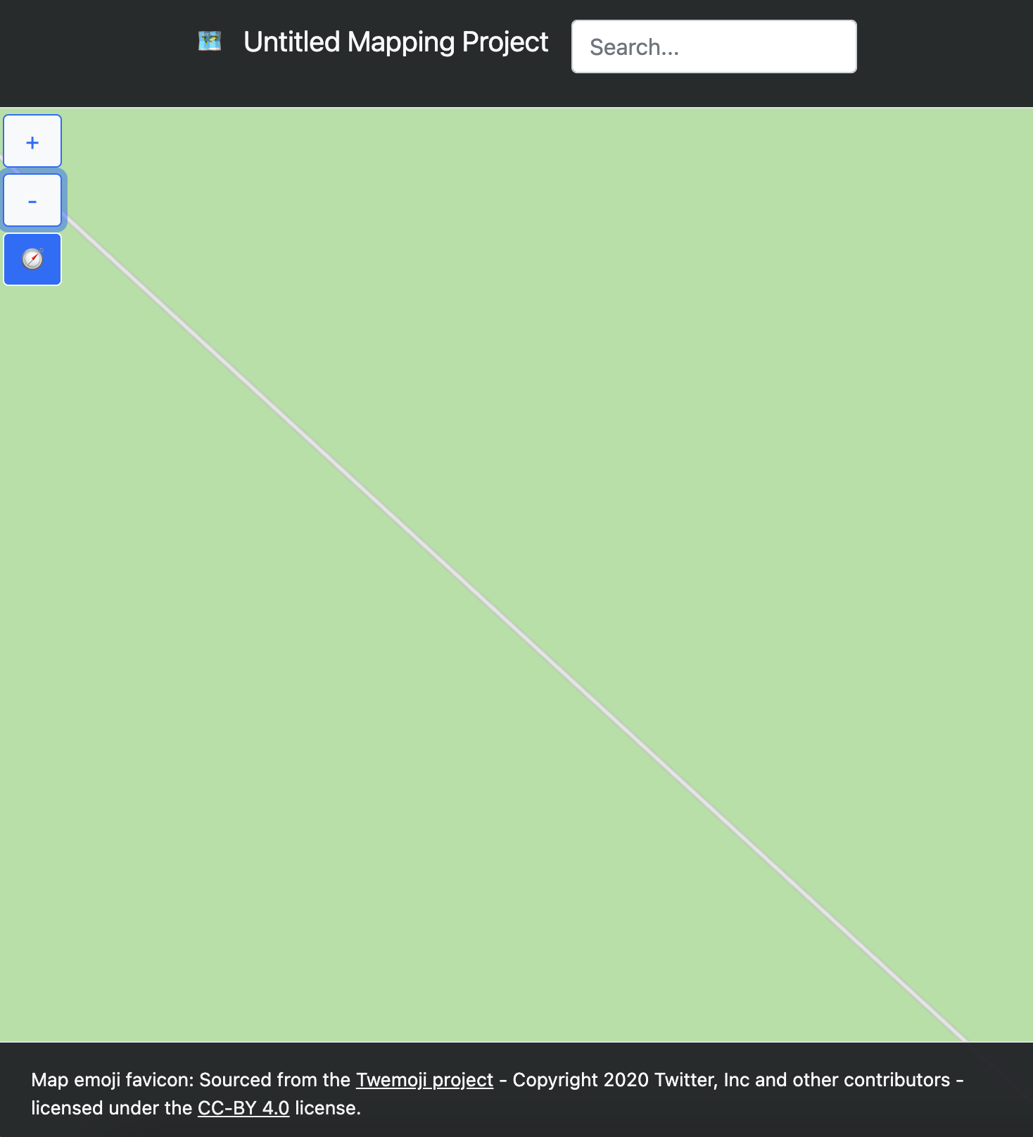

Zoom in until no map features

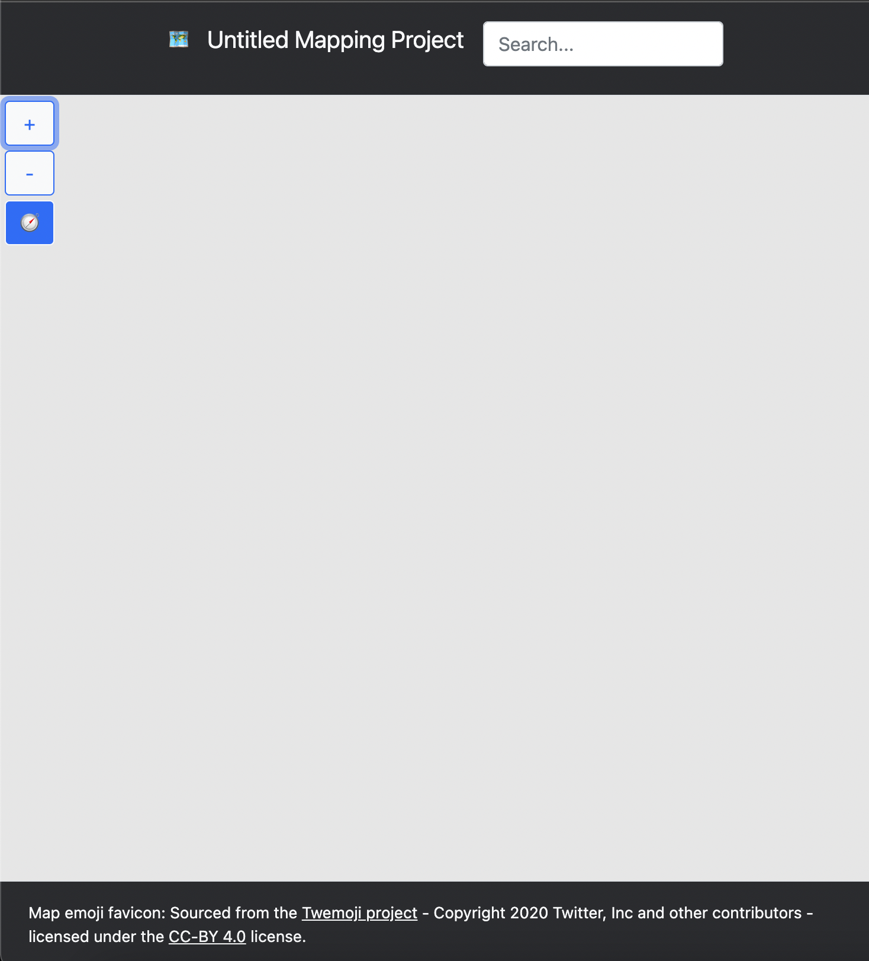

Map area colour is lost, but this is only a minor error.

Zoom back out to initial zoom level

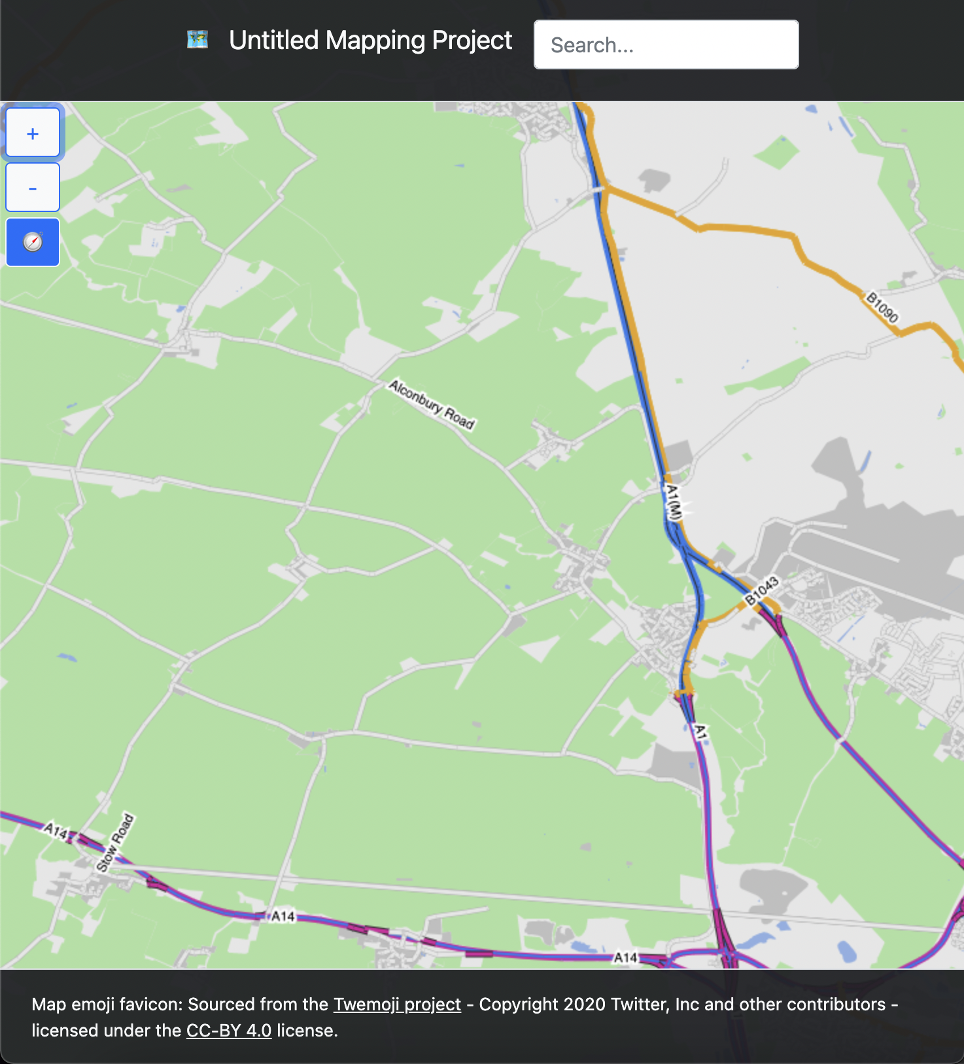

Partial success.

### Zoom in, pan, zoom out

Action: Zoom in so that map features are still displayed, pan into Cambridge, then zoom out to show the entire city.

Expected output: Map is successfully displayed at all points

Actual output:

Initial

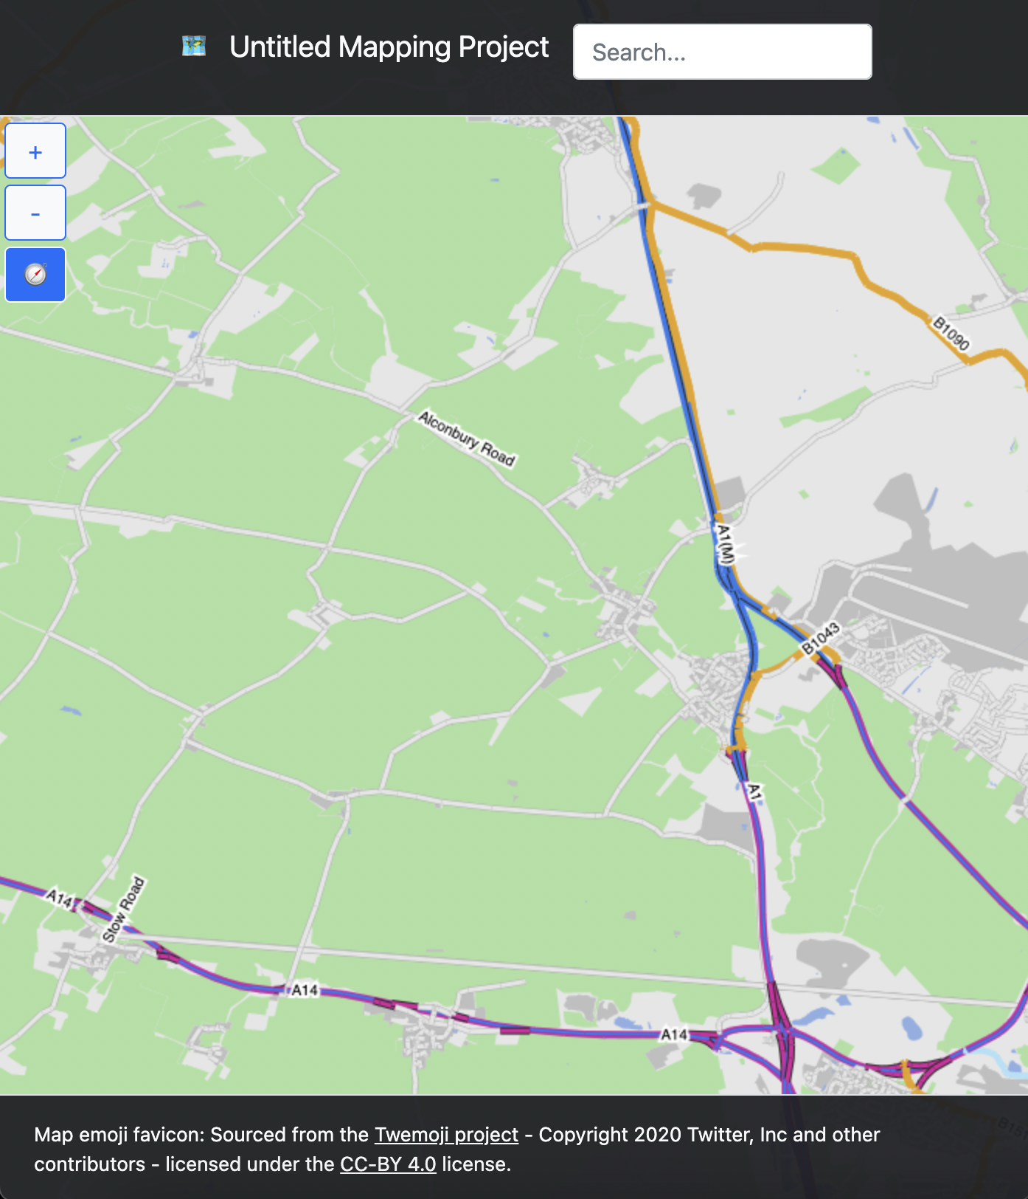

Initial with zoom

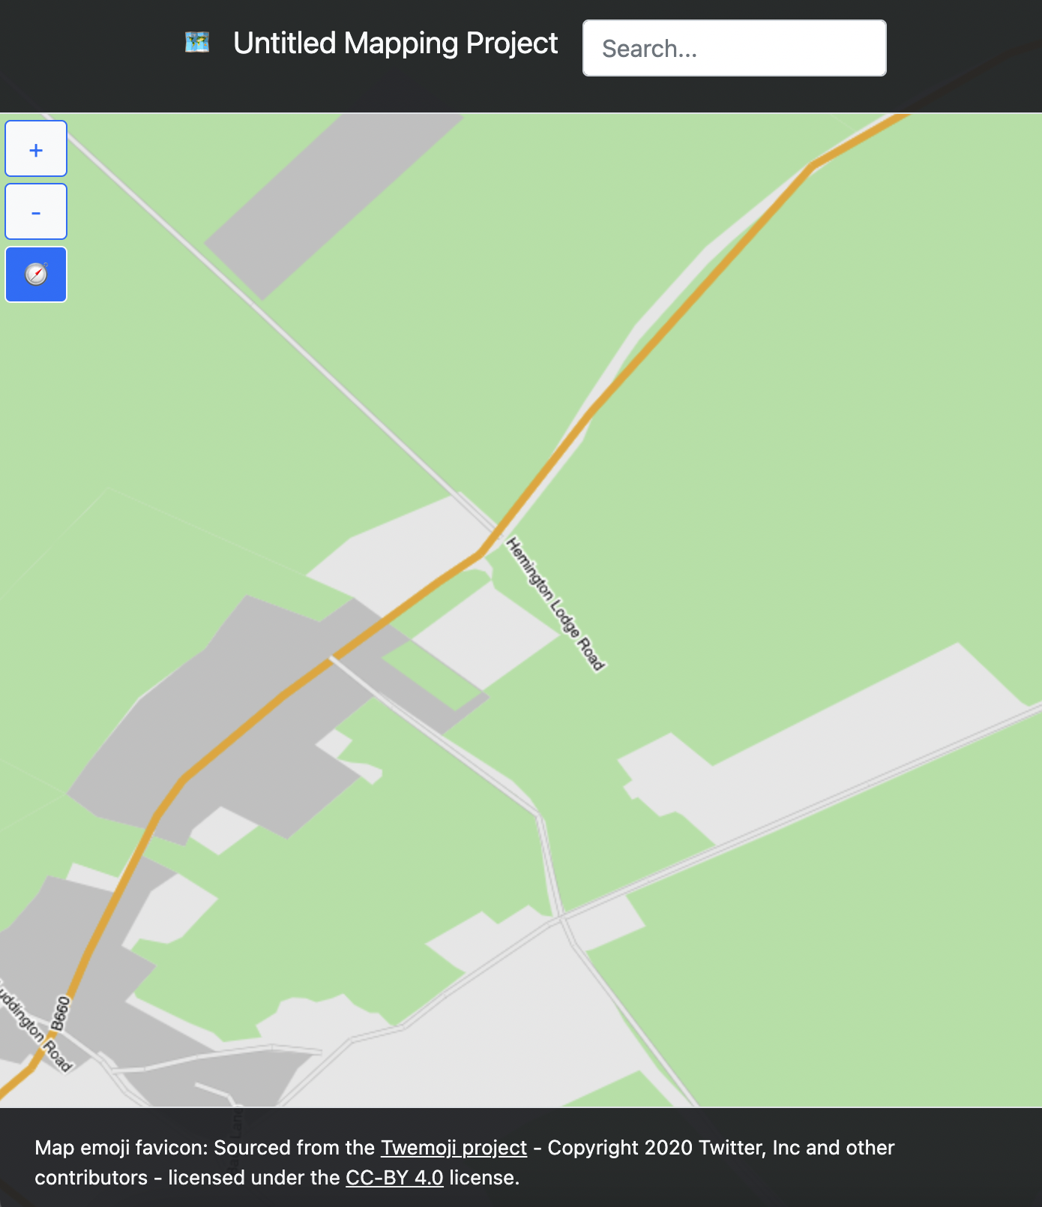

Panned from same zoom level into Central Cambridge

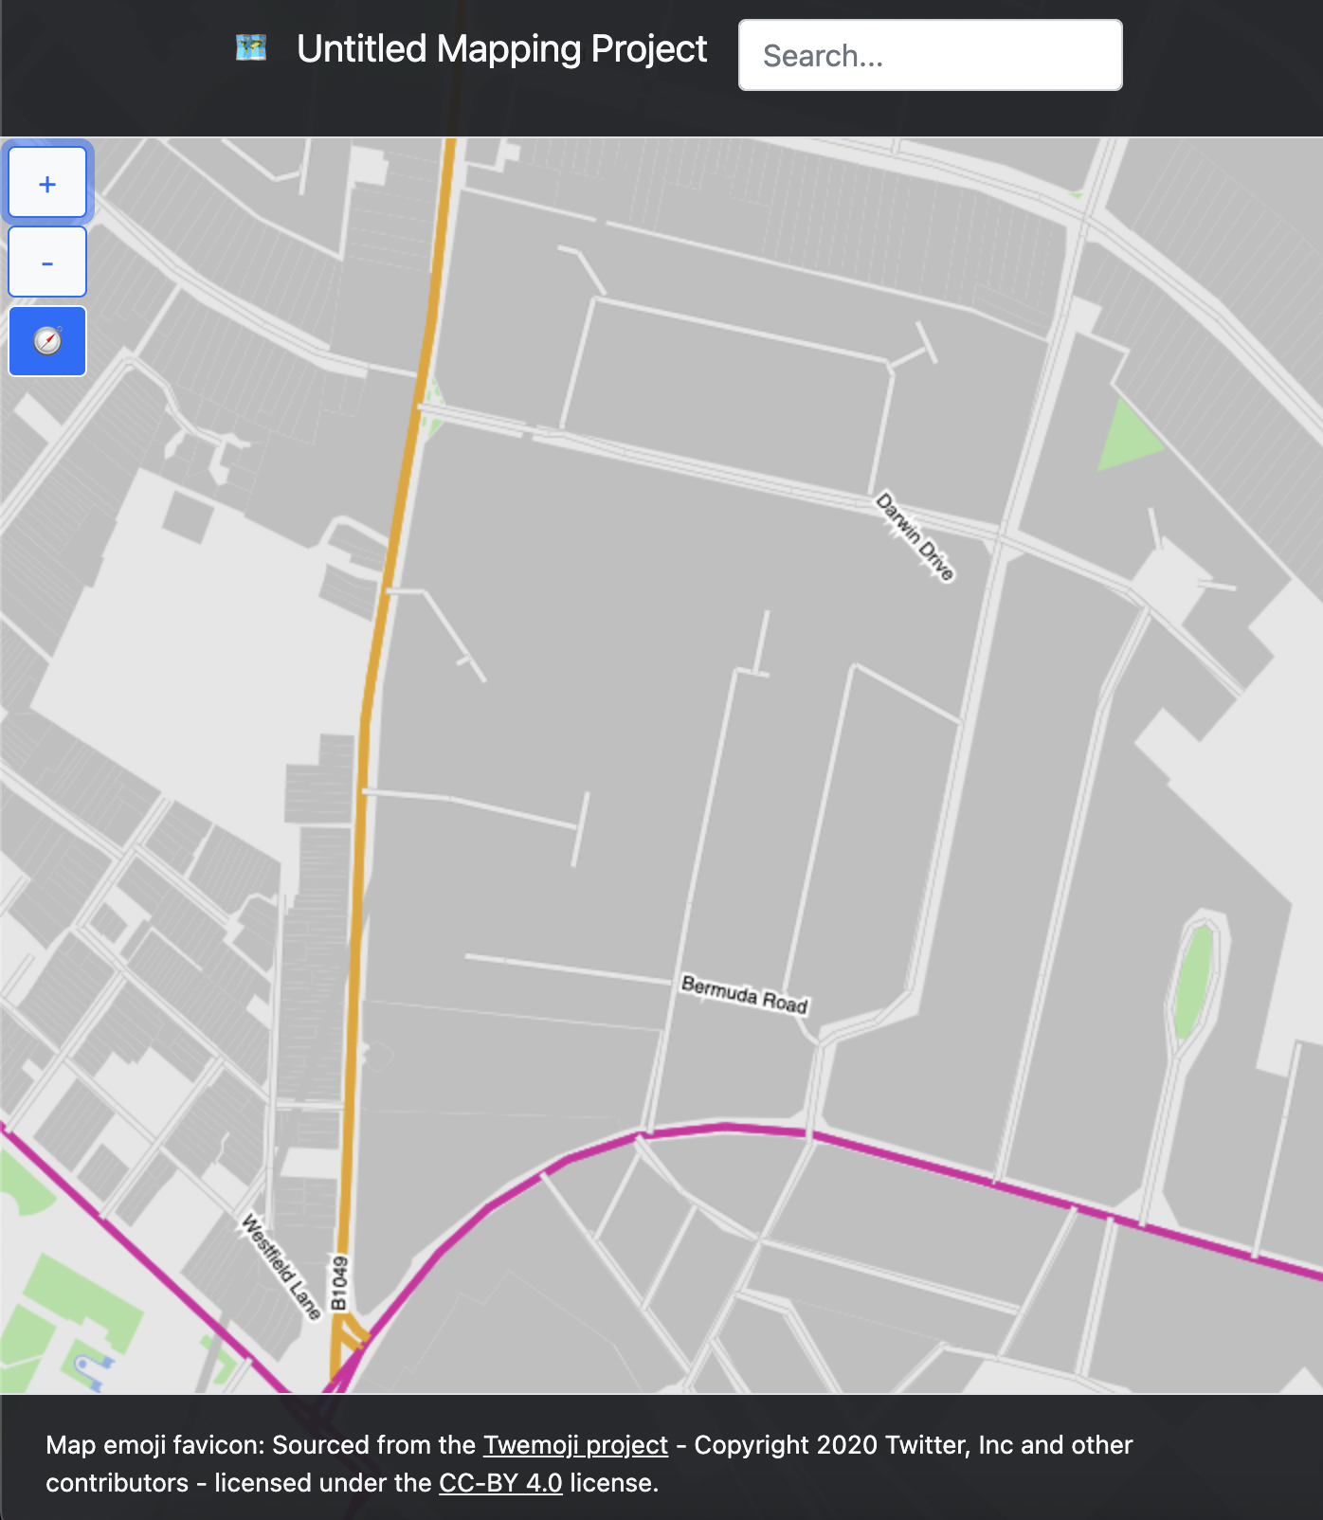

Zoomed out from central Cambridge

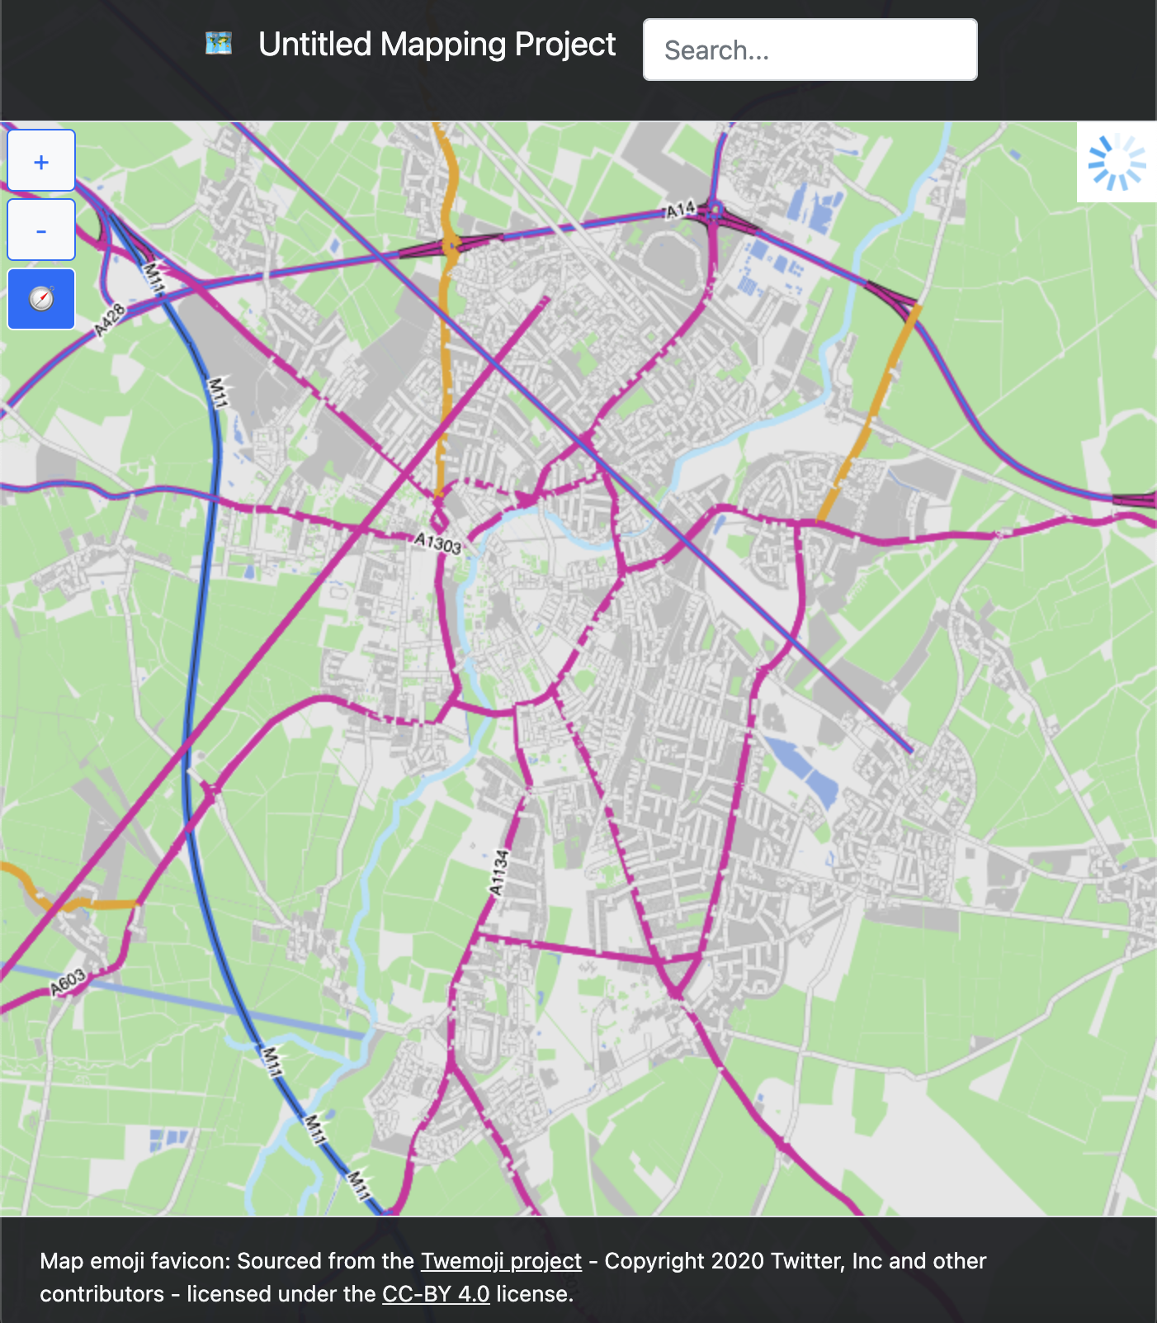

Success.

### Zoom out, pan, zoom in

Action: Zoom out so that whole of Cambridge is displayed, pan to Cambridge, zoom in

Expected output: Map data is displayed correct

Actual output:

Zoom out

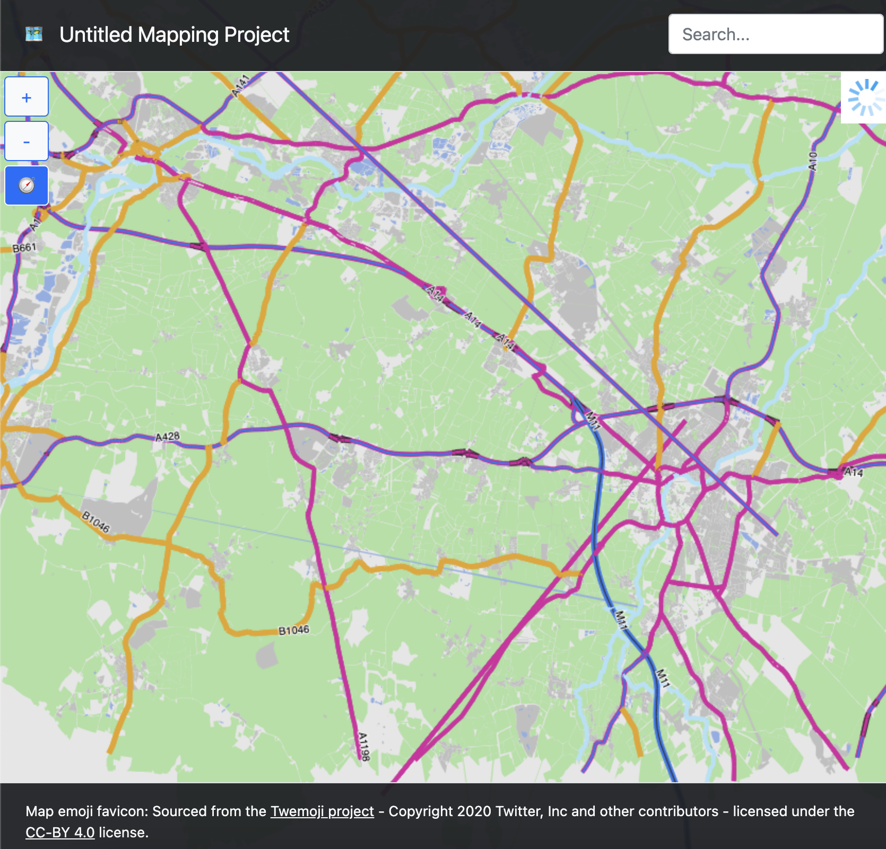

Pan

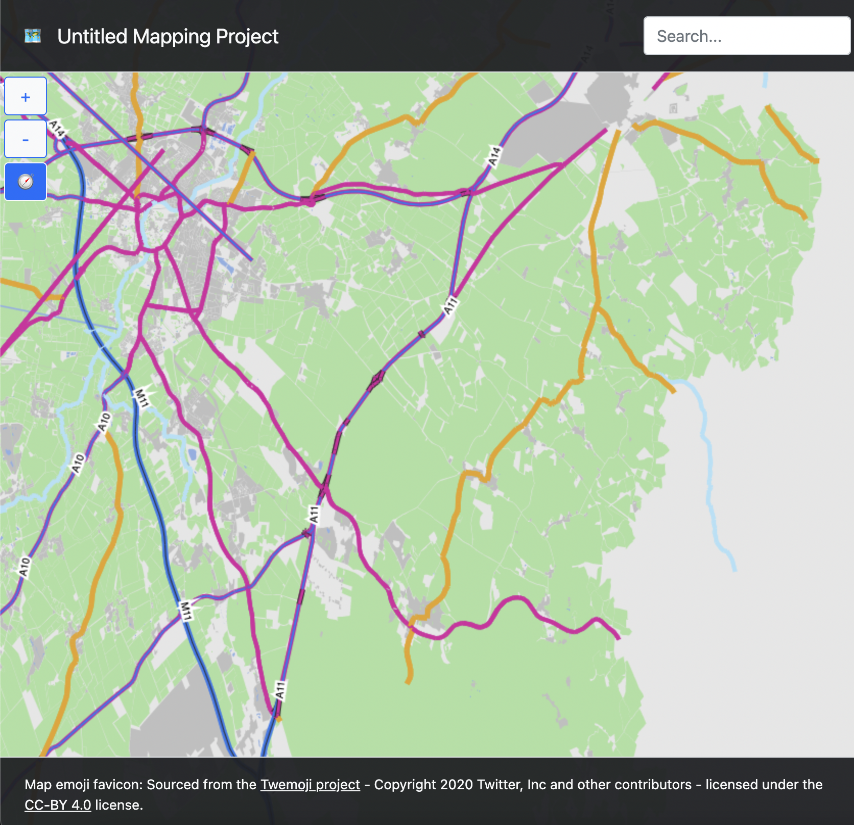

Zoom in

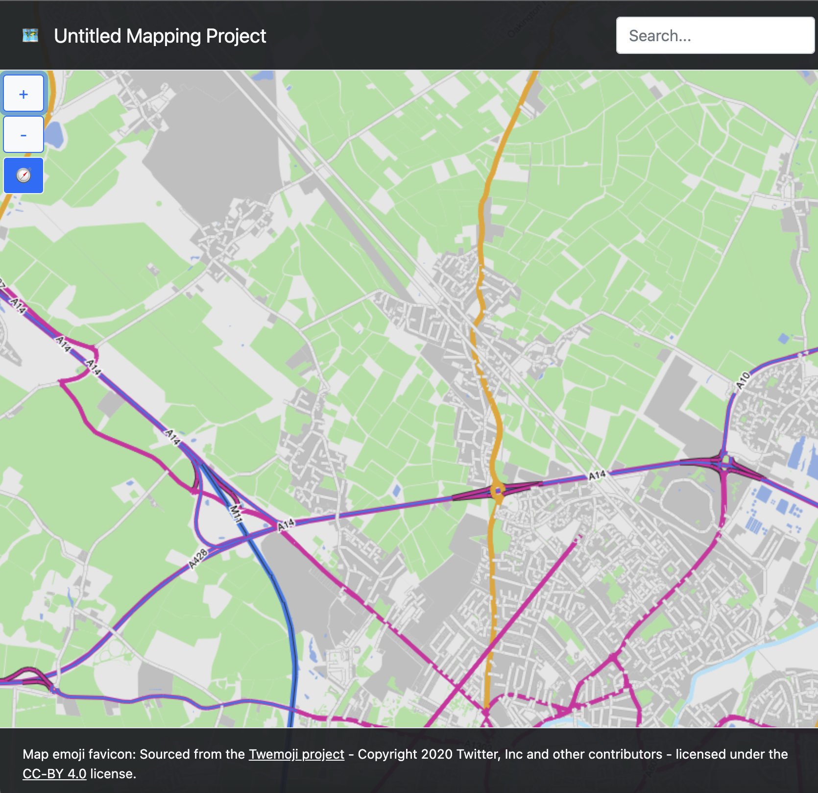

Success

## Objective 4 (“A search function is available on this web client to be able to find locations using the API”)

### API request to /api//PointSearch, searching for “museum”

Action: CURL initiated GET request to /api/PointSearch?searchTerm=%22museum%22

Expected output: An array of up to 20 corresponding points and their associated search confidences.

Actual output:

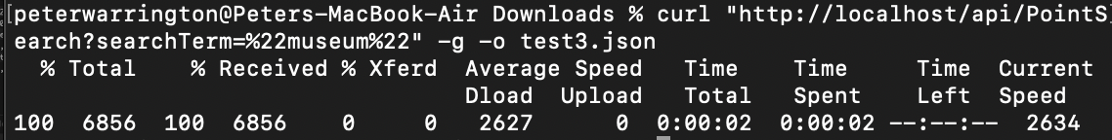

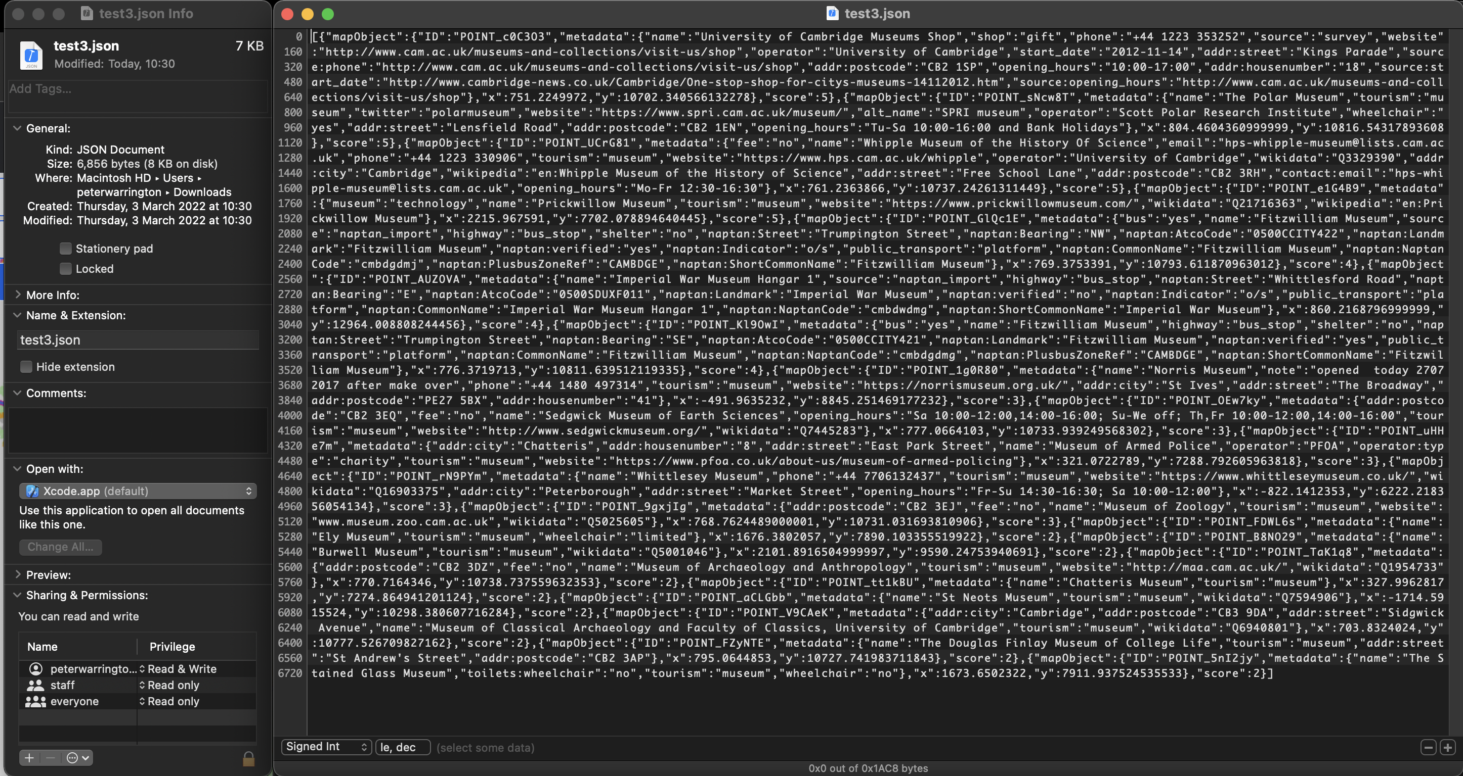

Success

### API request to /api/PointSearch for a specific point ID

Action: CURL initiated GET request to “/api/PointSearch?searchTerm=%22POINT_CRBL9o%22”

Expected output: An array containing one map object and its associated search confidence will be returned. The map object should be the point with ID “POINT_CRBL9o” (Hills Road Sixth Form College).

Actual output:

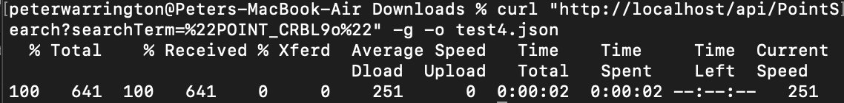

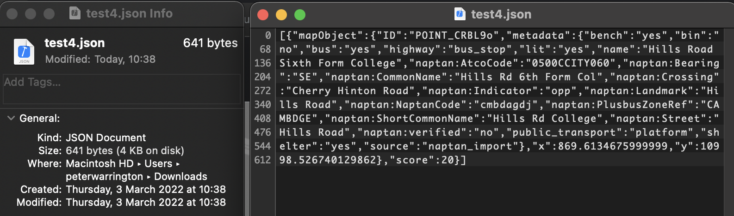

Success.

### Searching for “museum” via web app

Action: Search for “museum” using web app search function.

Expected output: The map translates and zooms to show a view showing all points, with a displayed list of results and associated metadata.

Actual output:

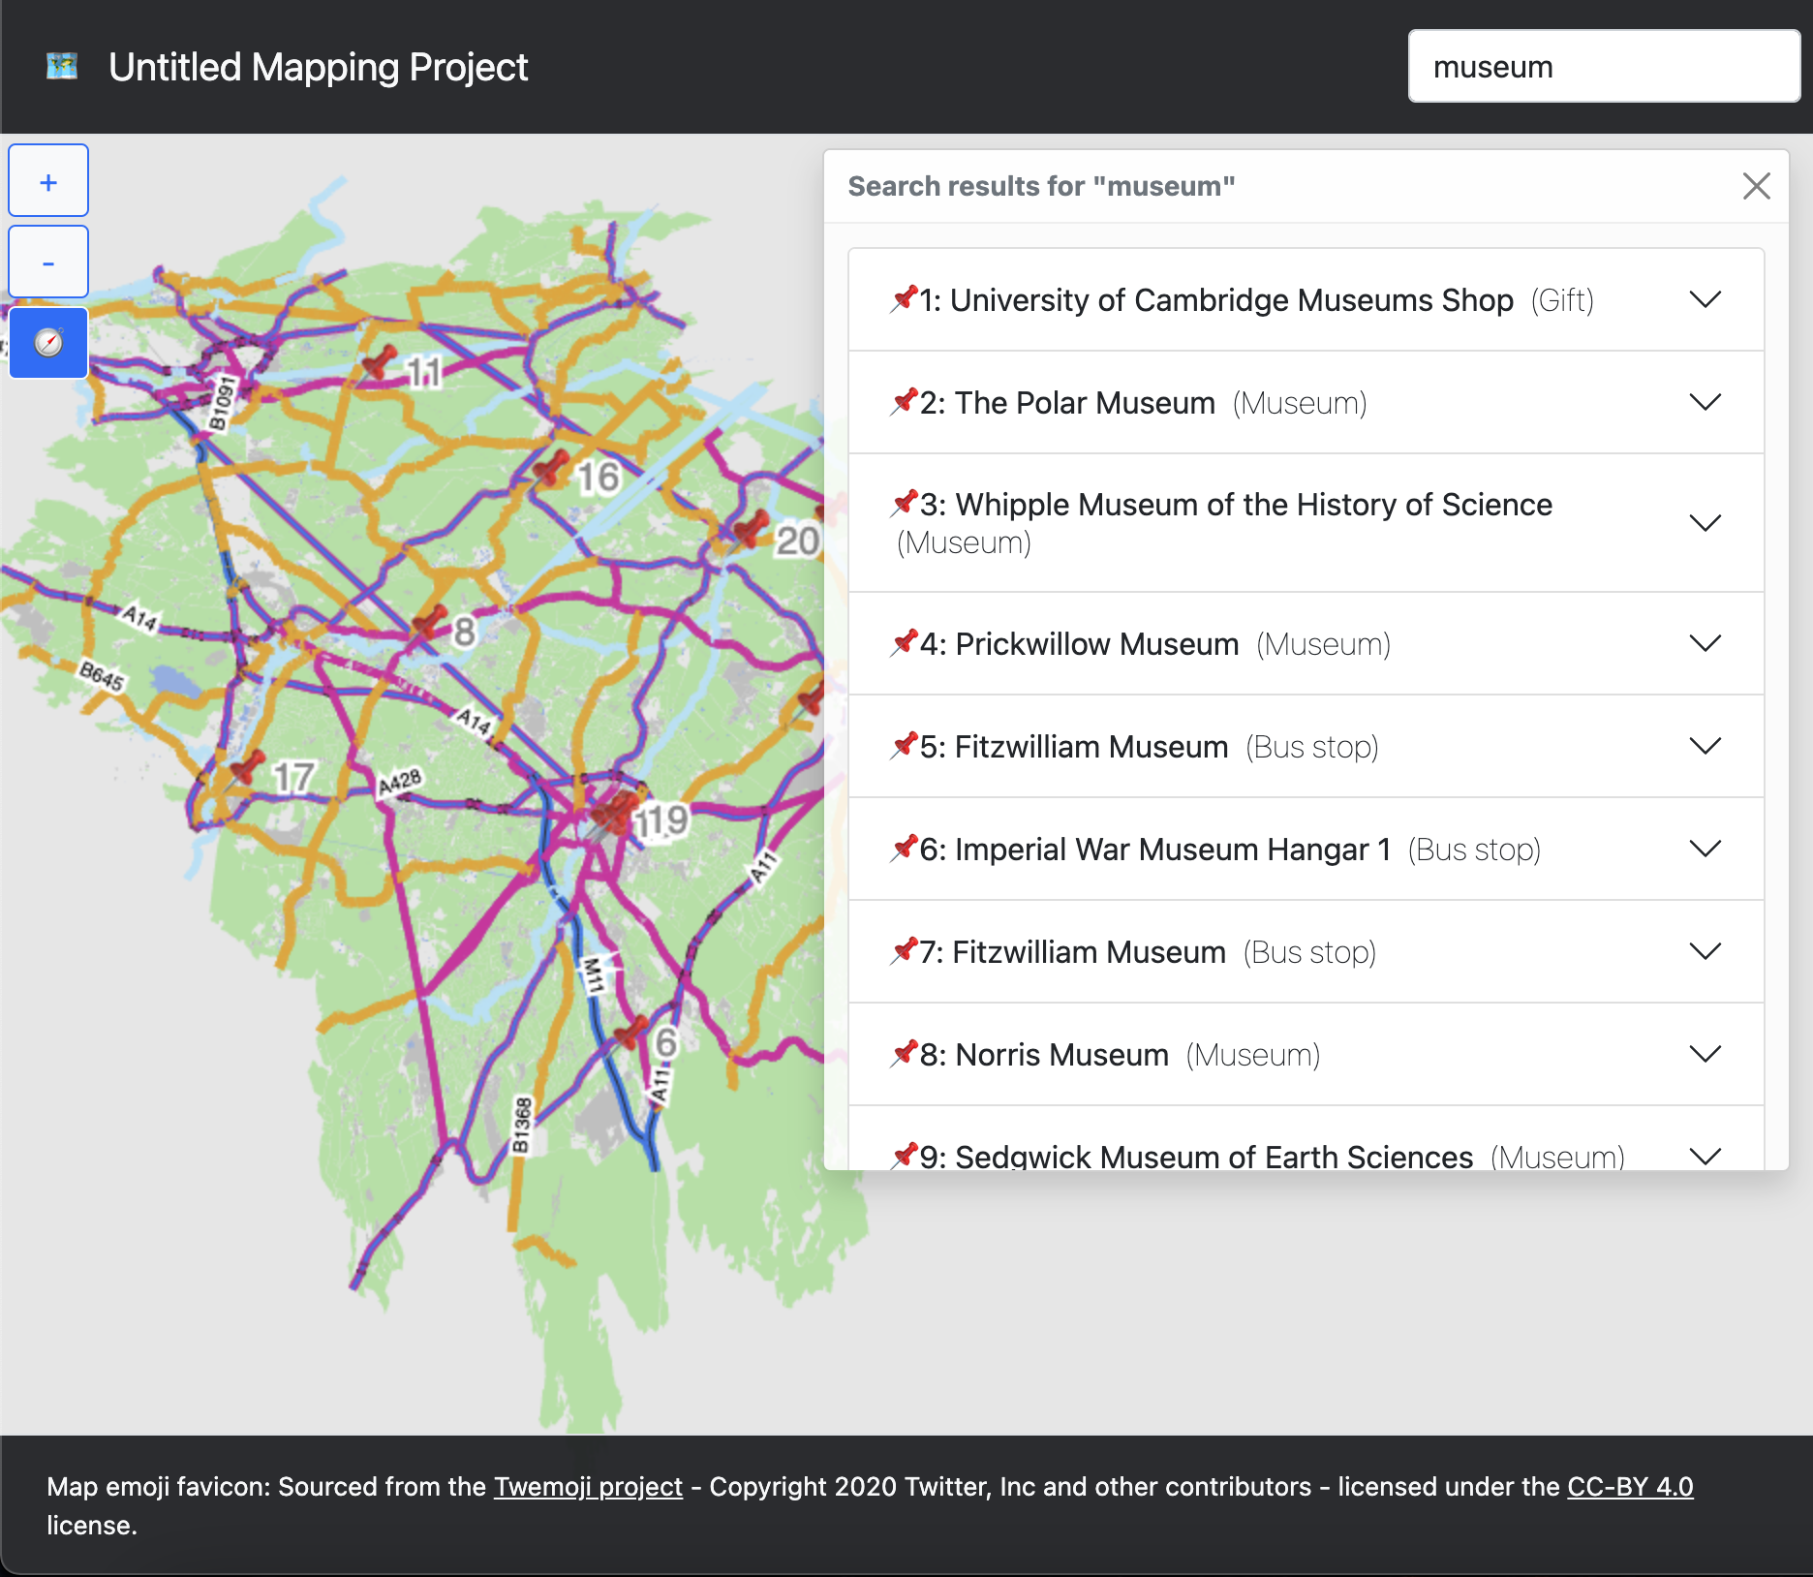



Success.

### Search for specific point via web app

Action: Search for “POINT_CRBL9o” using web app search function

Expected output: Single point displayed and zoomed onto on map, with single result detail displayed.

Actual output:

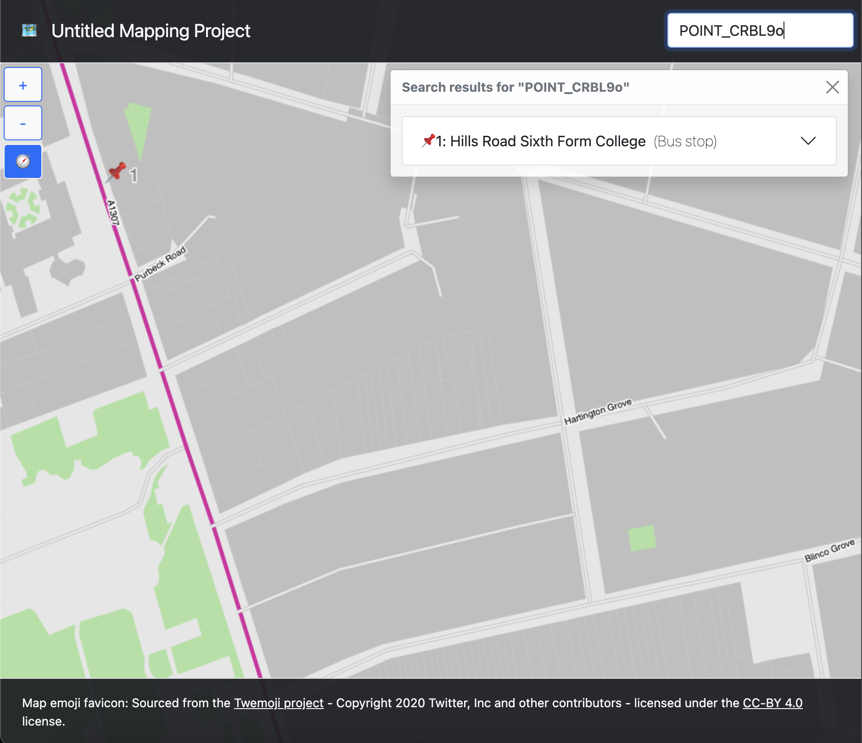

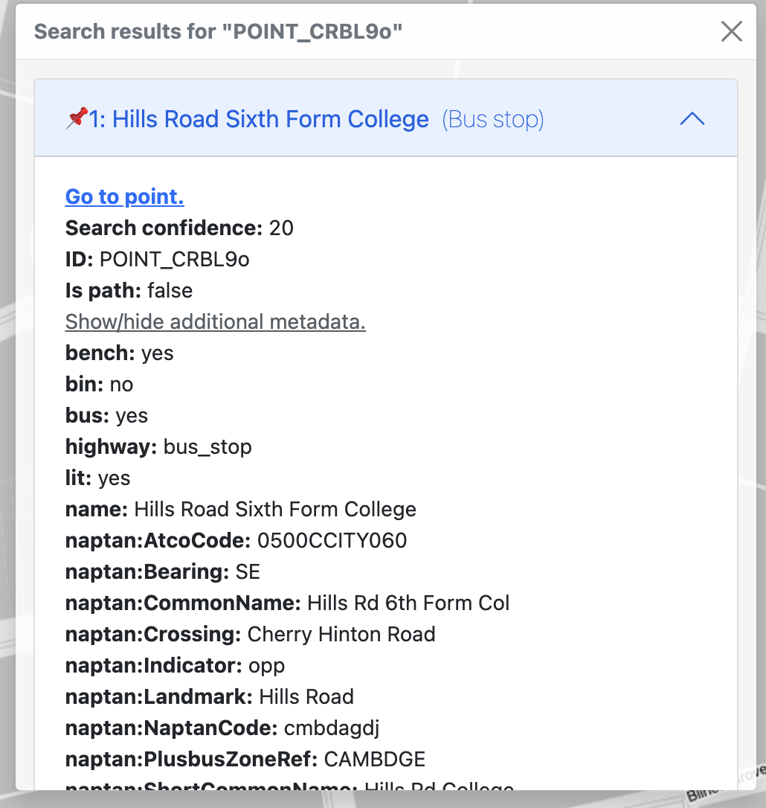

Success.

## Objective 5 (“A function will be available to find an efficient route from one location on the map to another using path theory. This will take into account distance and this route must be traversable in the real world.”)

### API request to /api/FindRoute searching between “Cambridge station” and “Cambridge north”

Action: CURL initiated get request to /api/FindRoute?startingPointTerm=%22Cambridge%20station%22&destinationPointTerm=%22Cambridge%20north%22

Expected output: An array of points that make up the route.

Actual output:

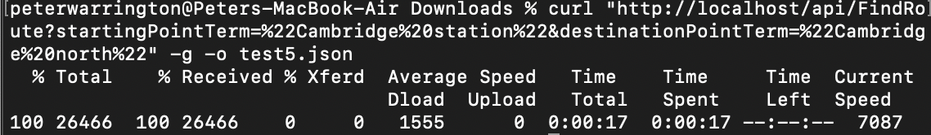

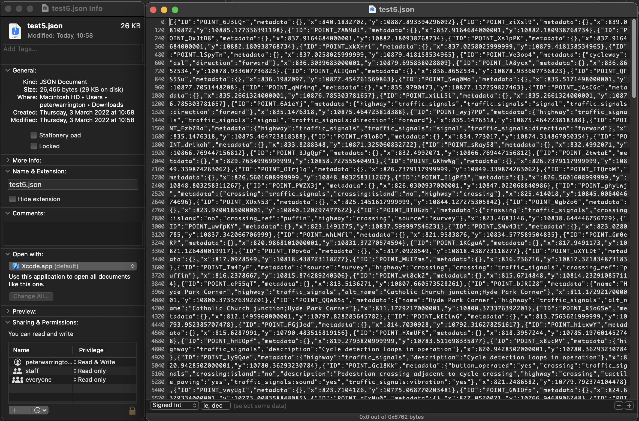

Success, though slow as finding a route from a set of thousands of nodes.

### Search for route between “Cambridge station” and “Cambridge north” via web app

Action: Search for route between “Cambridge station” and “Cambridge north” via web app routing function.

Expected output: Map translated and zoomed to display route styled on map in red, success status message displayed.

Actual output:

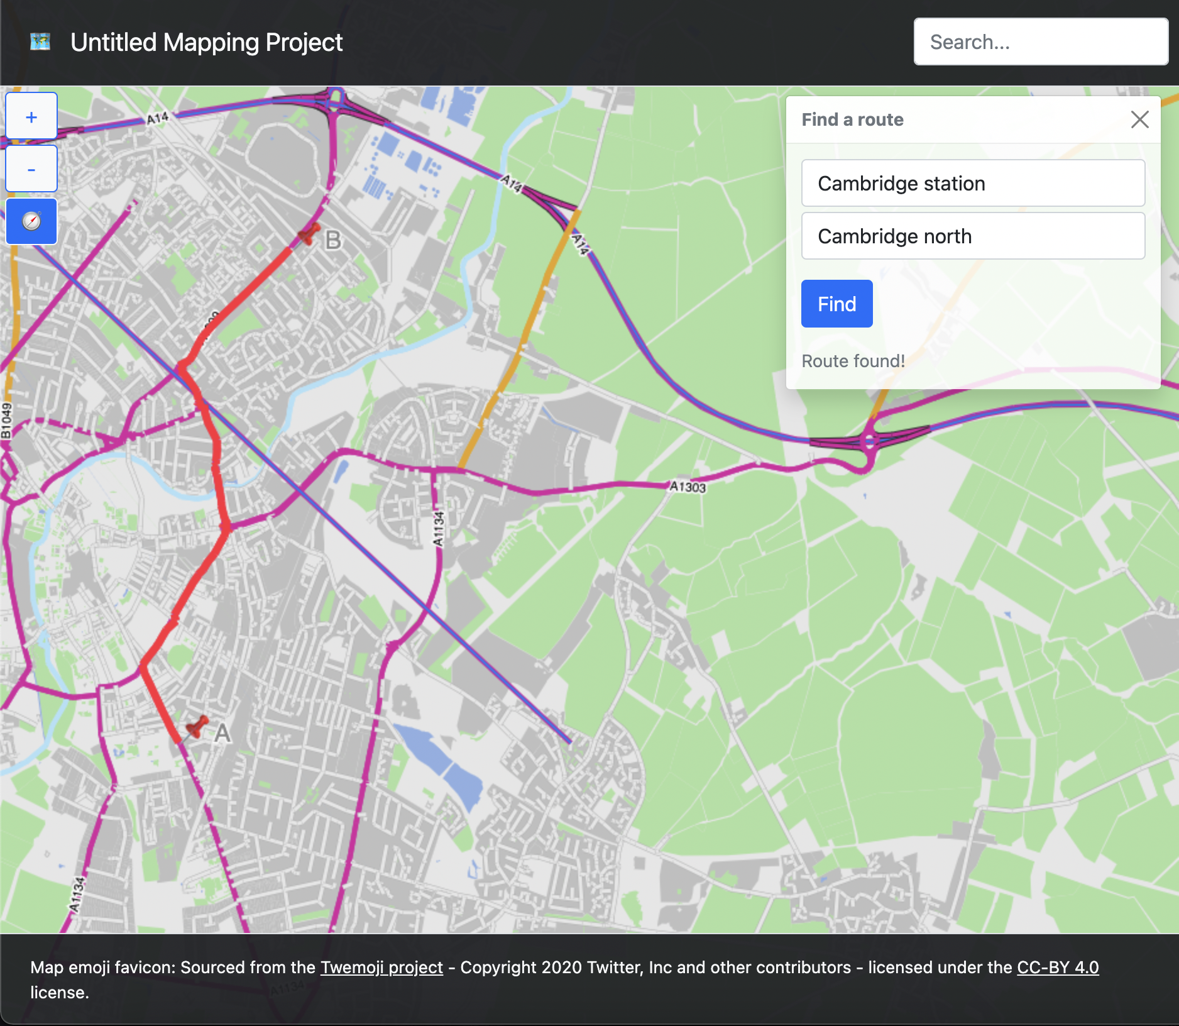

Success, though spent same amount of time finding route as CURL request.

## Objective 6 (“Function serviced by database on the backend to allow a user to sign-in/register and save places/routes”)

Objective was not implemented due to time restraint, and to focus on the complexity of the rest of the project that was perhaps underestimated.

## Objective 7a (“Testers reports that they are able to easily find their home using the search function”)

Action: With an explanation that searching only takes place at street level (no house numbers), I tasked the testers with finding their house given the initial map view of the app.

Expected outcome: Users are successfully able to quickly locate their street and their house after.

Actual outcome:

Tester A

User was not able to find their street as out of the 20 results for their road, none were their own. User reported that the map was “laggy” and that map makers could be stylised.

Tester B

User was able to find their street from the list of results and identify it on the map. They reported that the application was intuitive and easy to use, and at their zoom level did not identify any lag.

Tester C

User was easily able to find their street and identify their house on the map, stating that it was convenient to do so in an accessibly presented way.

## Objective 7b (“Testers reports that they are able to easily generate a route”)

Action: Testers were tasked with finding a route between their home and a point of their choosing, with the same disclaimer about searching only at street level.

Expected outcome: Users are successfully able to generate a route.

Actual outcome:

Tester A

User was able to easily find a route between their house and their college, reporting that it was accurate and the route they in fact take to college.

Tester B

This user was able to easily find a route between their house and their college, reporting that it was easy, though they noted it only routed via the main road nearest to their house, not via their residential road.

Tester C

The user was able to plot a route between two nearby points, but this was not routed through residential roads like was appropriate for this purpose, instead the nearby primary roads to both points, and therefore was not useful for this application.

## Objectives 7c and 7d (“Testers report that they are able to easily register and log in, save their location and route to their account”)

These features were not implemented in the final project as explained previously.

Other objectives are related to the technical design of the project therefore cannot be assessed through testing.

# Evaluation

Overall, I believe I have created a mapping project that successfully meets the main objectives of a web-based mapping application, providing much of the map display, search, and routing features that users generally expect from a mapping service, in an intuitive and simple interface. Compared to mainstream services like Google maps however, it does not offer the same level of functionality, with routing being slow and only being able to be conducted on major roads, while map translation and zooming at higher zoom levels generally faces high latency due to the lack of map tiling. More generally however, I believe my project has made effective and wide-ranging use of object-oriented data structures throughout the whole project and has benefitted from the use of a custom database and caching implementation and design. The use of these data structures in this way made building on code iterations over the course of development easier, with many of the main data structures having been established in the first prototype.

## Evaluating against set objectives

1. **Web client is able to send requests and receive appropriate data back to/from backend**

An API has been created to allow transfer of data between client and server over HTTP.

1. **The backend is able to read from OpenStreetMap (OSM xml) data and return this to clients via this API**

The convertFromOSM.js script handles this process and is able to import reliable and comprehensive map data for Cambridgeshire to the project’s custom database format, though struggles with some other OSM data sets, unable to handle those above 512mb.

1. **The web client is then able to display and represent data returned from the server on a map that can be panned and zoomed**

This objective has been achieved, with colour coded map features such as land usage, water bodies and roads successfully displayed, but while panning and zooming can be slow and laggy at higher zoom levels containing lots of map data.

1. **A search function is available on this web client to be able to find locations using the API**

A search function is provided accessible via the web app, which can search through all points and paths using their associated OSM metadata. The search algorithm I have designed isn’t perfect, and isn’t available at house level, but is generally reliable and fast, with relevant results sorted via an index ranking system.

1. **A function will be available to find a efficient route from one location on the map to another using path theory. This will take into account distance and this route must be traversable in the real world.**

This was achieved, where the application can return a route via main roads between two points using Dijkstra’s algorithm. This is however slow and is not suitable for small distances best connected by residential and other minor roads, or where points are too far away from a main road for output to be produced or be useful.

* 1. **a. Extension: Take into account traffic, whether that be based on a custom specified metric or the location of traffic lights along a route**

This was not achieved due to the lack of available traffic data and time constraints

1. **Function serviced by database on the backend to allow a user to sign-in/register and save places/routes**

This was not achieved due to time constraints and underestimated complexity of working on other functionality.

1. **Testers reports that they are able to easily:**

**a. Find their home using the search function**

**b. Generate a route**

**c. Register and log-in**

**d. Save this location and route to their account**

See testing section.

1. **Data structures and important algorithms are well-documented using comments**

Data structures and algorithms are generally commented, with the most documentation given to those structures and algorithms that are most confusing to follow without comments. Commenting therefore can vary throughout the code base.

1. **API is well documented**

API is not documented other than in the code, with it generally being simple to understand given the list of possible API endpoints in /src/index.js, by referencing the web app implementation, and by examining specific API implementation files to understand parameters.

1. **Effective use of object-oriented programming to be able to create effective data structures shared across the project, including the appropriate use of inheritance.**

Object-oriented objects and classes are used extensively throughout my project, with inheritance widely used, most notably to implement different map objects. Map objects all inherit from a base map object class which can be added to the database, where the parts that make up complex areas additionally inherit from the Area class. These are clearly organised

1. **Normalised database structure to store the data mentioned above.**

The database system used by my project has been custom implemented using hard coded tables, but which offers fast and efficient access, including for iteration, with the use of primary and foreign keys much like in a traditional database. I took care to make sure I met the 3rd normal form when do this, to ensure a lack of data redundancy.

**Extension:**

1. **Cache the most frequently accessed places directly on the database**
2. **Function to be able to plot new data on map that is then made available**
3. **Ability to add notes to the map**
4. **Ability to add other annotations to the map**

Extension objectives were not met due to time limitations and underestimation of the complexity of other objectives as explained previously.

## Possible improvements to project

From the feedback I have received during testing, it is clear that the routing function would be the focus of my attention in building any improvements. In its current implementation it is slow (up to a minute at some distances), and limited in the routes that can be generated, only using main roads at present in order to reduce the number of nodes and therefore run time.

In order to improve this, I would try two main things. One of these is to use an algorithm to reduce the number of nodes on the paths used to determine routes, for example using the Ramer–Douglas–Peucker algorithm, via a process known as cartographic generalization.[12] This would also decrease latency when translating across the map where applied to the client-side, given less processing for every frame has to take place as a result. The other method I could use is to use an alternative path-finding algorithm, such as A*, which uses heuristics to make path finding more efficient.

Another issue has been latency when translating and panning the map, where the client must redraw every single vertex on screen, something that takes a noticeable amount of time when more zoomed out and more are displayed. A solution to this would be to use map tiling so that all views of the map are generated in advance and stored on the server, to be quickly downloaded by the client, without the extensive mathematical calculations that would normally be needed, simply displaying images to the screen. I began an attempt at this during the project as explained previously but was not able to complete this.

In addition to these improvements, I would also work to meet my extension goals and implement user authentication as described in my objectives, to build those features that allow users to easily exercise the control that a self-hosted mapping solution uniquely offers, with the ability to add annotations and draw map features to the map.

# Apendix

## Analysis

### Graph theory research from start of project:

**# Graph theory research**

This document will look at how graph theory can be utilised with details on how this can be implemented, making notes from sources.

**# Notes**

- Graph theory models paths in terms of pairs between nodes (also called vertices) which are connected by links (also called edges) [1]

- Pathfinding is largely based on Dijkstra's algorithm, and the use of weighted graphs [2]

- Weighting refers to the "cost" it takes to traverse a link, e.g. how long it takes, it is a number [2,3]

- For Dijkstra's algorithm:

"This algorithm begins with a start node and an "open set" of candidate nodes. At each step, the node in the open set with the lowest distance from the start is examined. The node is marked "closed", and all nodes adjacent to it are added to the open set if they have not already been examined. This process repeats until a path to the destination has been found. Since the lowest distance nodes are examined first, the first time the destination is found, the path to it will be the shortest path."

**# References**

[1] https://en.wikipedia.org/wiki/Graph_theory

[2] https://en.wikipedia.org/wiki/Pathfinding

[3] https://en.wikipedia.org/wiki/Glossary_of_graph_theory#Weighted_graphs_and_networks

### Planned database/object structure

**# Database/object structure**

This document will detail a potential model for my database, and the requirements for this. This will additionally be used to update my existing data structures.

**## Requirements**

- Store map data

- Points

- Paths

- PathParts

- Store user data

- User name

- User email

- Hashed & salted user password

- Saved map data

- Saved routes

- Store cached routes

**## Structure**

In order to be normalised:

*\*"Every non-key attribute is a fact about the key, the whole key, and nothing but the key"\**

- https://hrsfc.sharepoint.com/Sites/CompSci-Stu/Essentials/AQA%20Computer%20Science%20Unit%202.pdf

**### Map data**

**#### Point**

PointID

string

lat

decimal

lon

decimal

metadata

object

Serving as a collection of optional metadata such as name and description.

options

object

Contains options for drawing to the screen, and potentially other things.

**#### Path**

PathID

string

BeginningPathPartID

string

metadata

object

options

object

**#### PathPart**

PathPartID

string

PointID

string

NextPathPartIDs

string[] (nullable)

Metadata

object

**### User data**

**#### User**

UserID

string

UserName

string

UserEmail

string

UserPassword

string

Salted hash

**#### UserMapData**

UserID

string

MapDataObject

string

Params

Object

### Version of analysis documentation during early stages of project

**# NEA Analysis**

**# The problem:**

User wants access to a self-hosted mapping platform for their organisation, from which they can import real-world map data and modify this. They want to be able to add things like notes, rough drawings, and would like the ability to calculate paths. This should be accessible on a variety of platforms - Including phones, tablets and desktop computers.

**# Proposed solution:**

A web-based mapping app that operates on a client-server model, which can import map data in the OpenStreetMap XML format, and return this to web clients from a custom database so that it can be displayed to the user. This can then be used to find paths between points, and where this data can be modified, able to add things like annotations. This will use a authentication system.

**# Objectives:**

See attached "Project objectives" document.

**# Research:**

- I have conducted research on the OSM XML file format and the useful information that can be extracted from this, proposing a written alogrithm for how to do this (OSM Conversion algorithm document).

- I have been researching the Bootstrap framework and implementing it so that I can generate UI without spending lots of time worrying about implementation of UI elements. For this I have been making use of the Bootstrap reference from their website.

- I have done some research on path theory, including specifically on Dijkstra's algorithm which I have included in my "Graph theory research" document. This will be used to generate paths given connecting points on a map.

**# Proposed solution detail:**

- See High level project structure document and diagram for an outline of my initial plan, and how different project elements will interact.

- TODO: Create database layout.

**# Current implementation**

At the moment, I have a web client serviced by a basic web server that can display data returned from the backend on a scaleable and translateable map. The server and client use shared classes in order to represent this map data. Large parts of my OSM conversion algorithm have also been implemented, reading OSM points from a ~400MB file (Cambridgeshire) and converting them into instances of my classes, which can then be shown on the client. Displaying this OSM map data is currently buggy however and has some issues, for example some roads seem to be missing and scaling is conducted about map origin making navigating the map difficult.

### Early project purpose documentation

I am working to create a project that is capable of parsing, representing and displaying real-world map data, which can then be used to calculate the most efficient paths between points. This would work in conjunction with a backend API that returns map data to a client, where the backend is responsible for calculating paths and caching these so that they can be returned to clients more quickly.

I believe that a web app built using standard web technology (HTML5, CSS, JS) would be the most effective way to achieve this, as it enables use of the service using one client codebase regardless of device specifics and is well supported by mobiles in particular. This is what I have started to create as part of my mini-project, leaving behind the backend for now so I can build the data structures and build a more simple base from which the rest of the project can be effectively built on. The codebase I have created as it stands is capable of displaying map data to the user given a set of connecting points, where this map is scalable and translatable.

The backend I have built at the moment simply serves the static site that acts as the client, but is and will be built using Node.JS, a backend JavaScript runtime environment that is suited to building APIs and is well used in professional environments. It means that in addition I can reuse the same data structures for both client and server, making transfer and development between the two faster and more efficient such that I do not have to make two separate implementations of two data structures for example.

I will be using OpenStreetMap data as part of my project, which provides comprehensive, worldwide community built map-data under a freely-usable license given attribution.

**OSM Conversion algorithm:**

**# OSM Conversion algorithm**

**## Objective**

To convert OSM data into the format required by the client.

**## Formats**

**### Custom JS format (Desired)**

* JSON

* Each road is a Path object.

* Each road is given a unique path ID

* A Path is defined in terms of its initial PathPart

* Each Point of a Path is connected in a chain of PathParts

* Each PathPart contains its point and the next PathParts in the chain

**### OSM (To be converted)**

* XML

* Each road is defined in terms of a list of nodes

* Road metadata is given using <tag> elements in the format

`<tag k="key" v="value"/>`

* Each road is a <way> and has <tag>s with k="highway"

* Each <way> contains component nodes expressed as <nd>s in the format:

`<nd ref="idOfTheNode"/>`

* Each <node> has node in the format:

`<node id="25496583" lat="51.5173639" lon="-0.140043" version="1" changeset="203496" user="80n" uid="1238" visible="true" timestamp="2007-01-28T11:40:26Z"></node>`

**## Objectives**

* Convert OSM data from XML to JSON

* Find ways with "highway" tag

* For each of these ways, find the component nodes

* For each of these nodes, convert the latitude and longitude to x,y coordinates

* Convert each node to a MapPoint

* Create path for each way using connecting MapParts of MapPoints

## Project development screenshots over time

### 02/07/2021

Early version of prototype, simply demonstrating some points joined by a path.

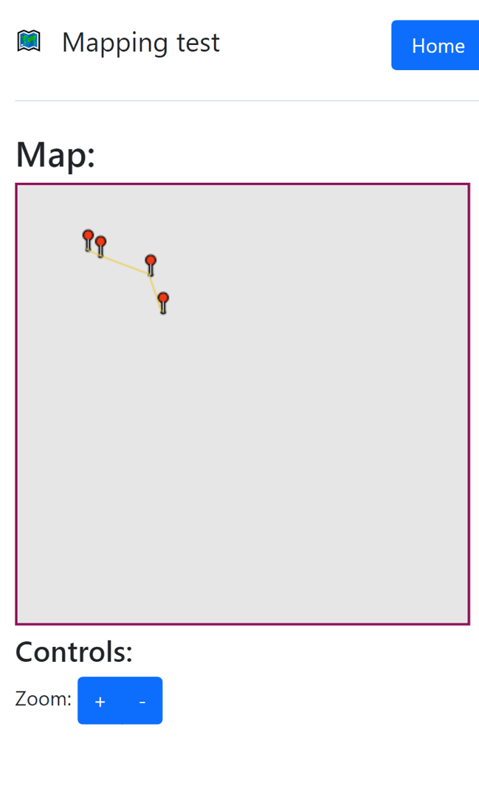

### 18/11/2022

Screenshot showing some of the first OSM-imported map data returned to the client.

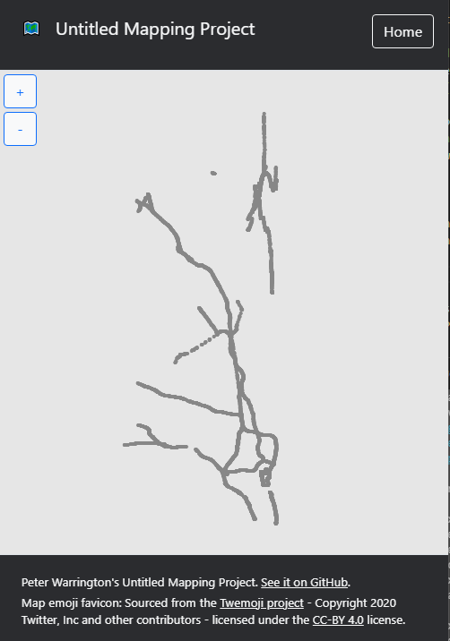

### 17/02/2022

Trying to implement road labels, the issue seen here was due to incorrectly assigning rotation of labels relative to origin rather than from the path.

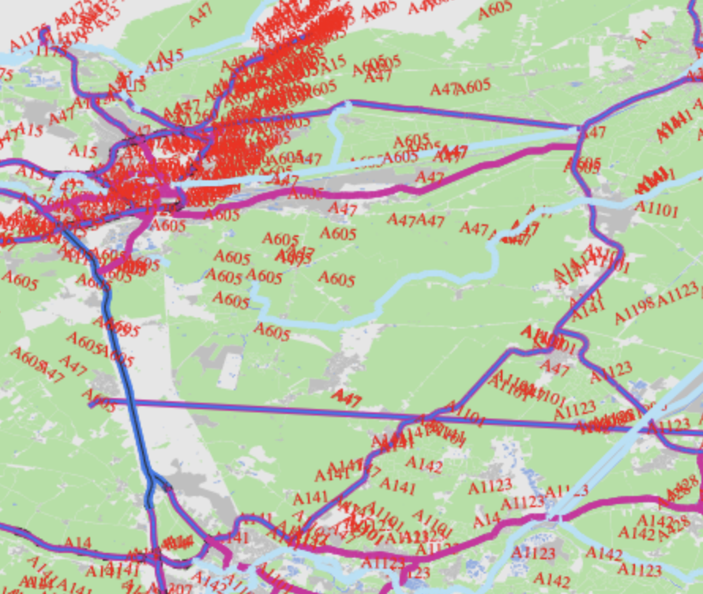

### 20/02/2022

During initial work to implement local caching based on map grid positions.

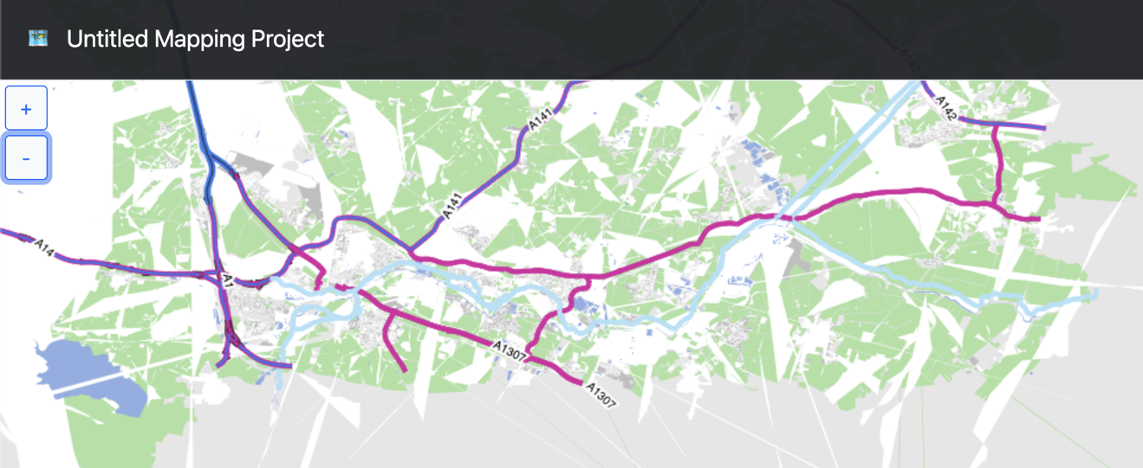

### 21/02/2022

Screenshot showing how complex areas (shapes with holes in them) were not yet displayed at this point.

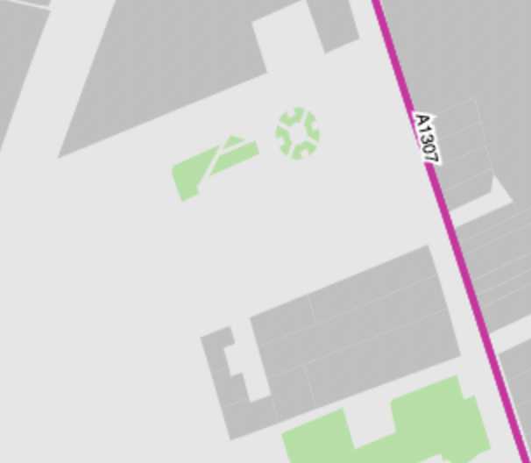

### 23/02/2022

Screenshot showing earlier work in implementing complex areas, with simply the outer sections of these areas being implemented, with no styling yet.

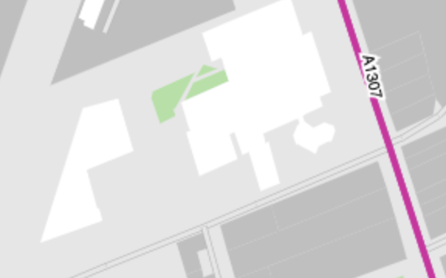

### 24/02/2022

Screenshot showing complex areas having been implemented

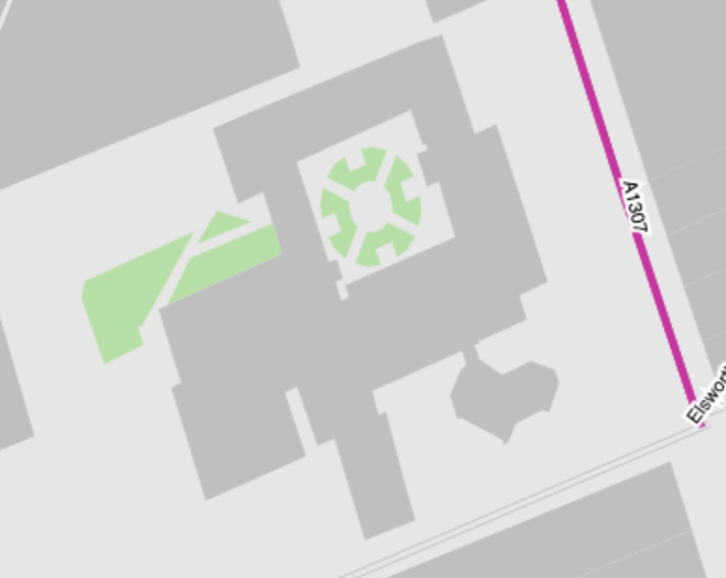

Screenshot showing more trouble with caching based on grid positions

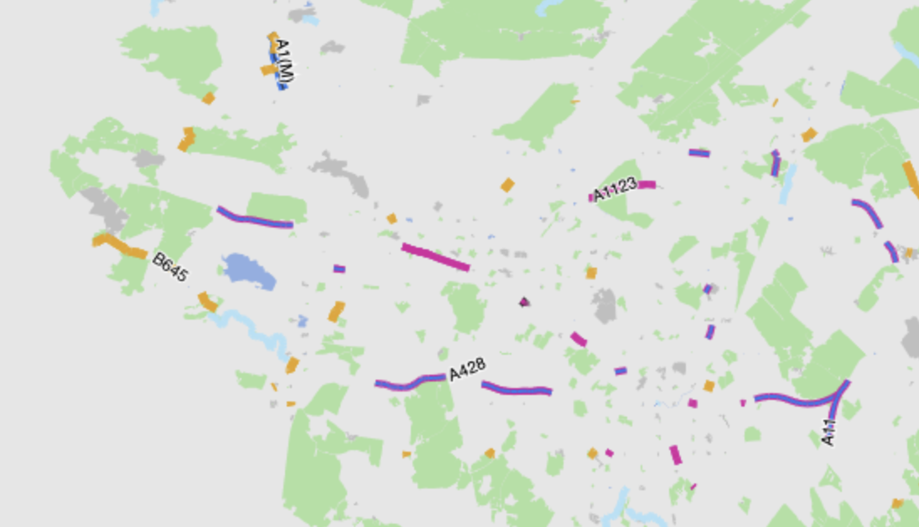

### 26/02/2022

Screenshot showing lack of distinguishment of search results with same name, due to the lack of location type descriptors being displayed, and the lack of a search ranking system.

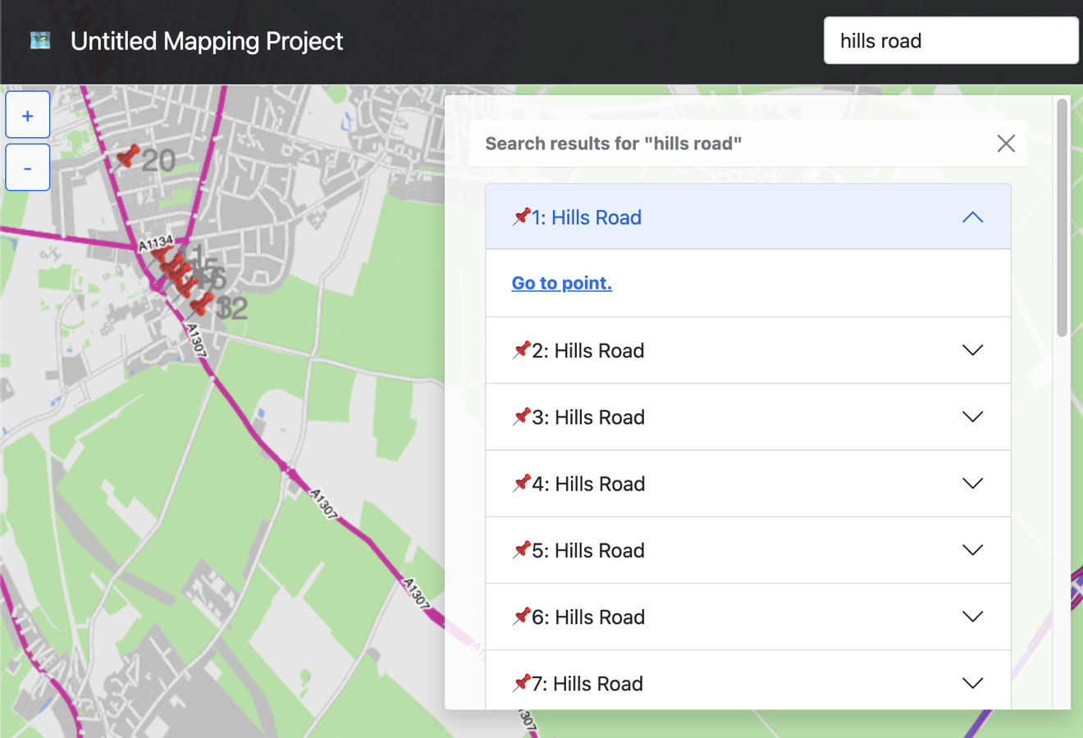

### 27/02/2022

Screenshot showing early route finding code returning path of all nodes visited in determining route, rather than the route itself.

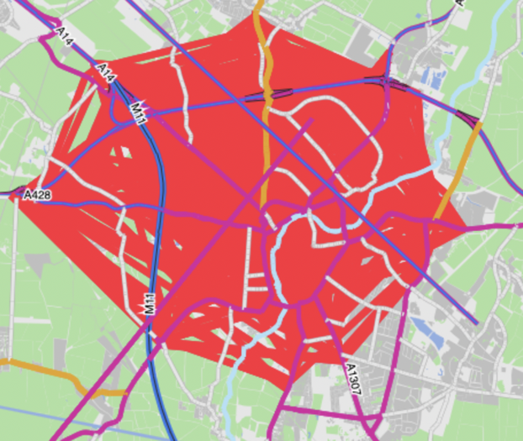

## Early testing

### 27/12/2021

Testing was conducted to verify that there was no difference in displayed map data after a commit to only display points that were on screen.

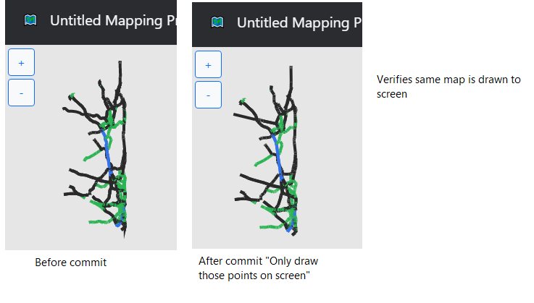

## Code

### Final project - index.html

<!DOCTYPE html>

<html lang="en">

<head>

<meta charset="UTF-8">

<meta http-equiv="X-UA-Compatible" content="IE=edge">

<meta name="viewport" content="width=device-width, initial-scale=1.0, maximum-scale=1.0, user-scalable=no">

<title>Untitled Mapping Project</title>

<script src="sharedStructures.js"></script>

<script src="index/index.js"></script>

<link href="https://cdn.jsdelivr.net/npm/bootstrap@5.1.3/dist/css/bootstrap.min.css" rel="stylesheet" integrity="sha384-1BmE4kWBq78iYhFldvKuhfTAU6auU8tT94WrHftjDbrCEXSU1oBoqyl2QvZ6jIW3" crossorigin="anonymous">

<link rel="stylesheet" href="index/index.css">

</head>

<body>

<!-- header -->

<header class="d-flex flex-wrap justify-content-center py-3 border-bottom px-2" id="header">

<a href="/" class="d-flex align-items-center mb-3 mb-md-0 me-3 me-md-auto text-light text-decoration-none">

<span class="header-icon mx-3">🗺</span>

<span class="fs-5">Untitled Mapping Project</span>

</a>

<ul class="nav nav-pills d-flex">

<li class="nav-item">

<div class="d-flex">

<input type="text" class="form-control" id="search_input" placeholder="Search...">

</div>

</li>

</ul>

</header>

<!-- Contains page content, mainly map and map controls-->

<div id="mapContainer">

<canvas id="mapCanvas" height="350px" width="100%"></canvas>

</div>

<!-- controls -->

<div id="controls" class="d-grid gap-1 m-1">

<button type="button" class="btn btn-outline-primary bg-light text-primary" id="zoom-in">+</button>

<button type="button" class="btn btn-outline-primary bg-light text-primary" id="zoom-out">-</button>

<button type="button" class="btn btn-outline-light bg-primary text-light" id="route-ui-show-btn">🧭</button>

</div>

<!-- Loading indicator -->

<div id="loading-indicator-container" style="display:none">

<img src="/spinner.gif" id="loading-indicator">

</div>

<!-- Search results display -->

<div id="results" class="container toast" role="alert" aria-live="assertive" aria-atomic="true" data-bs-autohide="false">

<div class="toast-header">

<strong class="me-auto" id="results-title">Search results</strong>

<button type="button" class="btn-close" data-bs-dismiss="toast" aria-label="Close"></button>

</div>

<div class="accordion toast-body" id="results-accordion">

</div>

</div>

</div>

<!-- Route search display -->

<div class="container toast" id="route-search-toast" role="alert" aria-live="assertive" aria-atomic="true" data-bs-autohide="false">

<div class="toast-header">

<strong class="me-auto">Find a route</strong>

<button type="button" class="btn-close" data-bs-dismiss="toast" aria-label="Close"></button>

</div>

<div class="accordion toast-body" id="route-search-body">

<input type="text" class="form-control mb-1" id="pointA_input" placeholder="Point A">

<input type="text" class="form-control mb-3" id="pointB_input" placeholder="Point B">

<button type="submit" class="btn btn-primary mb-3" id="route-submit-btn">Find</button>

<br/>

<span id="route-status" class="text-secondary"></span>

</div>

</div>

<footer class="text-light mt-3 border-top pt-3 px-4" id="footer">

<p class="mb-3" style="font-size: 10pt;">

Map emoji favicon: Sourced from the <a href="https://twemoji.twitter.com/" class="link-light">Twemoji project</a> -

Copyright 2020 Twitter, Inc and other contributors -

licensed under the <a href="https://creativecommons.org/licenses/by/4.0/" class="link-light">CC-BY 4.0</a> license.

</p>

</footer>

<script src="https://cdn.jsdelivr.net/npm/bootstrap@5.1.3/dist/js/bootstrap.bundle.min.js" integrity="sha384-ka7Sk0Gln4gmtz2MlQnikT1wXgYsOg+OMhuP+IlRH9sENBO0LRn5q+8nbTov4+1p" crossorigin="anonymous"></script>

<!-- Used to make search results draggable -->

<script src="https://code.jquery.com/jquery-3.6.0.js" integrity="sha256-H+K7U5CnXl1h5ywQfKtSj8PCmoN9aaq30gDh27Xc0jk=" crossorigin="anonymous"></script>

<script

src="https://code.jquery.com/ui/1.13.1/jquery-ui.js"

integrity="sha256-6XMVI0zB8cRzfZjqKcD01PBsAy3FlDASrlC8SxCpInY="

crossorigin="anonymous"></script>

</body>

</html>

### Final project - Index.css

.header-icon {

font-size: 12pt;

color: #fff;

}

#mapCanvas {

position: absolute;

top: 0;

left: 0;

z-index: -1000;

}

html, body {

overflow-x: hidden;

overflow-y: hidden;

touch-action: none;

}

#header {

background-color: #202124f1;

}

#footer {

position: absolute;

bottom: 0;

width: 100%;

background-color: #202124f1;

}

#controls {

width: 15px;

position: absolute;

}

#loading-indicator-container {

position: absolute;

padding: 5pt;

background: #fff;

right: 0px;

}

.toast {

position: absolute;

padding: 0;

right: 5pt;

margin: 5pt;

width: 500px;

max-width: 90vw;

}

#results-accordion {

overflow-y: scroll;

max-height: 60vh;

}

.toast-header {

cursor: grab;

}

.toast-header button {

cursor: auto;

}

#route-search-toast {

width: 300px;

}

#loading-indicator {

width: 35px;

}

**Prototype - src/web/index/index.js:**

class CanvasState {

/** The {CanvasRenderingContext2D} that is used on the canvas */

ctx

/** The canvas element that displays the map */

canvas

/** Indicates whether the mouse button is down */

canvasMouseDown = false

/** Indicates the last recorded mouse position relative to the page in X */

lastPageX = -1

/** Indicates the last recorded mouse position relative to the page in Y */

lastPageY = -1

/** The array of {Path}s to be drawn to screen */

paths = []

/** A {int} multiplier to represent the zoom level */

zoomLevel = 1

/** {int} representing how the map has been translated in x */

xTranslation = 0

/** {int} representing how the map has been translated in y */

yTranslation = 0

constructor () {

this.canvas = document.getElementById("mapCanvas");

this.ctx = this.canvas.getContext('2d');

// Zoom functionality

document.getElementById("zoom-in").onclick = (event) => {

this.zoom(1);

};

document.getElementById("zoom-out").onclick = (event) => {

this.zoom(-1);

};

// Translation functionality

this.canvas.onmousedown = (event) => {

this.lastPageX = event.pageX;

this.lastPageY = event.pageY;

this.canvasMouseDown = true;

if (this.canvas.style.cursor == "grab")

this.canvas.style.cursor = "grabbing";

}

this.canvas.onmouseup = (event) => {

this.lastPageX = -1;

this.lastPageY = -1;

this.canvasMouseDown = false;

if (this.canvas.style.cursor == "grabbing")

this.canvas.style.cursor = "grab";

}

this.canvas.onmousemove = (event) => {

if (this.canvasMouseDown) {

var relativeMouseX = event.pageX - this.lastPageX;

var relativeMouseY = event.pageY - this.lastPageY;

this.xTranslation += relativeMouseX;

this.yTranslation += relativeMouseY;

this.lastPageX = event.pageX;

this.lastPageY = event.pageY;

this.draw();

}

}

this.canvas.onmouseenter = (event) => {

this.canvas.style.cursor = "grab";

}

this.canvas.onmouseleave = (event) => {

this.canvas.style.cursor = "default";

}

// Redraw on window resize to make sure canvas is right size

window.addEventListener('resize', () => this.draw());

}

/**

* Method to change the zoom level of the displayed map

* @param {int} multiplier The multiplier to change the zoom by, normally either -1 or 1

*/

zoom(multiplier) {

let zoomChange = 0.1 * multiplier;

if (this.zoomLevel + zoomChange < 0.1)

return;

this.zoomLevel += zoomChange;

this.draw();

}

/**

* Calls functions to draw path to screen

*/

draw() {

// Update canvas width

this.updateCanvasWidth();

// Clear canvas

this.ctx.clearRect(0, 0, this.canvas.width, this.canvas.height);

// Fill background

this.ctx.fillStyle = "#e6e6e6";

this.ctx.fillRect(0, 0, this.canvas.width, this.canvas.height);

this.paths.forEach(path => path.plotPoints());

this.paths.forEach(path => path.plotLine());

}

/**

* Updates the width of the canvas displayed on screen

*/

updateCanvasWidth() {

let mapContainerStyles = window.getComputedStyle(document.getElementById("mapContainer"));

// Resize to 100% (html decleration does not work)

let paddingLeft = parseInt(mapContainerStyles.getPropertyValue('padding-left'));

let paddingRight = parseInt(mapContainerStyles.getPropertyValue('padding-right'));

let spacing = paddingLeft + paddingRight + 5;

this.canvas.width = document.getElementById("mapContainer").clientWidth - spacing;

}

}

class MapPoint {

/** Fixed x position of point in relation to others */

x

/** Fixed y position of point in relation to others */

y

/** The {canvasState} instance */

canvasState

/** Gets the x position relative to the canvas */

get displayedX() {

return (this.x * this.canvasState.zoomLevel) + this.canvasState.xTranslation;

}

/** Gets the y position relative to the canvas */

get displayedY() {

return (this.y * this.canvasState.zoomLevel) + this.canvasState.yTranslation;

}

/** Gets the x position of where the path should be drawn relative to canvas */

get pathPointDisplayX() {

return this.displayedX + this.options.pathDrawPointX;

}

/** Gets the y position of where the path should be drawn relative to canvas */

get pathPointDisplayY() {

return this.displayedY + this.options.pathDrawPointY;

}

/** Options for the point when drawing to screen */

options = {

pointDrawMethod: "text",

pointText: "📍",

pointFont: "sans-serif",

pointFontWidth: 16,

pointFillStyle: "#878787",

pathDrawPointX: 5,

pathDrawPointY: 1

}

/** {MapPoint[]} array containing the {MapPoint}s that this point connects to. Can be undefined. */

pointsConnectingTo

/**

* Creates a point that can form part of a path and be displayed on a canvas.

* @param {int} x Fixed x position of point in relation to others

* @param {int} y Fixed y position of point in relation to others

* @param {CanvasRenderingContext2D} ctx The {CanvasRenderingContext2D} that is used on the canvas

* @param {MapPoint} pointsConnectingTo The sequential {MapPoint} that follows this one. Can be undefined.

* @param {object} options Options for the point when drawing to screen

*/

constructor (x, y, canvasState, options={}, pointsConnectingTo=undefined) {

this.x = x;

this.y = y;

this.canvasState = canvasState;

this.pointsConnectingTo = pointsConnectingTo;

this.options = {...this.options, ...options};

}

/**

* Function to draw the point to the screen

*/

drawPoint() {

this.canvasState.ctx.fillStyle = this.options.pointFillStyle;

this.canvasState.ctx.font = `${this.options.pointFontWidth}px ${this.options.pointFont}`;

this.canvasState.ctx.fillText(this.options.pointText, this.displayedX, this.displayedY);

}

/** Returns wether this is the last point of a path */

get isEndOfPath() {

return this.pointsConnectingTo == undefined;

}

/**

* Connects a point to this point

* @param {Point} pointConnectingTo The point that you want to connect this point to

* @returns The point that you are connecting to this point

*/

connectingTo(pointConnectingTo) {

if (this.pointsConnectingTo == undefined)

this.pointsConnectingTo = [];

this.pointsConnectingTo.push(pointConnectingTo);

return pointConnectingTo;

}

}

class Path {

/** The {string} used to identify the path */

pathId

/** The {MapPoint} object that starts the path */

startingPoint

/** The {canvasState} instance */

canvasState

/** Options for the path when drawing to screen */

options = {

pathFillStyle: "#e8cc4a",

pathLineWidth: 4,

recalculatePathFlag: false

}

/** Returns the line width to be displayed on the canvas */

get lineWidth() {

return this.options.pathLineWidth;

}

/**

* Creates a path using a starting points

* @param {MapPoint} startingPoint The {MapPoint} object that starts the path

* @param {CanvasRenderingContext2D} ctx The {CanvasRenderingContext2D} that is used on the canvas

* @param {object} options Options for the path when drawing to screen

*/

constructor (startingPoint, canvasState, pathId, options={}) {

this.startingPoint = startingPoint;

this.canvasState = canvasState;

this.options = {...this.options, ...options};

this.pathId = pathId;

}

/**

* Converts a tree of connecting points to a array of all points (for drawing individual points unconnectedly)

* @param {MapPoint} startingPoints The {MapPoint[]} object containing a starting point on a path

* @param {MapPoint[]} pathArray A sequential array of {MapPoint}s

* @returns {MapPoint[]}

*/

static getAllPointsOnPath(startingPoints, pathArray=[]) {

startingPoints.forEach(startingPoint => {

pathArray.push(startingPoint);

if (startingPoint.pointsConnectingTo != undefined)

Path.getAllPointsOnPath(startingPoint.pointsConnectingTo, pathArray);

});

return pathArray;

}

/**

* Converts a sequential array of points to a tree of connecting points

* @param {MapPoint[]} pathArray A sequential array of {MapPoint}s

* @returns {MapPoint} The {MapPoint} object that starts the path

*/

static connectSequentialPoints(pathArray) {

var pathArrayCopy = Object.values(Object.assign({}, pathArray)).reverse();

for (let i = 1; i < pathArrayCopy.length; i++) {

pathArrayCopy[i].pointsConnectingTo = [pathArrayCopy[i-1]];

}

return pathArrayCopy[pathArrayCopy.length - 1];

}

/**

* Plots line connecting points in this.startingPoint to screen.

*/

plotLine() {

// Set properties

this.canvasState.ctx.lineWidth = this.lineWidth;

this.canvasState.ctx.strokeStyle = this.options.pathFillStyle;

this.canvasState.ctx.beginPath();

// Initialize array containing the initial points to draw

let startingPointsToDraw = [...this.startingPoint.pointsConnectingTo];

// Iterate through startingPointsToDraw

for (let i = 0; i < startingPointsToDraw.length; i++) {

const startingPoint = startingPointsToDraw[i];

// Move to the starting point

this.canvasState.ctx.moveTo(this.startingPoint.pathPointDisplayX, this.startingPoint.pathPointDisplayY);

// If we get to a branch, push the other branches to startingPointsToDraw to iterate through later

let currentPoint = startingPoint;

while (!currentPoint.isEndOfPath) {

// Plot a line from the last plotted point to the point at currentPoint

this.canvasState.ctx.lineTo(currentPoint.pathPointDisplayX, currentPoint.pathPointDisplayY);

if (currentPoint.pointsConnectingTo.length > 1) {

for (let j = 1; j < currentPoint.pointsConnectingTo.length; j++) {

startingPointsToDraw.push(currentPoint.pointsConnectingTo[j]);

}

}

// Advance pointer to next connecting point in the closest branch

currentPoint = currentPoint.pointsConnectingTo[0];

}

this.canvasState.ctx.lineTo(currentPoint.pathPointDisplayX, currentPoint.pathPointDisplayY);

// Draw line to canvas

this.canvasState.ctx.stroke();

}

}

/**

* Plots markers for points in this.startingPoint

*/

plotPoints() {

Path.getAllPointsOnPath([this.startingPoint]).forEach(point => point.drawPoint());

}

}

/**

* Function called at page load to test some points on canvas

*/

function MapTest() {

// Create canvas state

canvasState = new CanvasState();

// Create path 1

var startingPointPath1 = new MapPoint(50, 50, canvasState, {pointText: "📍\t\tPath 1"});

startingPointPath1.connectingTo(new MapPoint(60, 55, canvasState))

.connectingTo(new MapPoint(100, 70, canvasState))

.connectingTo(new MapPoint(110, 100, canvasState));

var path1 = new Path(startingPointPath1, canvasState, "Path1");

// Create path 2

var startingPointPath2 = new MapPoint(30, 200, canvasState, {pointText: "📍\t\tPath 2"});

startingPointPath2.connectingTo(new MapPoint(400, 170, canvasState))

.connectingTo(new MapPoint(300, 250, canvasState))

.connectingTo(new MapPoint(270, 20, canvasState))

.connectingTo(new MapPoint(120, 100, canvasState))

.connectingTo(new MapPoint(160, 160, canvasState));

var path2 = new Path(startingPointPath2, canvasState, "Path2");

canvasState.paths = [path1, path2];

// Draw points

canvasState.draw();

}

// Once the page has fully loaded, call MapTest

document.addEventListener('DOMContentLoaded', MapTest, false);

## Git commit log

2021-06-25:Peter Warrington::Initial plan

2021-06-25:Peter Warrington::Fix plan checkboxes

2021-06-25:Peter Warrington::Fix plan checkboxes again

2021-07-02:Peter Warrington::Create static map testing site, able to display array of points

2021-07-09:Peter Warrington::Add zoom foundations

2021-07-09:Peter Warrington::Add zoom functionality

2021-07-12:Peter Warrington::Add vs code launch.json

2021-07-12:Peter Warrington::Add consts

2021-07-12:Peter Warrington::Add comments to web/index.js

2021-07-12:Peter Warrington::Add logging functionality

2021-07-12:Peter Warrington::Amend gitignore

2021-07-12:Peter Warrington::Fix request logging

2021-07-12:Peter Warrington::Set vscode current dir in launch.json

2021-07-12:Peter Warrington::Fix width of map canvas

2021-07-12:Peter Warrington::Add map translation functionality

2021-07-12:Peter Warrington::Prevent negative scaling

2021-07-12:Peter Warrington::Dynamic resizing of map canvas

2021-07-12:Peter Warrington::Move zoom into seperate function

2021-07-16:Peter Warrington::Create project purpose document

2021-07-16:Peter Warrington::Mutli-path support, CanvasState to store globals

2021-09-16:Peter Warrington::Create initial project objectives

2021-09-16:Peter Warrington::Delete README.md

2021-09-16:Peter Warrington::Change objectives to check boxes

2021-09-16:Peter Warrington::Objectives update

2021-09-16:Peter Warrington::Objectives update

2021-09-16:Peter Warrington::Objectives update

2021-09-23:Peter Warrington::Seperate points and paths

2021-09-23:Peter Warrington::Add favicon and footer

2021-09-23:Peter Warrington::Add basic touch support

2021-09-23:Peter Warrington::Full-screen map redesign

2021-09-23:Peter Warrington::Add specific map translation function

2021-09-23:Peter Warrington::disable phone zoom

2021-09-23:Peter Warrington::Adjust text sizes in line with static demo

2021-09-27:Peter Warrington::Move map structures to back/frontend shared file

2021-09-27:Peter Warrington::Rename page title from "Map test page"

2021-09-30:Peter Warrington::High level project structure

2021-09-30:Peter Warrington::move shared structures into single shared object

2021-09-30:Peter Warrington::Client access paths from backend

2021-09-30:Peter Warrington::Add route finding to high level project diagram

2021-09-30:Peter Warrington::Fix typo

2021-10-15:Peter Warrington::Seperate drawing methods/properties from shared

2021-10-15:Peter Warrington::Merge branch 'main' of https://github.com/PeterWarrington/NEA-mapping into main

2021-10-18:Peter Warrington::Add commentst to index.js

2021-10-18:Peter Warrington::Fix point options not being passed to client

2021-11-13:Peter Warrington::Detail OSM conversion algorithm plan

2021-11-13:Peter Warrington::Script to create project format map data from OSM

2021-11-13:Peter Warrington::Add libraries neccessary for conversion from osm

2021-11-13:Peter Warrington::Config VS code to be able to launch OSM conversion

2021-11-13:Peter Warrington::Add ability to display OSM test points in browser

2021-11-13:Peter Warrington::Gitignore output files

2021-11-15:Peter Warrington::Create initial analysis report, containing TODOs

2021-11-15:Peter Warrington::Begin graph theory research notes

2021-11-18:Peter Warrington::Move analysis, implementation details, export pdf

2021-11-18:Peter Warrington::Switch from 📍 point marker to •

2021-11-18:Peter Warrington::Switch from 📍 point marker to •

2021-11-18:Peter Warrington::Merge branch 'main' of https://github.com/PeterWarrington/NEA-mapping into main

2021-11-18:Peter Warrington::Plot points over lines so visible

2021-11-18:Peter Warrington::Update screenshot

2021-11-18:Peter Warrington::Add pandoc generation example

2021-11-18:Peter Warrington::Add newline to saved log messages

2021-11-18:Peter Warrington::Add newline to saved log messages

2021-11-18:Peter Warrington::Merge branch 'main' of https://github.com/PeterWarrington/NEA-mapping into main

2021-11-19:Peter Warrington::Merge branch 'main' of https://github.com/PeterWarrington/NEA-mapping into main

2021-11-19:Peter Warrington::Merge branch 'main' of https://github.com/PeterWarrington/NEA-mapping into main

2021-11-19:Peter Warrington::Remove extra new lines from terminal logs

2021-11-19:Peter Warrington::Create initial database strucutre file, map data

2021-11-29:Peter Warrington::Write up initial database and object structure

2021-12-02:Peter Warrington::Update database structure

2021-12-02:Peter Warrington::Convert data structures to a normalised db format

2021-12-06:Peter Warrington::Improve zoom control relative to translation

2021-12-06:Peter Warrington::fix symbolic link

2021-12-06:Peter Warrington::Revert "fix symbolic link"

This reverts commit 14ee950e5f24c9bb6dcb67d40fb4aa331cfc56e8.

2021-12-06:Peter Warrington::fix symbolic link

2021-12-06:Peter Warrington::Number objectives

2021-12-13:Peter Warrington::Amend OSM conversion algorithm detail

2021-12-13:Peter Warrington::WIP OSM conversion changes undergoing testing

2021-12-16:Peter Warrington::Improve convertFromOSM iteration

2021-12-16:Peter Warrington::unsuccesful work on threading convertFromOSM

2021-12-16:Peter Warrington::Make threaded convert from osm run for testing

2021-12-16:Peter Warrington::Fix import

2021-12-21:Peter Warrington::gitignore cpuprofile files

2021-12-21:Peter Warrington::Add '--cacheRead' to convertOSM launch.json config

2021-12-21:Peter Warrington::gitignore src/db.json

2021-12-21:Peter Warrington::Decrease convertOSM time from 5 hours to 2 mins

... and add metadata for convertOSM map objects

2021-12-25:Peter Warrington::allocate more ram to server for db cacheing

2021-12-25:Peter Warrington::colour code roads

2021-12-25:Peter Warrington::GetDBfromQuery endpoint add

2021-12-27:Peter Warrington::Only draw those points on screen

2021-12-27:Peter Warrington::Test 'Only draw those points on screen'

2021-12-27:Peter Warrington::Fix logging not being instantaneous

2021-12-27:Peter Warrington::Log that server has started

2022-01-01:Peter Warrington::Add getMapObjectIDsOfType to db implementation

2022-01-01:Peter Warrington::Request specific map area from server

2022-01-01:Peter Warrington::Fix dbFromQuery map area

2022-01-01:Peter Warrington::Update web DB query

2022-01-02:Peter Warrington::Add express dependency

2022-01-02:Peter Warrington::Add .DS_store to gitignore

2022-01-02:Peter Warrington::Change backslash to forwardslash in launch.json

2022-01-06:Peter Warrington::Only request points that are not already on screen

2022-01-06:Peter Warrington::Remove debug console.log

2022-01-22:Peter Warrington::Revert timered map load, add debug_viewWholeMap

2022-01-22:Peter Warrington::Add debug mode, with some debug logging

In order to try and fix map area filtering

2022-01-22:Peter Warrington::Fix map data dispaly issues

Issue arrose from plotLine incorrectly reading from a global database

object defined in MapTest that was only for intermediary conversion

purposes.

Made sure it read from canvasState.database instead to fix this.

Also added database merging.

2022-01-22:Peter Warrington::Fix reference to database not canvasState.database

2022-01-22:Peter Warrington::Add map data update on map translation

2022-01-22:Peter Warrington::Move http req receive data func into canvasState

2022-01-22:Peter Warrington::Fix excludeAreas not working

2022-01-24:Peter Warrington::Fix db returned when no highway or search filter

2022-01-24:Peter Warrington::Add more roads colours and catch cache error

2022-01-24:Peter Warrington::.gitignore changes

2022-01-24:Peter Warrington::Apply borders to roads

2022-01-28:Peter Warrington::Add Area map object definition

2022-01-28:Peter Warrington::osmConvert: Convert water bodies

2022-01-28:Peter Warrington::change requested highways

2022-02-03:Peter Warrington::add metadata to areas

2022-02-03:Peter Warrington::add basic code to return map areas on query

2022-02-03:Peter Warrington::basic code to draw areas to screen

2022-02-03:Peter Warrington::Filter areas by map area

2022-02-04:Peter Warrington::only draw areas on screen to improve perfromance

2022-02-04:Peter Warrington::add search button (no functionality)

2022-02-11:Peter Warrington::Basic search API improve

Should have more data on raw map before start searching

2022-02-11:Peter Warrington::Seperate OSM and non-OSM metadata

My philosophy is that metadata should be queried from the custom

defined metadata keys, which sources from OSM metadata,

but can still fall back on raw OSM metadata

2022-02-11:Peter Warrington::Add river to accepted "highways"

2022-02-11:Peter Warrington::"highway" -> "pathType"

2022-02-12:Peter Warrington::convertFromOSM: convert land

2022-02-12:Peter Warrington::allocate server more memory

2022-02-12:Peter Warrington::custom JSON stringify to workaround data too large

2022-02-12:Peter Warrington::dbFromQuery: Rtn whole Area not just Area onscreen

2022-02-12:Peter Warrington::add ID and metadata in areaFromObject

2022-02-12:Peter Warrington::draw areas on different layers, custom area style

2022-02-12:Peter Warrington::fix colours for areas

2022-02-12:Peter Warrington::add more cache error handling

2022-02-15:Peter Warrington::Fix lat-lng projection to x-y by using mercator

2022-02-15:Peter Warrington::specify URLs to request map data as vars

2022-02-15:Peter Warrington::Only request map data when not already downloaded

2022-02-15:Peter Warrington::Add load spinner, use multiplier based zoom level

2022-02-15:Peter Warrington::Load whole paths at a time

2022-02-17:Peter Warrington::optimise getMapObjectIDsOfType

decreasing query time substantially (measured from ~5.5s -> ~3s)

2022-02-17:Peter Warrington::optimise query by doing custom json conversion

for some reason using a return string takes less time than using

res.write(), not quite sure why

2022-02-17:Peter Warrington::Test draw highway labels to screen

2022-02-17:Peter Warrington::part: add getPoint(),getNextPart(),getNextPoint()

2022-02-17:Peter Warrington::Add better label drawing (angles, spaced out)

2022-02-17:Peter Warrington::sharedStructures: fix error during getNextPoint

2022-02-17:Peter Warrington::Translate highway labels slightly

2022-02-17:Peter Warrington::Actually examine width during query

2022-02-17:Peter Warrington::Add another test url

2022-02-18:Peter Warrington::server-side db: remove point display options

Decreases db file size to ~54% original size

decreases query load (~2.5s -> ~2.25s)

2022-02-19:Peter Warrington::labels: Calculate angle using distance, add border

Calculating angle using distance rather than points away, as points

away is not a reliable indicator of distance

2022-02-19:Peter Warrington::Define more area colours

2022-02-21:Peter Warrington::Add complex area definition (revert)

2022-02-21:Peter Warrington::Change paths displayed based on zoom level

2022-02-21:Peter Warrington::Shared structs to one file, not use symbolic links

2022-02-21:Peter Warrington::Load new roads despite exclude area

2022-02-21:Peter Warrington::Fix water way colour

2022-02-21:Peter Warrington::Fix road styles being overriden wrong

2022-02-23:Peter Warrington::ComplexAreas made of ComplexAreaParts, add drawing

2022-02-23:Peter Warrington::osmConvert: Extract complex areas

2022-02-24:Peter Warrington::Proper complex area drawing

2022-02-24:Peter Warrington::Improved performance and complex area drawing

2022-02-24:Peter Warrington::Merge branch 'main' of https://github.com/PeterWarrington/NEA-mapping

2022-02-25:Peter Warrington::Use map instead of object for grid

2022-02-25:Peter Warrington::Use map for db

2022-02-25:Peter Warrington::Code to write map areas images to file for clients

2022-02-26:Peter Warrington::Draw full map (not labels) to map images

2022-02-26:Peter Warrington: (origin/tile-code-broken, tile-code-broken):Not working map area tile code

2022-02-26:Peter Warrington::git ignore left over map area images

2022-02-26:Peter Warrington::Add search functionality

2022-02-26:Peter Warrington::Also enable to search for paths

2022-02-27:Peter Warrington::Improve search

2022-02-27:Peter Warrington::Don't expand search results by default

2022-02-27:Peter Warrington::Add pinch zoom mobile

2022-02-27:Peter Warrington::Add all nodes to db.json for searching

2022-02-27:Peter Warrington::Search improvements

2022-02-27:Peter Warrington::Move grid square cache into shared structures

This is to make path finding easier later, and just helps with

organisation

2022-02-28:Peter Warrington::Add code to find route via dijkstra

2022-02-28:Peter Warrington::Better error handling

2022-02-28:Peter Warrington::Improve search, route experience: status print etc

2022-02-28:Peter Warrington::Increase bounds route finder finds nearby highway

2022-02-28:Peter Warrington::Toggle to show search result metadata

2022-02-28:Peter Warrington::Can use search terms to find route

2022-02-28:Peter Warrington::Send route request on enter key

2022-02-28:Peter Warrington::Rank places first in search results

Helps with routing

2022-02-28:Peter Warrington::Fix search scoring

2022-02-28:Peter Warrington::Road names as route source/destination support

2022-02-28:Peter Warrington::Improve db from query time, and queries made

2022-02-28:Peter Warrington::Optimise route finding

2022-02-28:Peter Warrington::Optimise search and therefore routing using index

2022-03-01:Peter Warrington::Add title page for full doc

2022-03-02:Peter Warrington: (HEAD -> main, origin/main, origin/HEAD):Work on documentation

1. <https://www.reuters.com/article/us-china-lawmaking-idUSKBN17T1S4>
2. <https://www.statista.com/statistics/865413/most-popular-us-mapping-apps-ranked-by-audience/>
3. <https://cloud.google.com/maps-platform/terms#:~:text=3.2.3%C2%A0Restrictions%20Against%20Misusing%20the%20Services>
4. <https://www.openstreetmap.org/copyright>
5. <https://journals.plos.org/plosone/article?id=10.1371/journal.pone.0180698>
6. <https://wiki.openstreetmap.org/w/index.php?title=OSM_XML&oldid=2265532>
7. <https://www.ordnancesurvey.co.uk/business-government/products/open-map-local>
8. <https://wiki.openstreetmap.org/wiki/Map_features>
9. <https://stackoverflow.com/a/14457180>
10. <https://www.e-education.psu.edu/geog585/node/706>
11. <https://taginfo.openstreetmap.org/keys>
12. <https://en.wikipedia.org/wiki/Ramer%E2%80%93Douglas%E2%80%93Peucker_algorithm>